Neural mechanisms in processing of emotion in real and virtual faces using functional-near infrared spectroscopy (fNIRS)

by

Dylan Rapanan

A thesis submitted to the

School of Graduate and Postdoctoral Studies

in partial fulfillment of the requirements for the degree of

**Masters of Science** in **Computer Science**

Faculty of Science Ontario Tech University Oshawa, Ontario, Canada

© Dylan Rapanan 2025

**Abstract**

As avatars permeate social media, gaming, and telecommunications, understanding how the brain reads emotions from virtual faces is increasingly important. We recorded func- tional near-infrared spectroscopy (fNIRS) data from adults viewing real photographs and matched computer-generated faces expressing Anger, Disgust, Fear, Joy, Sadness, Sur- prise, or Neutral (control). General-linear-model mapping revealed higher activation in virtual faces in the left occipital region, and higher activation in Neutral and Surprise compared to the other emotions in parietal and occipital regions. Functional-connectivity analysis revealed higher connectivity in real faces across the brain, and higher connectiv- ity across the brain in Anger and Fear compared to the other emotions. Collectively, the results demonstrate differences in activation in occipital areas, and differential process- ing of face and emotion types across the whole brain. These neural signatures provide quantitative targets for refining the realism and emotional efficacy of digital characters in virtual and augmented environments.

**Acknowledgements**

** Put your Acknowledgements here. ***

**Contents**

|  |  |  |
| --- | --- | --- |
| **Abstract**  **Acknowledgment** |  | **ii**  **iii** |
| **1 Introduction** |  | **1** |
| 1.1 Functional Near-Infrared Spectroscopy (fNIRS) | . . . . . . . . . . . . . . | 2 |

* 1. Facial Emotion Perception . . . . . . . . . . . . . . . . . . . . . . . . . . 4
  2. Real vs. Virtual (Avatar) Face Perception . . . . . . . . . . . . . . . . . 6
  3. Objectives and Hypotheses . . . . . . . . . . . . . . . . . . . . . . . . . . 8

1. Methodology 10
   1. Participants 10
   2. Stimuli and apparatus 12
      1. Stimuli 12
      2. Apparatus 12
   3. Design and procedure 15
      1. Design 15
      2. Procedure 15
   4. Analyses 16
      1. fNIRS preprocessing 17
      2. Activation magnitude with General Linear Model (GLM) 19

Design Matrix 19

Contrast Computation 20

* + 1. Network mapping with Functional Connectivity Analysis 21

Paired Sample t-tests 22

ROI Chord Plots 22

Emotion Summary Ratio Plot 23

Region Summary Plot 23

* + 1. Memory Task Analysis 24

1. Results 25
   1. Neural activation magnitude 25
   2. Functional Connectivity Mapping 29
   3. Memory Task Results 36
2. Discussion 38
   1. Left occipital activation for virtual faces 38
   2. Higher Activation for Neutral and Surprise 39
   3. Stronger connectivity for real faces 40
   4. Stronger connectivity for Fear 41
   5. Superior memory for real faces 42
   6. Limitations and Future Directions 43
   7. Conclusion 44

Bibliography 44

Appendix 54

A GLM Contrasts 55

1. Functional Connectivity Contrasts 60
2. Memory Task 70
   1. ANOVA Results 70
   2. Memory Task No Response Distribution 71

**List of Tables**

* 1. Table of significant contrast results from the GLM analysis. 55
  2. Ratio of positive to negative *t*-values for each contrast. The ratio is cal- culated as Ratio = (Number of Positive *t*-values - Number of Negative *t*-values) / (Number of Positive *t*-values + Number of Negative *t*-values). For condition1 - condition2, a positive ratio indicates that condition1 has more positive *t*-values than condition2, while a negative ratio indicates the

opposite. 63

* 1. Two-way ANOVA results for the effect of Face Type and Emotion and

their interaction on the correct responses. 70

**List of Figures**

|  |  |  |
| --- | --- | --- |
| 2.1 | Participant signal quality and inclusion flow . . . . . . . . . . . . . . . . | 11 |
| 2.2 | Montage and brain region map . . . . . . . . . . . . . . . . . . . . . . . | 14 |
| 2.3 | Experimental paradigm overview . . . . . . . . . . . . . . . . . . . . . . | 16 |
| 2.4 | Preprocessing steps for fNIRS data . . . . . . . . . . . . . . . . . . . . . | 17 |
| 2.5 | Sample design matrix for GLM . . . . . . . . . . . . . . . . . . . . . . . | 20 |
| 3.1 | GLM: Real vs. Virtual Faces . . . . . . . . . . . . . . . . . . . . . . . . . | 25 |
| 3.2 | GLM: Emotion vs. Neutral . . . . . . . . . . . . . . . . . . . . . . . . . . | 26 |
| 3.3 | GLM: Emotion vs. Surprise . . . . . . . . . . . . . . . . . . . . . . . . . | 27 |
| 3.4 | GLM: Face Type *×* Emotion Contrasts . . . . . . . . . . . . . . . . . . . | 28 |
| 3.5 | FC: Real vs. Virtual . . . . . . . . . . . . . . . . . . . . . . . . . . . . . | 29 |
| 3.6 | FC: Emotion Contrasts . . . . . . . . . . . . . . . . . . . . . . . . . . . . | 30 |
| 3.7 | FC: Summary of Contrasts by Emotion Pair . . . . . . . . . . . . . . . . | 32 |
| 3.8 | FC: Count of Significantly Different Channel Pairs by ROI . . . . . . . . | 33 |
| 3.9 | FC: Face Type *×* Emotion Contrasts . . . . . . . . . . . . . . . . . . . . | 35 |
| 3.10 | Correct Memory Task Responses by Face Type and Emotion . . . . . . . | 37 |
| B.1 | FC: Additional emotion contrasts . . . . . . . . . . . . . . . . . . . . . . | 60 |
| C.1 | Memory Task No Response Distribution . . . . . . . . . . . . . . . . . . | 71 |

**Chapter 1 Introduction**

Our brains are evolutionarily primed to process faces, as they are crucial for social interac- tions (Powell et al., 2018). A central aspect of this facial perception is the interpretation of emotional expressions, which underpins our interactions as social beings. Emotional expressions provide essential information about an individual’s internal state and inten- tions, allowing us to navigate complex social environments. Despite a rich literature examining human emotion perception, it remains unclear how the brain processes these emotional expressions definitively (Barrett, 2006a). This lack of clarity is particularly relevant as our interactions shift increasingly toward digital platforms featuring virtual representations of human faces.

There has been a dramatic increase in the use of avatars, which are computer- generated representations of humans, across a wide range of platforms, including social media, video games, virtual reality (VR), and augmented reality (AR). As our interac- tions with avatars become more prevalent, particularly in applications involving commu- nication and social interaction, their ability to convincingly express human-like emotions has become a subject of growing interest (Kegel et al., 2020). The capacity of avatars to produce recognizable and appropriate facial emotional expressions is key to their social acceptance and utility.

Unlike real human faces, which convey emotion through a complex interplay of subtle muscle movements, virtual faces must rely on pre-programmed or algorithmically gen- erated expressions. These expressions may differ in perceived realism, dynamicity, and authenticity, potentially altering how they are processed by the brain. This raises several important questions: Does processing virtual facial expressions engage the same neural mechanisms as processing real facial expressions? Do different emotional expressions elicit distinct neural responses in the brain? And finally, is processing emotional expressions in virtual faces fundamentally different from processing emotional expressions in real faces? To address these questions, this thesis investigates the neural mechanisms underlying facial emotion perception in both real and virtual faces using functional near-infrared spectroscopy (fNIRS).

* 1. **Functional Near-Infrared Spectroscopy (fNIRS)**

fNIRS is a non-invasive neuroimaging technique that measures brain activity by detecting changes in Blood Oxygenation Level Dependent (BOLD) signals, which are associated with neural activity, similar to functional magnetic resonance imaging (fMRI). fNIRS works by shining near-infrared light (760-850nm) through the scalp and measuring the amount of light that is absorbed by oxygenated (HbO) and deoxygenated hemoglobin (HbR) in the brain. This is possible through the Modified Beer-Lambert Law, which relates the concentration of hemoglobin to the absorption of light (Kocsis et al., 2006). It is substantially more portable and cost-effective than MRI, tolerates moderate partic- ipant movement, and can be deployed in more ecologically valid or naturalistic settings (Yu¨cel et al., 2017). Temporal resolution is moderate, on the order of seconds, which, although inferior to EEG’s millisecond fidelity, remains sufficient to capture the hemo- dynamic responses associated with emotional and cognitive processes. Despite these advantages, fNIRS remains limited to superficial cortical regions; it lacks sensitivity to

deeper subcortical structures such as the amygdala or insula, which play key roles in emotion processing (Sato et al., 2004). Its spatial resolution is also lower than fMRI’s, and signal quality can be influenced by factors like hair density and skin pigmentation (Holmes et al., 2024). Beyond systemic noise, fNIRS signals can also be affected by light in the recording environment and interference from participant hair; these issues can be minimized through careful preparation and room setup. These limitations are mit- igated through methodological refinements, such as high-density optode arrangements, short-separation channels (Scholkmann et al., 2014), and motion correction techniques (Fishburn et al., 2019; Bergmann et al., 2023).

Analysis methods such as the General Linear Model (GLM), and functional connec- tivity metrics allows for the identification of distributed activation/connectivity patterns within the cortical regions accessible to fNIRS. In standard fNIRS analyses, brain ac- tivation is often assessed using a general linear model (GLM), where the experimental design (modeled as a boxcar or impulse function) is convolved with a canonical hemody- namic response function (HRF) to estimate stimulus-evoked responses in cortical regions (Tak and Ye, 2014). Since fNIRS data tends to be noisy, correlated with physiological signals, is not independent across channels, and is non-uniformly distributed, the GLM is suited for analyzing fNIRS data due to its ability to deal with this noise (Huppert, 2016). The GLM can then be used to estimate the activation of specific brain channels/re- gions in response to different stimuli, and to contrast these activations across conditions, such as real versus virtual faces or different emotional expressions. While the GLM measures activation in specific channels, functional connectivity analysis examines the temporal correlations between different brain regions, providing insights into how these regions interact during emotional processing. Functional connectivity can be assessed using various methods, including coherence, phase-slope index, and Granger causality (Bastos and Schoffelen, 2016). The most common method for fNIRS functional connec- tivity analysis is the Wavelet transform coherence (WTC), having been employed in 90

fNIRS studies (Hakim et al., 2023). WTC is calculated by convolving the signals with a wavelet function, such as the Morlet wavelet. WTC measures the strength of shared frequency components between signals in the time-frequency domain, allowing for the assessment of how connectivity patterns change over time, a key advantage when analyz- ing non-stationary physiological signals from fNIRS. Additionally, WTC can detect both in-phase and out-of-phase relationships between channels, which is particularly valuable for distinguishing neural signals from physiological noise from fNIRS recordings.

Critically, fNIRS demonstrates strong sensitivity to the prefrontal cortex (PFC), a region heavily implicated in the perception, interpretation, and regulation of emotion (Westgarth et al., 2021; Bendall et al., 2016). Although prior studies have examined facial emotion perception and avatar realism independently, few have explored their in- teraction within the same neuroimaging paradigm. Even fewer studies have employed fNIRS to do so. To our knowledge, no existing research has directly compared neural re- sponses to emotional expressions in real versus virtual faces using a within-subject fNIRS design. This gap limits our understanding of how face realism and emotion interact to shape cortical activation patterns and functional connectivity during social perception. Addressing this gap will provide insights into how digital representations of human emo- tion are processed and perceived in the brain.

* 1. **Facial Emotion Perception**

There are three main core areas of emotion processing: emotion perception, experience, and regulation (Westgarth et al., 2021). Emotion perception involves recognizing social cues such as facial emotional expressions, which is the focus of this thesis. Human facial emotion perception has been a central topic in affective neuroscience, with Ekman and Friesen (1971) identifying a set of basic emotions that are universally recognized across cultures. Ekman proposed six basic emotions: happiness, sadness, anger, fear,

disgust, and surprise. As well, neutral faces serve as a baseline in many experiments, in addition to these basic emotions. These emotions are reliably associated with distinct facial configurations, known as the Facial Action Coding System (FACS), developed by Ekman and Friesen (1978), which provides a comprehensive taxonomy of facial muscle movements, known as action units, which underpin the visible expressions of emotion. FACS categorizes facial movements into action units (AUs), each corresponding to specific muscle contractions, such as the raising of the eyebrows or the curling of the lips. This system has informed both psychological research and the development of synthetic facial expression systems in virtual environments.

Datasets are crucial for studying facial emotion perception, as they provide standard- ized stimuli for experimental manipulation and analysis. The UIBVFED dataset is an example of a dataset that utilizes blendshapes to represent facial expressions in virtual characters (Oliver and Amengual Alcover, 2020). The UIBVFED dataset contains a set of 20 virtual characters that are also ethnically diverse, aged 20-80 years old expressing 32 emotions. The UIBVFED facial expressions were created using blendshapes, a tool that represents and manipulates clusters of facial landmarks similar to that of facial action units (AUs). The racially diverse affective expression (RADIATE) face stimulus set is an- other dataset that enables the study of facial emotion perception using real human faces (Conley et al., 2018). The RADIATE contains perceptually validated images of racially and ethnically diverse participants, aged 18-30 years old, each expressing 16 different emotions. The validity ratings indicated that the images were accurately perceived as expressing the intended emotions. These datasets provide a rich resource for examining how different facial expressions, whether from real or virtual faces, are processed in the brain.

More recent approaches, however, advocate a constructionist view of emotion. Ac- cording to Barrett (2006b), emotions are not fixed categories but constructed experiences emerging from the brain’s interpretation of internal and external stimuli. Lindquist et al.

(2012) argue that emotions arise from distributed and context-sensitive neural activity involving domain-general brain networks rather than discrete, emotion-specific regions. This debate has significant implications for avatar perception, if emotions are constructed rather than discrete, then the realism, dynamicity, and context of avatar expressions may critically shape how they are interpreted and processed neurologically. There is increasing evidence supporting this involvement of domain-general networks in emotion perception. While multivariate pattern analysis (MVPA) studies have shown that both localized and distributed neural patterns can predict emotional states (Kragel and LaBar, 2016), findings remain inconsistent, especially in the prefrontal cortex (PFC) (Westgarth et al., 2021; Bendall et al., 2016). Some fNIRS studies report increased PFC activation during facial emotion recognition (e.g., in the ventral and medial PFC), others find decreased or no significant changes in oxygenated hemoglobin (HbO) levels. Even studies using similar facial expression tasks report varying activation patterns depending on the spe- cific emotion or cortical region involved. For instance, happy and fearful faces have been associated with increased right PFC activation, whereas sad faces tend to elicit decreased activation in the left PFC. These mixed findings echo fMRI research, which implicates a wide network, including the medial PFC, amygdala, fusiform gyrus, superior temporal sulcus, and insula in emotion perception, with specific emotions such as anger, disgust, and sadness engaging distinct cortical and subcortical areas. These findings underscore the complexity of emotion processing and highlights the need for more nuanced investi-

gations of how different emotional expressions are represented in the brain.

* 1. **Real vs. Virtual (Avatar) Face Perception**

The increasing use of avatars has raised questions about how their facial expressions com- pare to real human faces. Garc´ıa et al. (2020) designed avatar facial expressions using the FACS that were validated by human observers, demonstrating the efficacy of using

FACS-based design principles to create reliable virtual human facial expressions. Studies have shown that expressions of happiness, anger, fear, and other basic emotions can be accurately interpreted from both static and dynamic virtual avatars (Faita et al., 2015; Dyck et al., 2008). However, in some cases, avatars may convey emotional expressions more or less effectively than real human faces, i.e. Dyck et al. (2008) found that while disgust was challenging to convey using current avatar technology, virtual expressions of sadness and fear were recognized more accurately than their natural face counter- parts. Hortensius et al. (2018) provides guiding principles for designing avatars that can effectively convey emotional expressions, and found people are generally less accurate at recognizing emotions from robotic faces compared to human faces. However, virtual agents can be as effective as humans in conveying emotions, particularly when their facial muscle movements are clearly depicted. This work highlights the potential for avatars to convey facial/emotional expressions effectively, but it also raises questions about how these virtual faces are processed in the brain compared to real human faces.

A growing body of affective and cognitive neuroscience research suggests that virtual faces, while often processed similar to real faces, can still elicit distinct neural responses due to differences in perceived authenticity, dynamicity, and realism. De Borst and De Gelder (2015) note that since humans are highly attuned to perceiving real human faces, viewing avatars may engage different perceptual and neural processes, potentially leading to altered brain activity. As a result, findings from studies using avatars and those using real human faces may not always be directly comparable and should be interpreted cautiously. The mechanisms underlying these differences remain unclear, highlighting the need for further neuroimaging research that systematically compares the physical characteristics of avatars and real faces. For instance, Kegel et al. (2020) demonstrated that fearful human expressions elicited significantly stronger neural responses than fear- ful avatar expressions in regions including the posterior and anterior superior temporal sulcus, anterior insular cortex, posterior cingulate cortex, and ventral anterior cingulate

cortex, with particularly strong effects observed in both the left and right superior tem- poral sulcus and inferior frontal gyrus. In contrast, neutral human and avatar expressions did not differ significantly. An EEG study by Sollfrank et al. (2021) used the same dy- namic stimuli as Kegel et al. (2020) and found that the avatar faces elicited significantly stronger reactions than the real faces for theta and alpha oscillations. Park et al. (2021) found that observers’ responses to avatar facial expressions are modulated by the degree to which the avatar resembles their own appearance and habitual expressions.

These perceptual discrepancies may partially stem from the so-called ”uncanny valley” phenomenon (Mori et al., 2012), wherein highly realistic but imperfect virtual faces evoke a sense of unease or cognitive dissonance in observers. K¨atsyri et al. (2017) empirically tested this hypothesis using semirealistic computer-animated film characters and found that characters perceived as more realistic were rated as more ’eerie’, compared to the more cartoonish characters. The N170 is an event-related potential (ERP) component, commonly investigated in EEG studies, that is typically observed over occipitotemporal scalp regions and is associated with the early perceptual processing of faces. Chen et al. (2024) found a non-linear modulation of EEG responses to the realness of face images, suggesting that the brain’s processing of facial stimuli is sensitive to their perceived authenticity. Similarly, Schindler et al. (2017) tested six face-stylization levels varying from abstract to realistic and found that the N170 was generated more occipitally for abstract/virtual faces than for real faces. These findings suggest that deviations from typical human facial expressions can lead to altered neural processing.

* 1. **Objectives and Hypotheses**

This thesis aims to investigate the neural differences in how humans perceive emotional expressions in real versus virtual faces. We used fNIRS to measure brain activation and functional connectivity while participants viewed both real and virtual faces expressing

various emotions. We hypothesize that 1) there will be significant differences in activation patterns and functional connectivity profiles when comparing virtual faces to real faces,

2) different emotional expressions will elicit distinct activation patterns and functional connectivity profiles. We have no a priori predictions regarding the specific nature of these differences, as they may vary based on the emotional content and the realism of the faces. To date, no study has employed a fully crossed factorial design that systemat- ically examines all basic emotions across both real and virtual face types within a single experiment, particularly using fNIRS. Most prior research has concentrated on a limited subset of emotions (typically fear or anger) and often only with avatars. As a result, our understanding of the interaction between emotion type and face realism remains incom- plete across the full range of basic emotions. In doing so, this research contributes to the broader understanding of emotional cognition in the age of digital interaction and informs the design of emotionally expressive avatars for applications in education, mental health, and human-computer interaction.

**Chapter 2 Methodology**

## Participants

Ninety-one participants were recruited from Ontario Tech University’s undergraduate student body through SONA. Participation flow is illustrated in Figure 2.1a. Four partic- ipants were removed due to equipment recording issues. Participants were then screened on inclusion criteria for a) task attention, and b) fNIRS signal quality. For attention, participants were required to achieve *>*= 60% accuracy on the behavioral memory task (chance accuracy = 50%) to ensure sufficient engagement. One participant failed to meet this criterion. The remaining 87 participants (69 females and 18 males, M = 21.09, SD

= 5.91, range = 17 to 51) were analyzed in the behavioral memory task. For neural analyses, signal quality of remaining 87 participants by computing the Peak Spectral Power (PSP) and the Scalp Coupling Index (SCI) (Pollonini et al., 2016). Measures were calculated using a 5-second sliding window across all channels (Bulgarelli et al., 2025; Hernandez and Pollonini, 2020). fNIRS inclusion criteria were: 1) PSP *>* 0.1 and SCI *>*

0.5 for more than 70% of the windows in a single channel, labelled ”good signal quality” (Holmes et al., 2024), and 2) *>* 70% of the channels for a single participant were marked as ”good”. Thirty-five participants failed to meet these criteria, illustrated in Figure 2.1b,

10

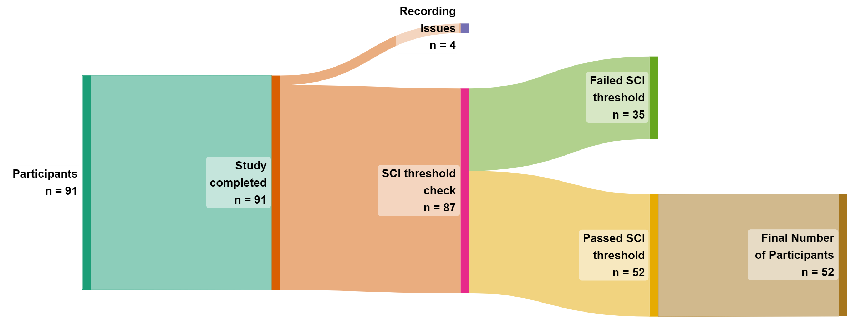and were removed prior to data analysis. The final sample consisted of 52 participants (39 females and 13 males, M = 21.62, SD = 6.67, range = 17 to 51). The study was approved by Ontario Tech’s Research Ethics Board (REB: 17656).

1. Sankey diagram showing the flow of participants through each stage of inclusion/exclusion in the study.

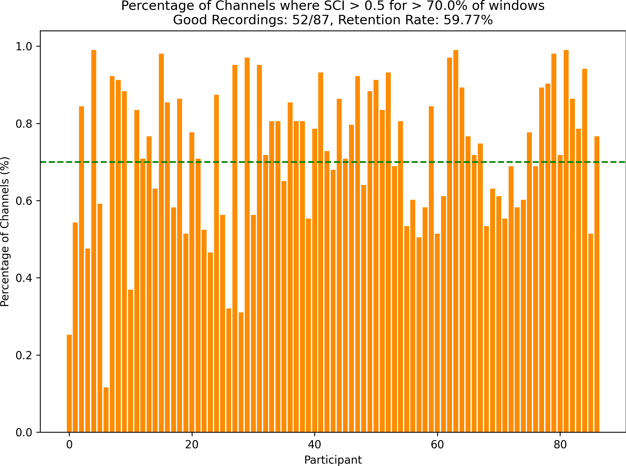

1. Percentage of Channels where SCI *>* 0.5 for *>* 70% of the windows. The green dashed line represents the threshold of 70% of windows that each participant must meet to be included in the analysis.

Figure 2.1: (A) Participant inclusion flow diagram. (B) SCI signal quality inclusion threshold.

## Stimuli and apparatus

### Stimuli

One hundred and forty images of facial expressions from the RADIATE and UIBVFED datasets were used (Conley et al., 2018; Oliver and Amengual Alcover, 2020). Then adult models (5 males and 5 females) from each dataset were identified and matched between- sets on face shape, sex, skin tone, and hair colour. Images of each model expressing seven emotions (anger, disgust, fear, happiness, sadness, surprise, neutral) were selected. Ex- pressions were selected for each model, that closely align with Ekman’s 6 basic emotions

+ neutral (Ekman and Friesen, 1971). UIBVFED images were cropped to the same size as RADIATE images.

### Apparatus

Participants were tested individually in a quiet dedicated testing room. Stimuli were pre- sented on a Dell U2415 24-inch monitor at 1920x1200 60Hz. Participants were seated in a comfortable non-movable chair, with the monitor placed at eye level. Stimuli were pre- sented using PsychoPy3 Experiment Builder (v2024.1.5) (Peirce et al., 2019). Participant brain activity was recorded using Aurora fNIRS while participants completed the task. fNIRS data was collected using two NIRSport2 systems (NIRx Medical Technologies, Berlin, Germany). Each NIRSport2 system was equipped with 16 source and 16 detector optodes, and daisy-chained together for a high density 32x32 optode configuration. Each neighboring pair of source and detector optode is referred to as a channel, resulting in a total of 103 HbO + 103 HbR channels (plus 16 short distance channels). The average distance between source and detector optodes was 30 mm, and 7mm for short distance channels, which were placed on a flexible fNIRS head cap (NIRScap) 58 cm in circum- ference. The optodes were arranged in a high density 32x32 montage with one bundle of short distance channels, as shown in Figure 2.2. This montage was designed to cover

a maximally large area of the brain, given increasing evidence that emotion processing is not localized to specific discrete areas of the brain, rather distributed across the brain (Lindquist et al., 2012). The fNIRS cap and optodes were positioned following the 10-20 international coordinate system. Light was emitted at 760 nm and 850 nm wavelengths, and the sampling rate was approximately 6.105 Hz.

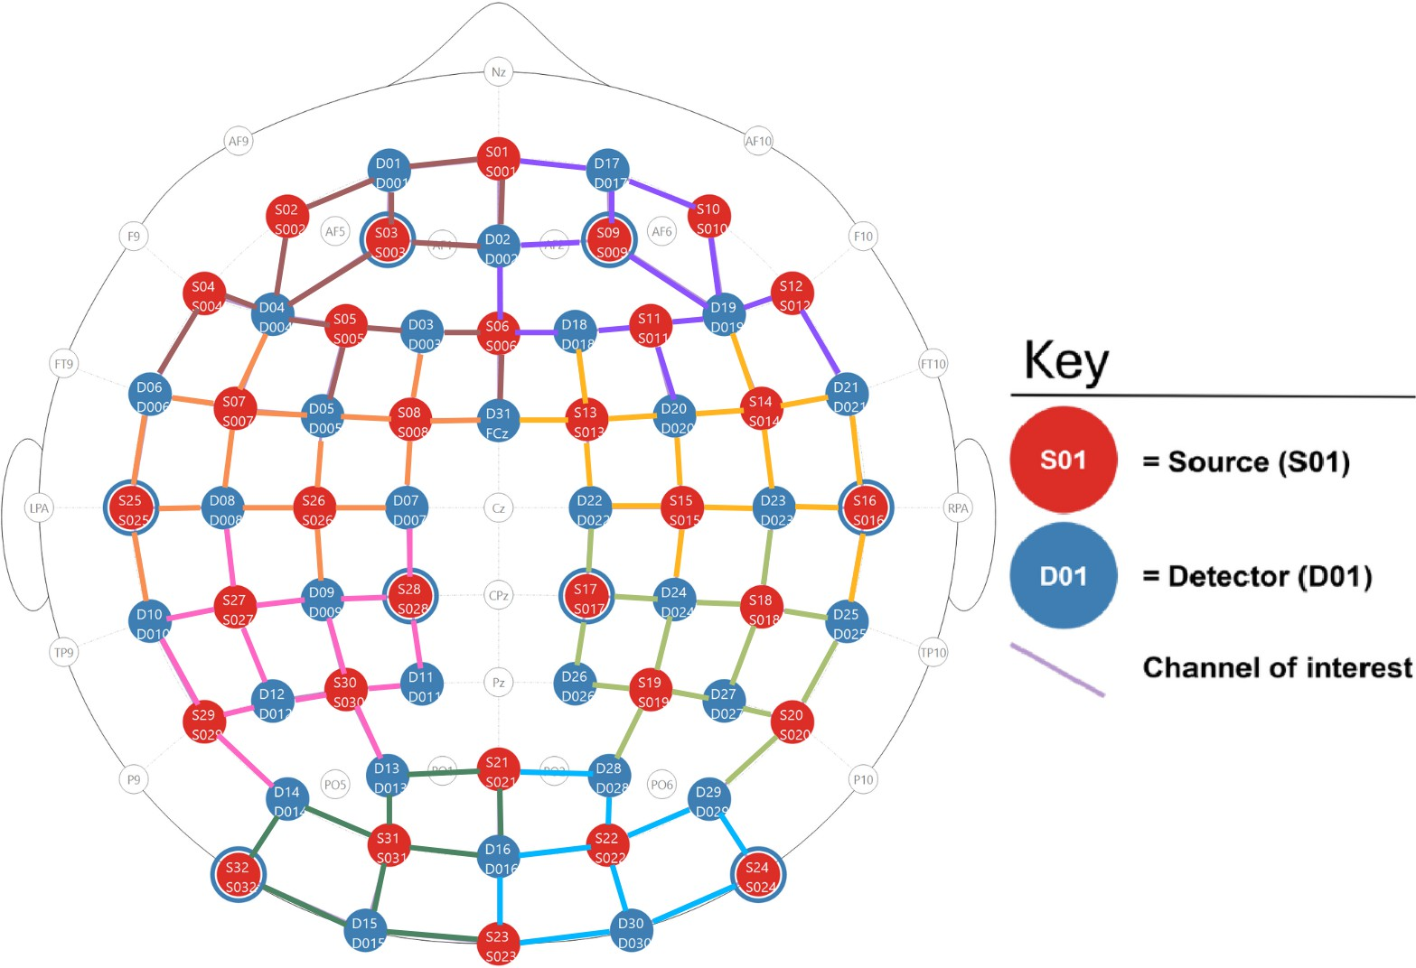

1. Depictions of the high density 32x32 optode montage. Red circles represent sources, blue circles represent detectors, the colored lines represent channels, and blue rings around sources represent the locations of the 8 short distance detectors. The colors of the channels represent the regions of interest (ROI’s) that the channels were grouped into, see (b) for the corresponding brain region labels.

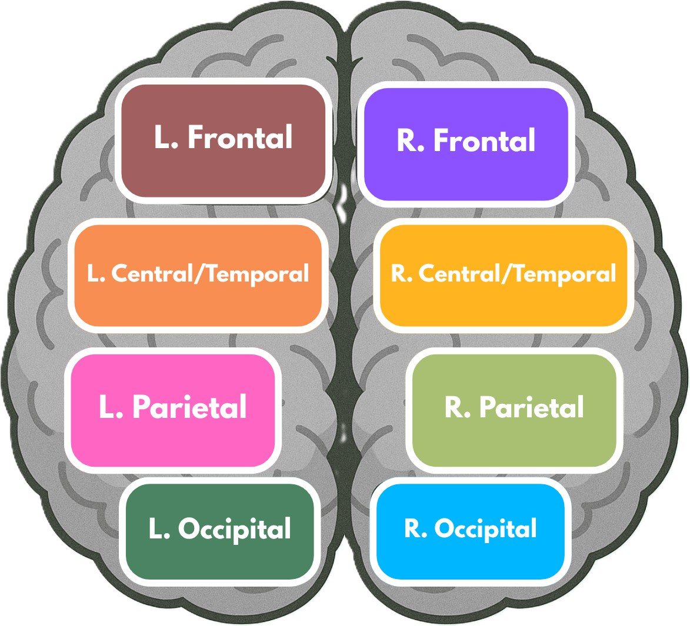

1. Brain region map, showing the regions of interest (ROI’s) that the channels were grouped into for certain analyses.

Figure 2.2: (a) High density 32x32 optode montage. (b) Brain region map for ROI grouping.

## Design and procedure

### Design

A full-factorial Face-type (2 levels: Real, Virtual) *×* Emotion (7 levels: Anger, Disgust, Fear, Joy, Sadness, Surprise, Neutral) *×* Model (4) *×* Sex (2 levels: Male, Female) *×* Repetition (4) experimental design was used, with each participant presented with 448 images. Stimuli were blocked and counterbalanced by Face-type and Emotion. Within each of the 56 Face-type-Emotion Blocks, participants were presented with 8 distinct model faces (4 male, 4 female).

### Procedure

Following consent and briefing, participant head size was measured and a size-appropriate fNIRS cap fitted. A signal optimization routine was then run within Aurora fNIRS to optimize participant channel signal levels. This routine worked by increasing source brightness in a stepwise manner, until the optimal signal levels for all channels was reached. Following optimization, participants were told that they would be presented with a series of facial expression images and asked to identify whether a probe face matched one of the faces they saw in the preceding block. Room lights were then switched off to avoid interference with the fNIRS cap, and participants were monitored from an adjacent room with a live camera feed.

The experiment began with instructions presented on screen. The trial timeline, shown in Figure 2.3, consisted of three main epochs: fixation cross, block presentation, and participant feedback. Each Block began with a fixed cross presented for 16 seconds, followed by 8 facial images. Facial images were each presented for 1.5 seconds, with a 250-750 ms (M=500 ms) interstimulus interval (ISI) between each face. To maintain participant attention, participants completed a memory task after each block. In the task, participants were presented with a model image with the same emotional expression as

the rest of the block’s images, and asked if the model was shown in the preceding block of 8 faces, with feedback provided using the keyboard (y/n). The probe face has a 50% chance of either being in the previous block or not. The experiment continued after seven seconds if no feedback was provided (the distribution of block missed responses is shown in Appendix C.1). Participants were given a break every seven blocks, and prompted to enter the space bar when they are ready to continue the experiment. After the experiment was completed, the experimenter(s) entered the room, removed the fNIRS cap, and the participant was debriefed about the experiment. Participation in the experiment took approximately 35 minutes.

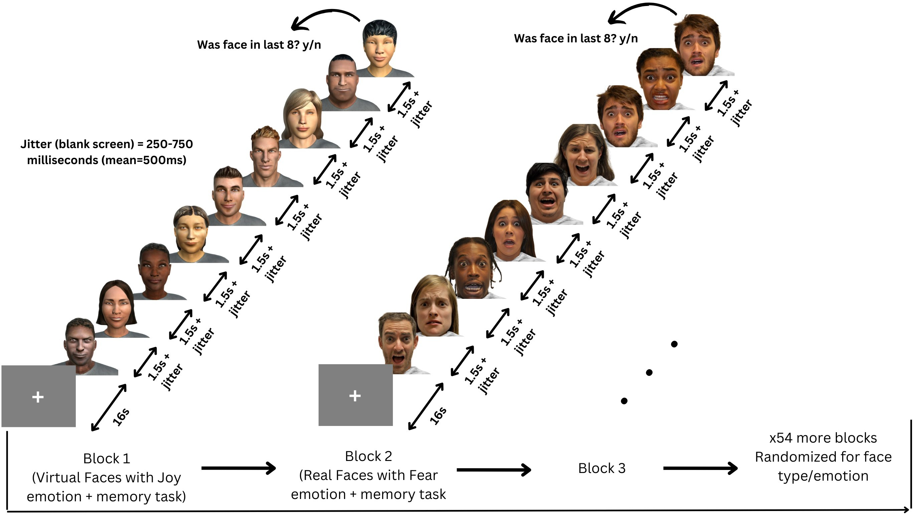

Figure 2.3: Participants viewed 56 blocks of 8 faces, each block being either all real or all virtual faces. Every face in a block displayed the same emotional expression, one of: anger, disgust, fear, happiness, sadness, surprise, neutral.

## Analyses

All fNIRS data was preprocessed and analyzed with Python 3.11.9 using MNE (version 1.9.0) (Gramfort et al., 2013) and MNE-NIRS (version 0.7.1) (Luke et al., 2021), which

used the Nilearn package (version 0.9.2). Data were analyzed with a General Linear Model (GLM), followed by a functional connectivity analysis. The memory task was analyzed in Python using the statsmodels package (version 0.14.4) (Seabold and Perktold, 2010).

### fNIRS preprocessing

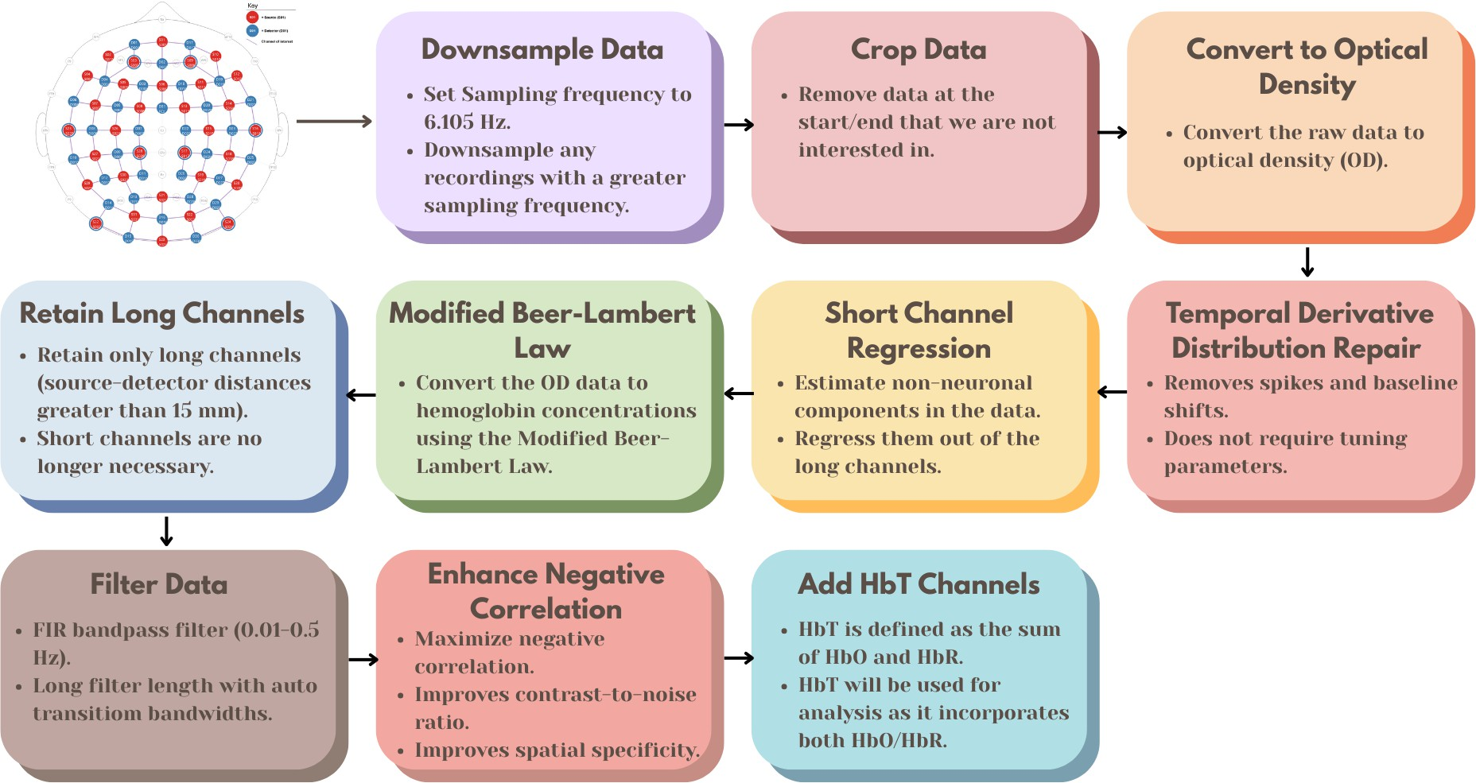

Figure 2.4: Preprocessing steps for fNIRS data, from the raw data to the fully processed data.

The preprocessing steps for the fNIRS data, as shown in Figure 2.4, were as follows:

1) Downsample the data if the sampling frequency is greater than 6.105 Hz, the initial two datasets were sampled higher than 6.105 Hz, and the sampling frequency should be consistent across all datasets. 2) Crop the data to the first and last annotation. This gets rid of the extra data at the beginning and end of the recording that are not of interest. 3) Convert the raw data to optical density. 4) Apply temporal derivative distribution repair to the OD data (Fishburn et al., 2019). TDDR is effective at removing spikes and baseline shifts from the data. 5) Apply short channel regression to the OD data (Scholkmann

et al., 2014). Short channels are used to estimate the superficial hemodynamics (non- evoked/extracerebral/systemic components) in the data, and then regress it out of the long channels (Tachtsidis and Scholkmann, 2016). 6) Convert the OD data to hemoglobin concentrations using the modified Beer-Lambert law. The MBLL relates the change in light attenuation to the change in hemoglobin concentration of chromophores in the tissue (Kocsis et al., 2006). 7) Retain only long channels (source-detector distance *>* 15 mm). Since the short channels have already been regressed out, it is no longer necessary to keep them in the data. 8) This FIR bandpass filter extracts signal components in the 0.01-0.5 Hz range, it uses a long filter length (2015 samples) with automatically determined transition bandwidths by MNE-Python (Pinti et al., 2019). 9) Maximizes negative correlation between HbO and HbR (Cui et al., 2010). This method removes spikes, improves contrast-to-noise ratio, and improves spatial specificity of the data. 10) Add HbT (hemoglobin total) channels to the data. HbT is defined as the sum of HbO and HbR. Often, fNIRS studies will only use either one of HbO or HbR channels (more frequently HbO), leaving out one channel with no justification (Kinder et al., 2022). Therefore, HbT channels are chosen, as HbT makes use of both HbO and HbR channels, and using both hemoglobin species improves the inferences as to where activation occurs (Hocke et al., 2018).

Variable length epochs were created for each block of 8 faces, which were 14-18 seconds long (mean = 16s), depending on the ISI’s (see 2.3.2). Epochs were sorted by Face Type (Real, Virtual), and Emotion (Anger, Disgust, Fear, Happiness, Sadness, Surprise, Neutral), and their interaction. Baseline correction was applied to remove any constant or slowly varying offsets in the data. The data was annotated with the onsets and offsets of each block, along with the duration and condition of each block. Block data were then analysed using a GLM and Functional Connectivity analysis.

### Activation magnitude with General Linear Model (GLM)

The General Linear Model (GLM) posits that the observed haemodynamic signal at each channel or Region of Interest (ROI) is a linear combination of task-related regressors convolved with a Hemodynamic Response Function (HRF), plus nuisance regressors (e.g., drift) and residual noise. Mathematically,

*Y* = *Xβ* + *ϵ,* (2.1)

where *Y* is the observed time series, *X* is the design matrix, *β* represents the parame- ters to estimate, and *ϵ* denotes the residuals assumed to be Gaussian noise. Estimation is performed via ordinary least squares (OLS), yielding parameter estimates that quantify condition-specific activation amplitudes.

#### Design Matrix

For each of the epochs, events are defined by their trial type (e.g., emotion or face type), and onsets/offsets relative to the procedure start, and duration. The design matrix is constructed using Nilearn’s make first level design matrix by convolving a boxcar function (based on the event timing) with a canonical HRF, which is a model of the expected haemodynamic response to neural activity. The canonical HRF Statistical Parametric Mapping (SPM) (Friston, 2007) is chosen to model neurovascular coupling, this model captures the stereotypical rise and fall of the BOLD/fNIRS response. The cosine drift model was utilized, which incorporates discrete cosine transform (DCT) basis functions into the design matrix to model and remove low-frequency drifts. The selection of the high pass cutoff frequency is guided by the structure of the experimental design. The cutoff period is set to twice the duration of the longest inter-trial interval, and each fixation period between epochs (or blocks) is 16 seconds. Therefore, a cutoff period of 32 seconds (i.e., high pass=0.03125 Hz) would be appropriate. This ensures that the drift

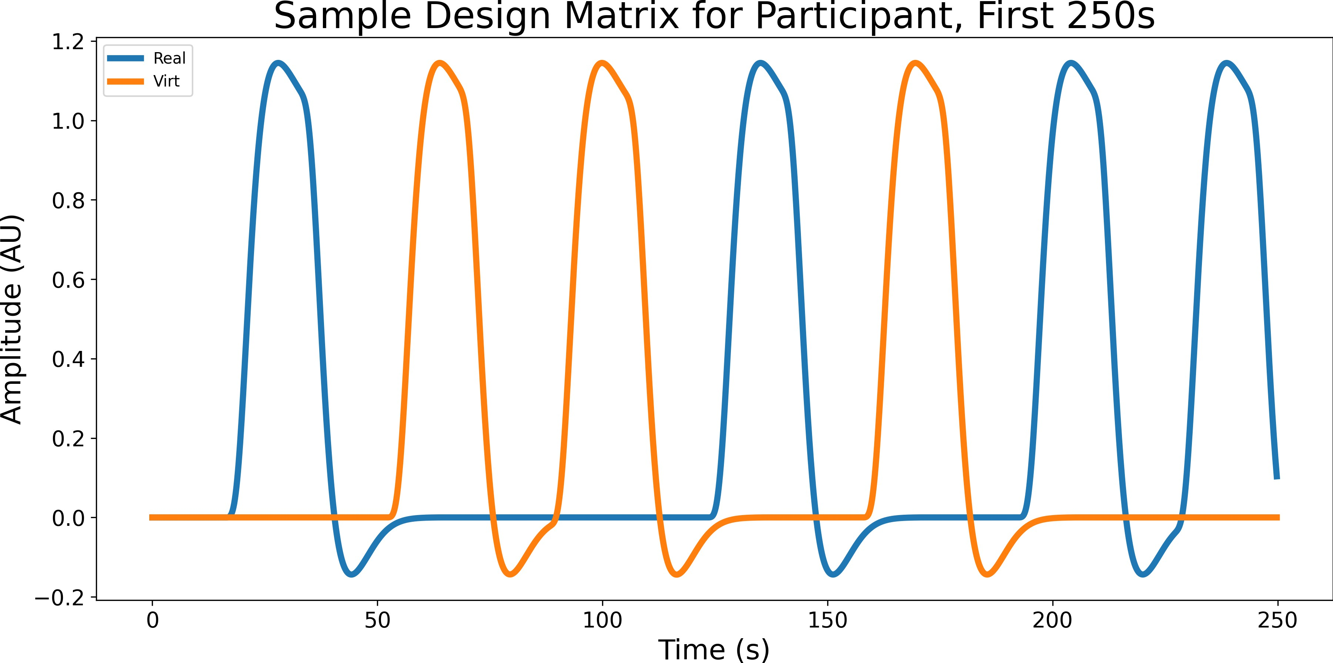model does not remove task-related signal components that occur at frequencies higher than the cutoff (Luke et al., 2021). The design matrix *X* and preprocessed time series are fed into MNE’s run glm function, which computes OLS estimates of *β* for each channel.

Figure 2.5: Sample design matrix for a single participant for the effect Face type, showing the first 7 blocks (250 seconds) of a single experiment. The design matrix is organized by condition (Blue for real, orange for virtual), this is the result of convolving the boxcar function with the canonical HRF SPM.

A two-way repeated measures GLM was conducted on participant’s HbT responses by Face-type (2 levels: Real, Virtual) and Emotion (7 levels: Anger, Disgust, Fear, Joy, Sadness, Surprise, Neutral). Pairwise contrasts were then computed between conditions to identify effects of interest.

#### Contrast Computation

All pairwise contrasts were generated between conditions by constructing an identity con- trast matrix over design columns. For each pair of conditions (*A, B*), the contrast vector is defined as: *c* = *eA − eB*, where *eA* and *eB* are the respective design matrix columns for conditions *A* and *B*. Contrasts are computed using MNE’s compute contrast function, which produces effect estimates and test statistics aggregated across channels. Since nu-

merous statistical tests are performed across channels and contrasts, *p*-values were FDR- corrected corrected using the Benjamini-Hochberg procedure (Singh and Dan, 2006) with a family-wise error rate of *α*=0.05.

### Network mapping with Functional Connectivity Analysis

To characterize the temporal coordination between fNIRS channels during face and emotion processing, functional connectivity matrices were computed using a continuous wavelet transform (CWT)-based spectral connectivity approach. CWT decomposes sig- nals into simultaneous time-frequency representations, providing an optimal framework for fNIRS connectivity analysis by accommodating the non-stationary, physiological na- ture of hemodynamic signals. The morlet wavelet, a gaussian function modulated by a sine wave, was picked as they are suited to capture both slow neural rhythms and faster systemic fluctuations in fNIRS data (Reddy et al., 2021). Wavelet-based approaches have been widely adopted in the fNIRS literature for connectivity and even artifact correction (Bergmann et al., 2023; Hakim et al., 2023) Coherence combines both phase and ampli- tude information into a single, normalized index, 0 (no coupling) to 1 (perfect coupling), and is a richer description of coupling than phase-only or amplitude-only metrics (Bastos and Schoffelen, 2016).

For each participant, MNE’s spectral connectivity time function was applied to compute time-resolved coherence across pairs of channels, the average of this was taken across epochs to obtain a single channel-by-channel connectivity matrix for each condi- tion. Each participants’ connectivity matrix was then averaged across participants to obtain a group-level connectivity matrix for each condition. fNIRS hemodynamics pre- dominantly fluctuate in very low frequencies (0.01-0.5 Hz) (Reddy et al., 2021). The frequency range was narrowed to five evenly spaced frequences between 0.2-0.5 Hz due to short epoch length, this range still targets systemic and neurogenic oscillations while avoiding high-frequency noise (Xu et al., 2017). Averaging across these closely spaced fre-

quencies reduces data dimensionality, simplifying downstream statistical analyses without sacrificing sensitivity to coupling dynamics.

#### Paired Sample t-tests

For each mode (Face type/Emotion), and pair of conditions (e.g., Joy vs. Fear), individual- level connectivity matrices were extracted by averaging across epochs to obtain symmetric channel-by-channel coherence matrices. Because coherence values are bounded between 0 and 1 and exhibit skewed distributions (Miranda de S´a et al., 2009), Fisher’s r-to-z transform (atanh) was applied to each matrix element to normalize the data prior to parametric testing. Paired *t*-tests for each unique channel pair (*i > j*) were then con- ducted across participants using SciPy’s ttest rel. This directly tests whether mean connectivity differs between conditions, leveraging the paired design to increase statisti- cal sensitivity (Hu et al., 2023). Given the large number of channel-pair tests, and similar to the GLM analysis above in 2.4.2, *p*-values were FDR-corrected using the Benjamini- Hochberg procedure (Singh and Dan, 2006) with a family-wise error rate of *α*=0.05.

#### ROI Chord Plots

To distill high-dimensional channel-by-channel connectivity into interpretable inter-regional summaries, we mapped individual fNIRS channels onto anatomically defined ROI’s. This includes left and right frontal, central/temporal, parietal, occipital regions of the brain as shown in Figure 2.2b, and the channels were grouped into these regions based on their location in the montage. Since multiple channels may map to the same pair of regions (e.g., several left central/temporal channels connecting to several right occipital channels), we calculated the sum of all signicant channel-pair connections for each ROI pair (separately for positive and negative *t*-values). We then subtracted the negative sum from the positive sum, resulting in a single integer representing the net connectivity which was positive if the positive connections outweigh the negative ones, and vice versa.

We then took the top 15% percentile of each net connectivity value, and set the rest to zero, to show only the strongest connections between regions. The lines were then plotted using a chord diagram, with the line color indicating the direction of the net connectivity (positive or negative), and the line width indicating the magnitude of the net connectivity (the absolute value of the net connectivity).

#### Emotion Summary Ratio Plot

To summarize the net connectivity between regions for each emotion, we calculated a ratio of positive to negative connections for each emotion pair. The ratio was calculated by taking the difference of the count of significant channels where the *t*-value was positive and the count of significant channels where the *t*-value was negative, and dividing it by the total number of significant channels for that emotion pair. This ratio provides a measure of the net connectivity across all ROI’s for each emotion, with a positive ratio indicating that one emotion has a stronger net connectivity than the other, and a negative ratio indicating that the other emotion has a stronger net connectivity.

#### Region Summary Plot

To summarize the net connectivity across all emotions for each region, we summed the number of significantly different channel pairs between each region pair across all emo- tions, disregarding the direction of the *t*-value. This provides a measure of the net con- nectivity across all emotions for each region, showing which regions are more connected across all emotions. The 3 regions with the highest and lowest number of significant channel pairs are marked, to emphasize the most/least connected regions across all emo- tions.

### Memory Task Analysis

Raw behavioral data captured from PsychoPy were preprocessed to identify participant keyboard responses. The total correct trials per participant were summed. Since each block of faces was either all real or all virtual, and all had the same emotional expression (as discussed in 2.3.2), each y/n response was labeled with Face type and Emotion. An OLS model was fit with accuracy (converted to numeric 0/1) as the dependent variable and categorical predictors for Face Type, Emotion, and their interaction. The goal is to determine the main effects of these two factors individually, as well as their interaction, on response accuracy. A two-way Type III ANOVA (via sm.stats.anova lm(model, typ=3)) provided *F* -statistics and *p*-values for main effects and interaction. This version of the ANOVA is especially suitable when interactions are included in the model, as it calculates each effect after accounting for all other terms.

**Chapter 3 Results**

## Neural activation magnitude

**Responses to real and virtual faces**

A main effect of Face type was reported, with pairwise contrasts revealing greater activation for virtual faces compared to real faces, as shown in Figure 3.1.

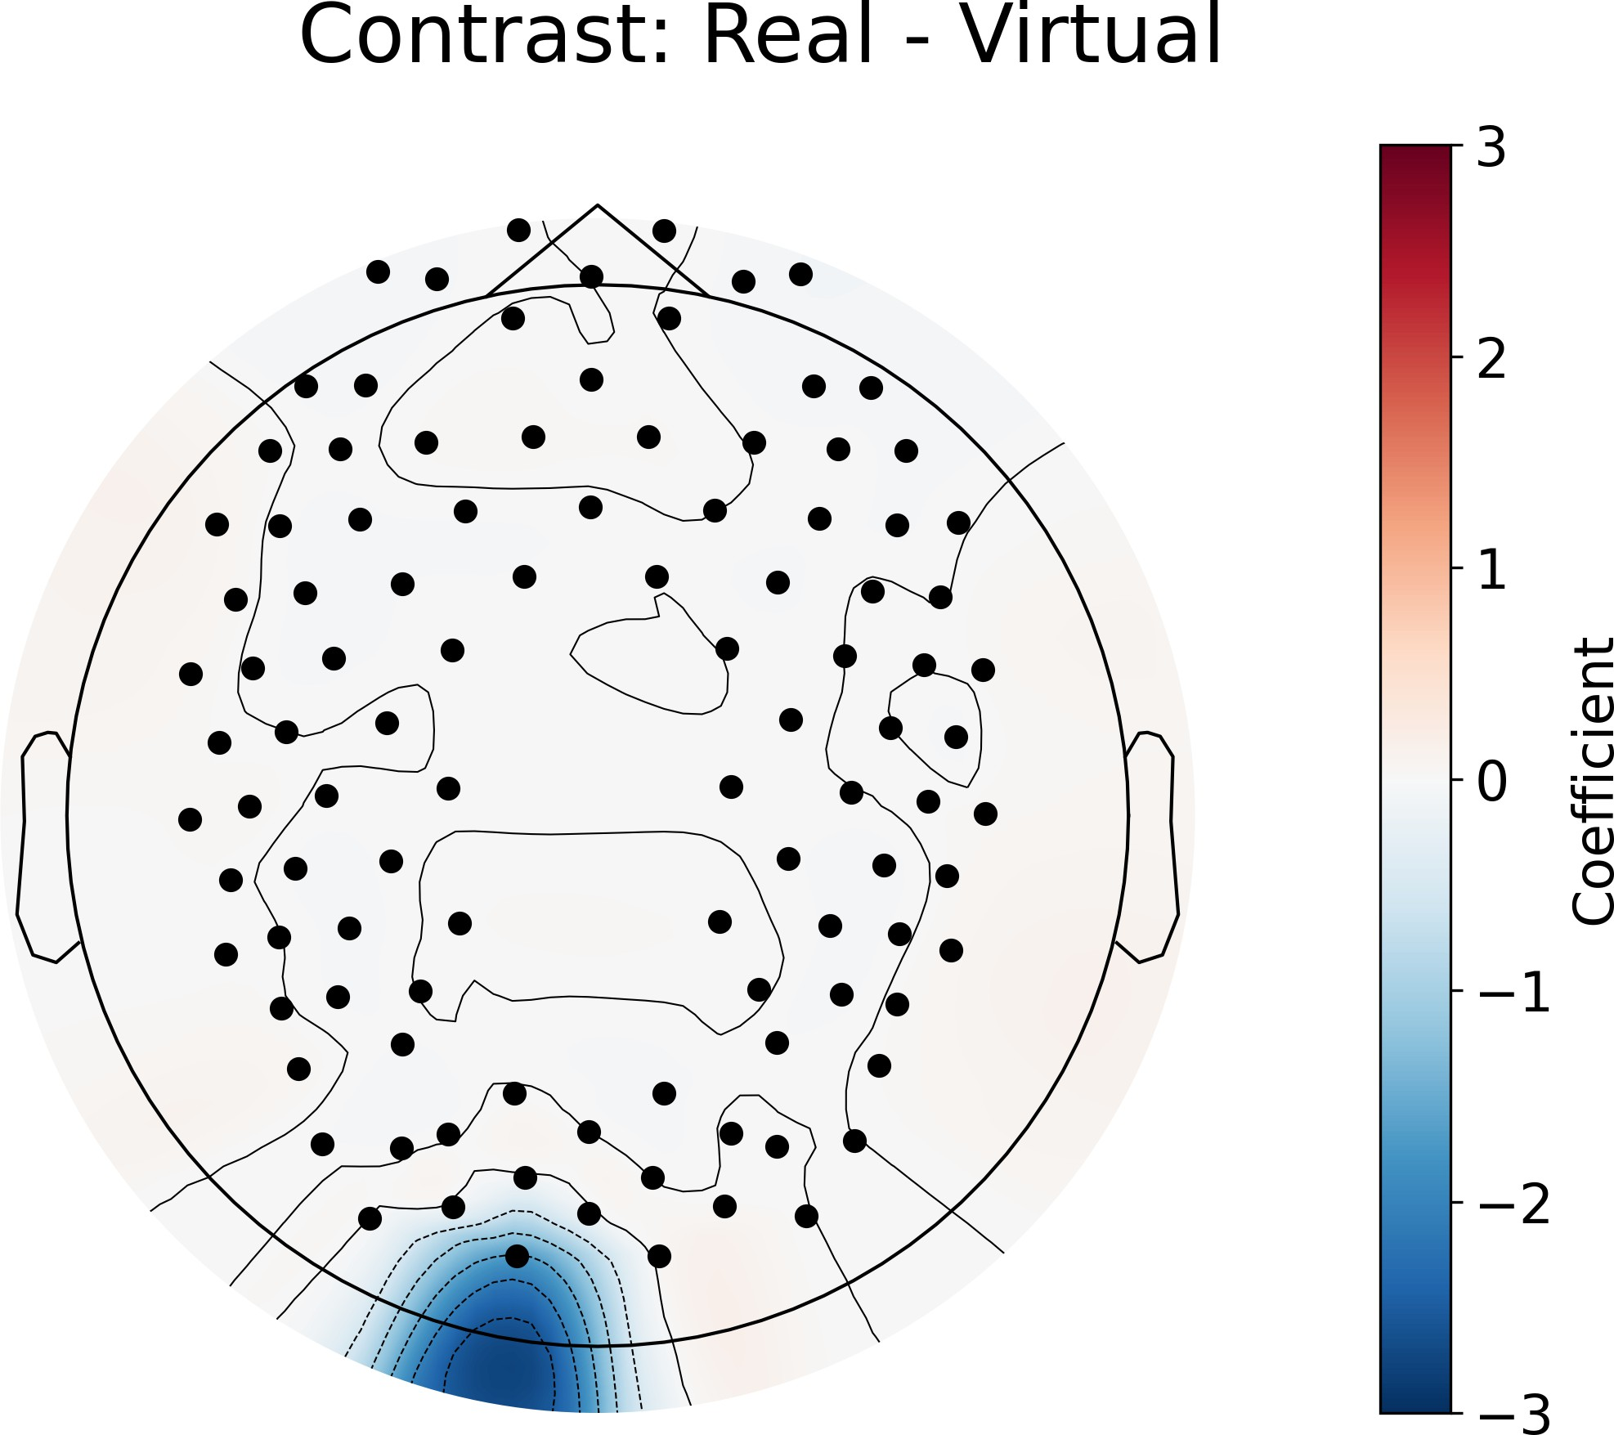

Figure 3.1: GLM contrast between real and virtual conditions which shows the differences in activation between the two conditions. Red signifies that condition 1 (real faces) has more activation in that area than condition 2 (virtual faces), while blue signifies that condition 2 (virtual faces) has more activation than condition 1 (real faces). The color bar on the right shows the coefficient of the contrast, which indicates the strength of the difference in activation between the two conditions.

25

**Responses to different facial emotions**

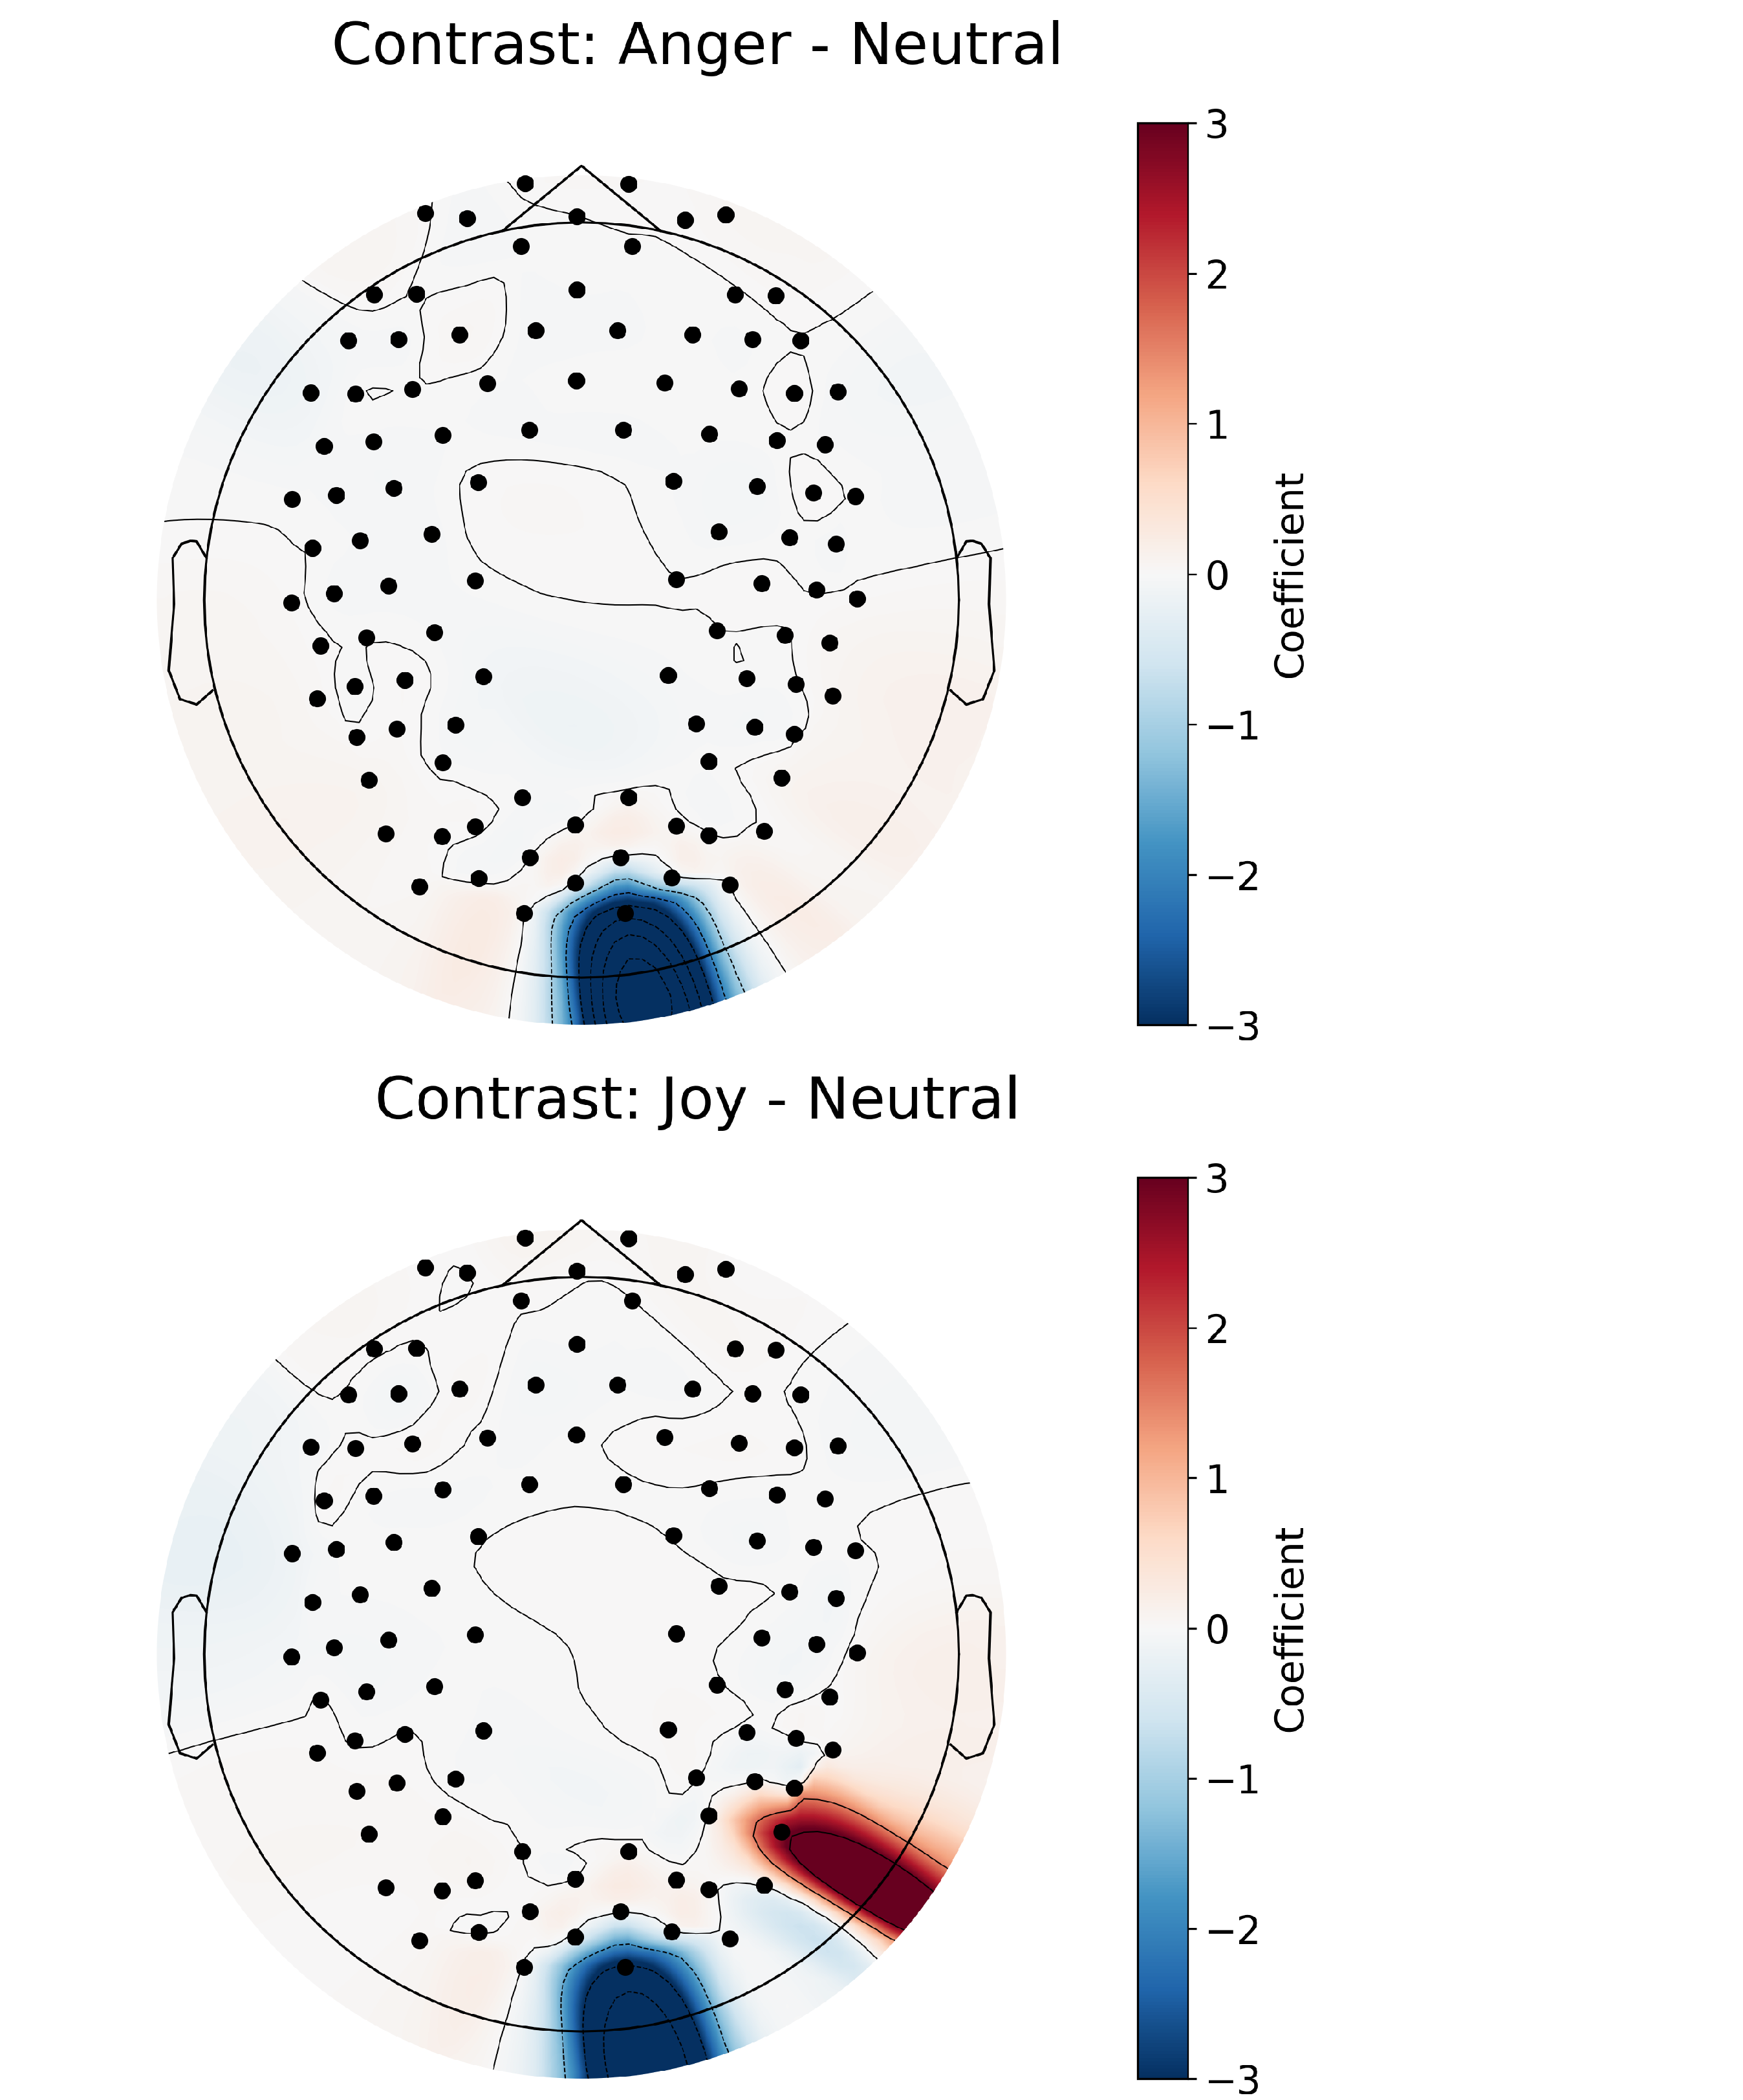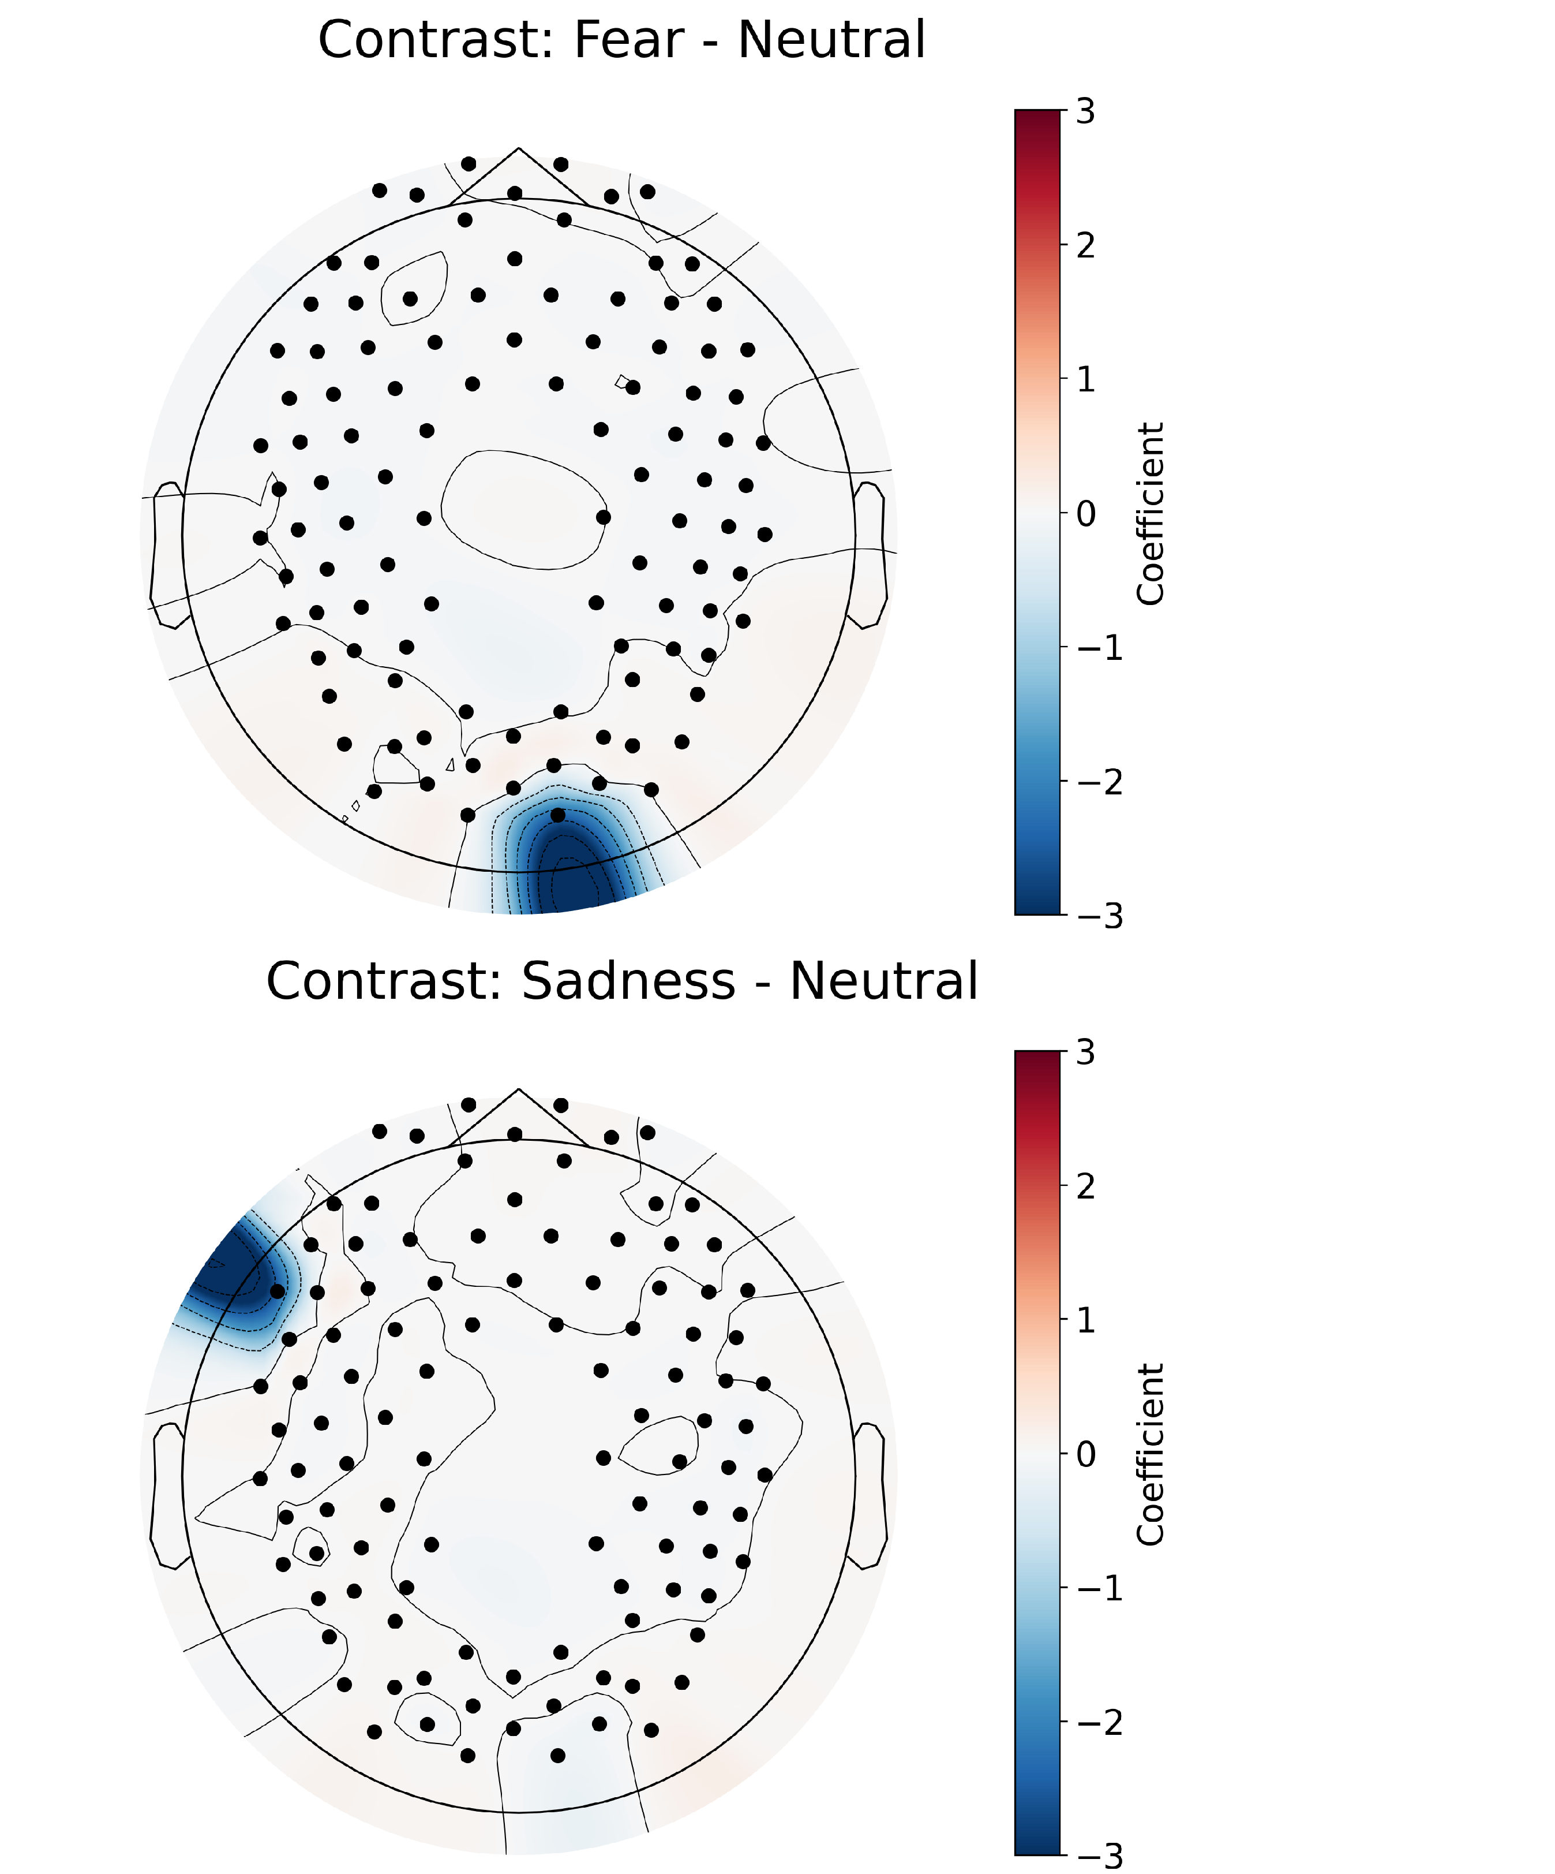Pairwise contrasts with Neutral (control) and other emotions revealed significant dif- ferences in activation across several brain regions (Figure 3.2). For instance, perceiving Anger, Fear, and Joy elicited less activity in the right occipital region than perceiving Neutral. Morever, processing Joy was associated with less activity in the right parietal region, while processing Sadness produced less activity in the left frontal region relative to processing Neutral. These results indicate distinct neural activation patterns for each emotion when contrasted against the ”baseline” Neutral condition, with most prominent differences in neural activity over the occipital region.

Figure 3.2: GLM results for the contrast between different emotions and neutral condi- tion.

Interestingly, processing Surprise was most consistently different from processing other emotions (Figure 3.3). We found processing Surprise produced 1) more activ- ity in the left central/temporal and right occipital regions relative to processing Disgust and Joy, 2) more activity in the right parietal region relative to processing Fear, 3)

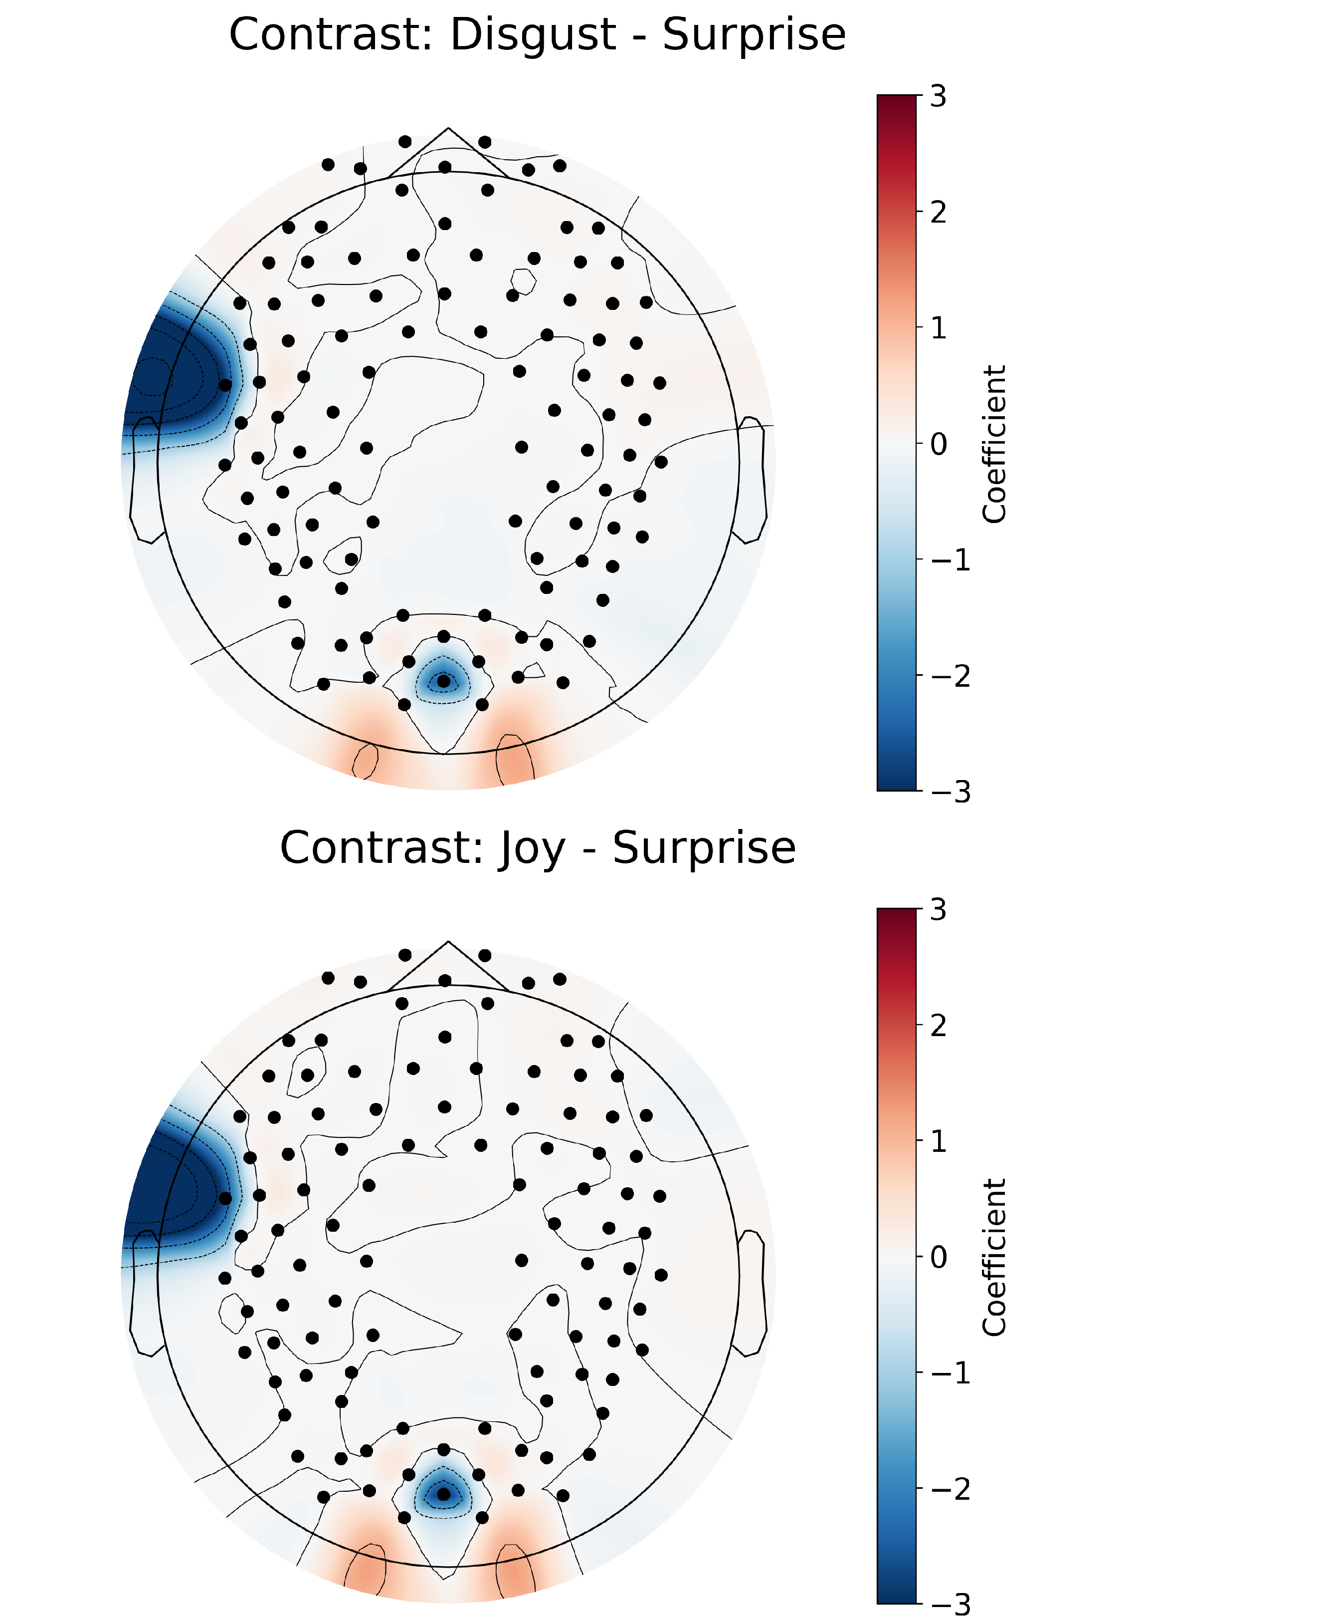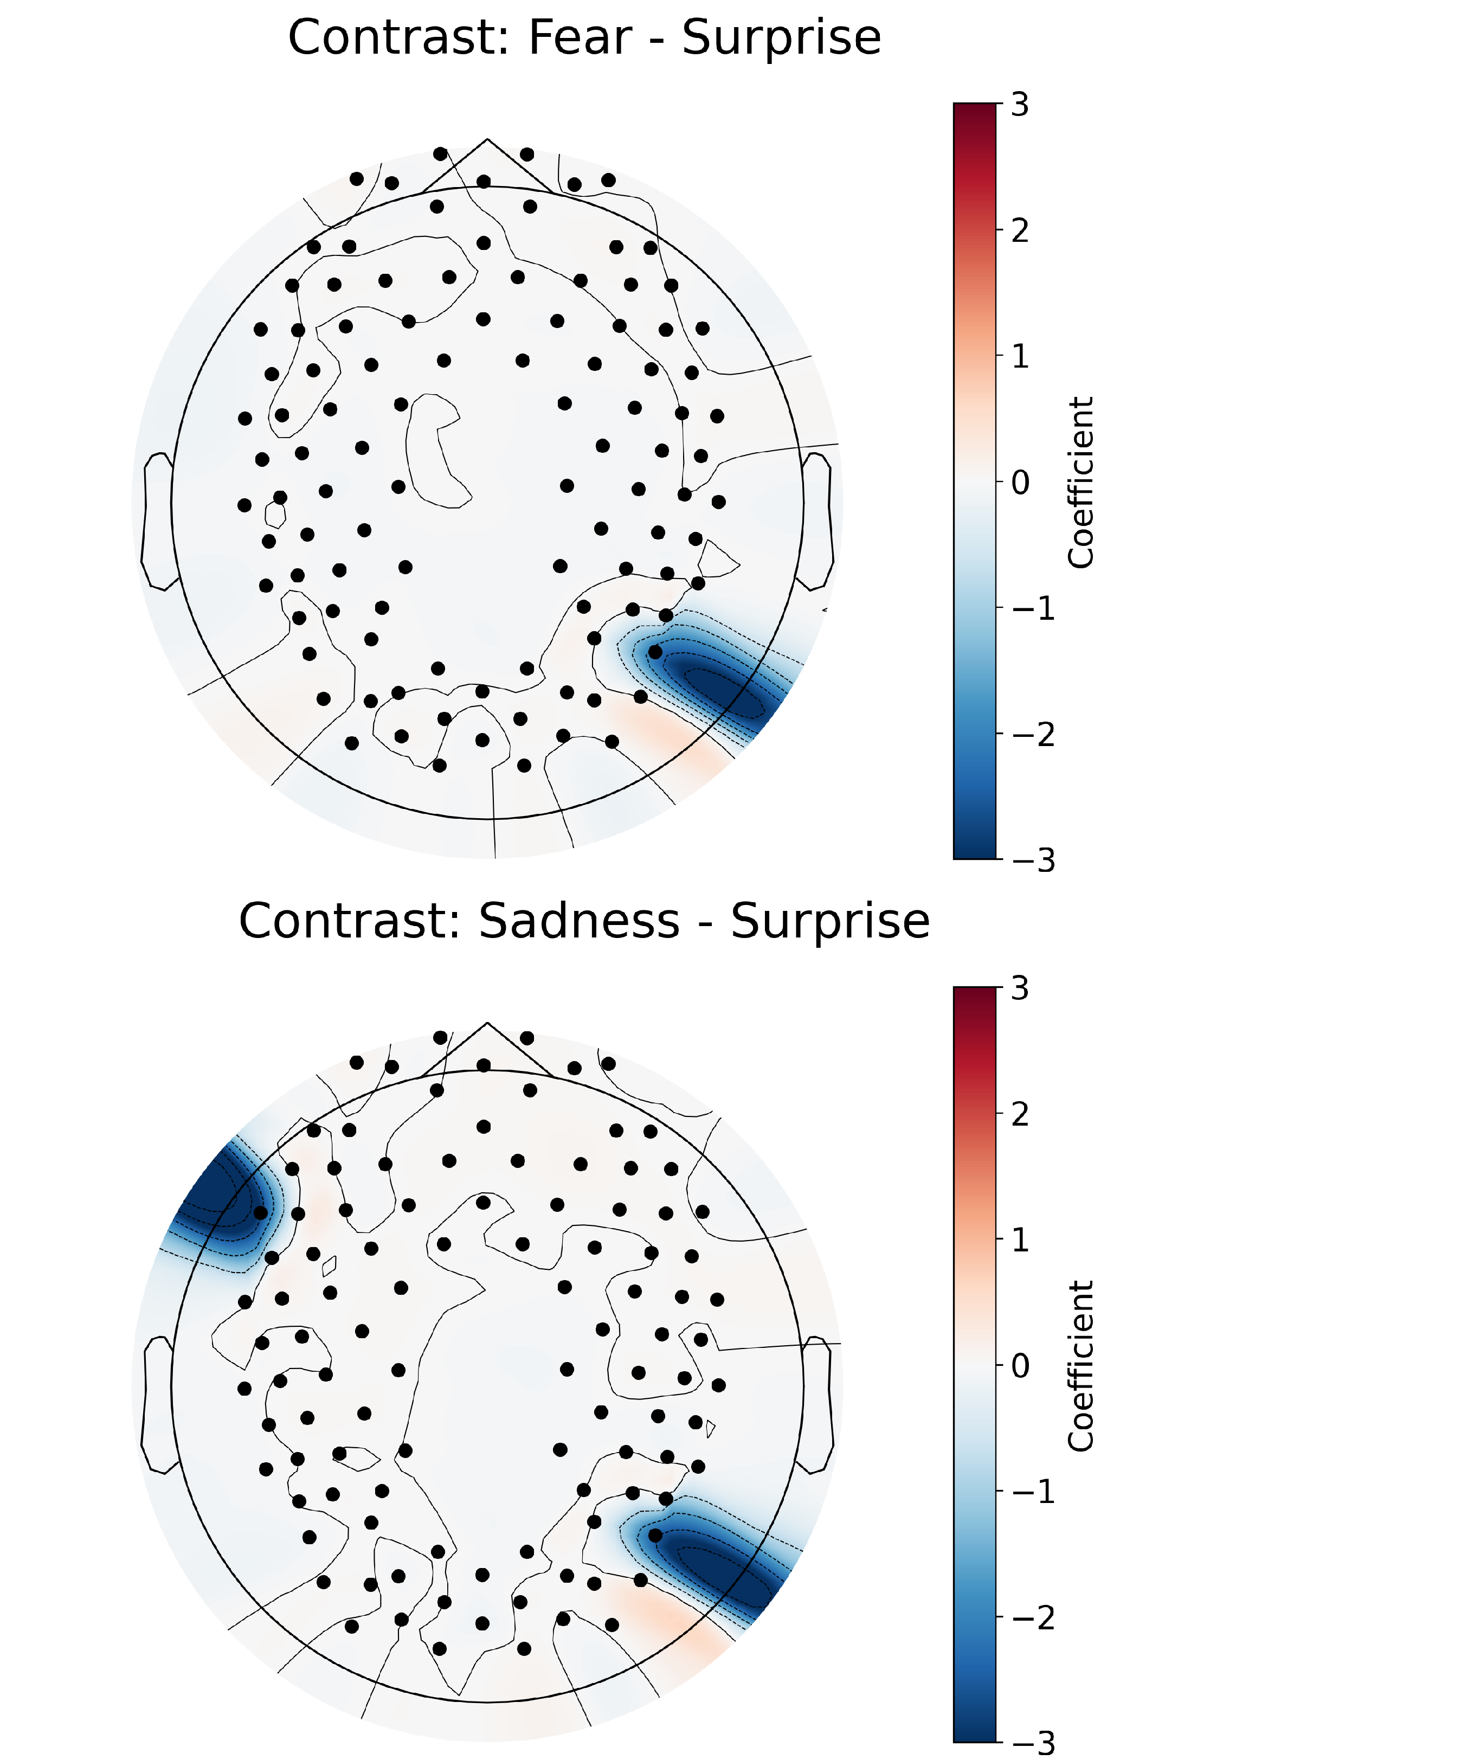more activity in the left frontal and right parietal regions relative to processing Sadness, and 4) more activity in the right parietal region and less activity in the right occipital region relative to processing Neutral. These findings suggest that Surprise is distinct from processing Neutral but also other emotions, with differences in neural activity more widespread that include central/temporal and parietal regions. All combinations of emo- tion contrasts were performed, significant differences were only found between Neutral relative to the other emotions, and between Surprise relative to the other emotions.

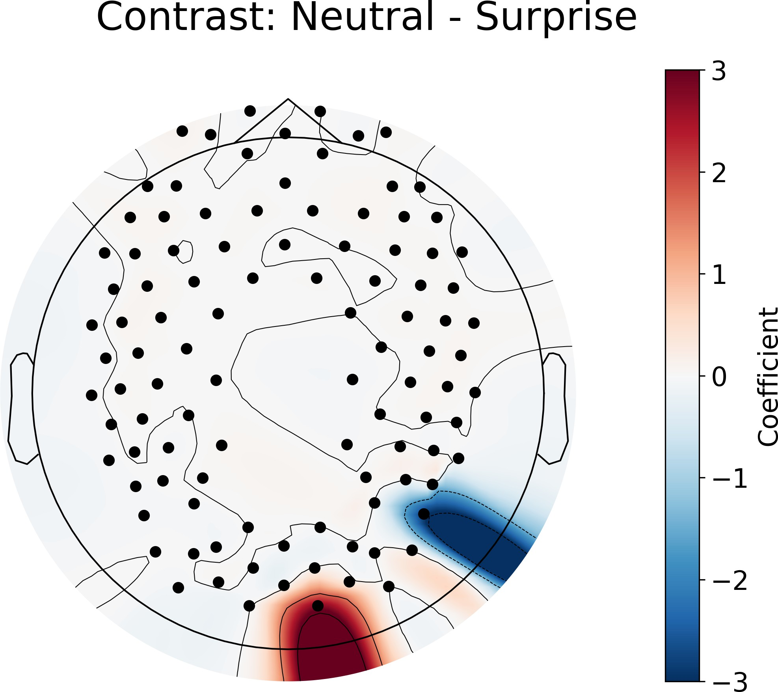

Figure 3.3: GLM results for the contrast between different emotions and surprise condi- tion.

**Interaction in the responses to face type and emotion**

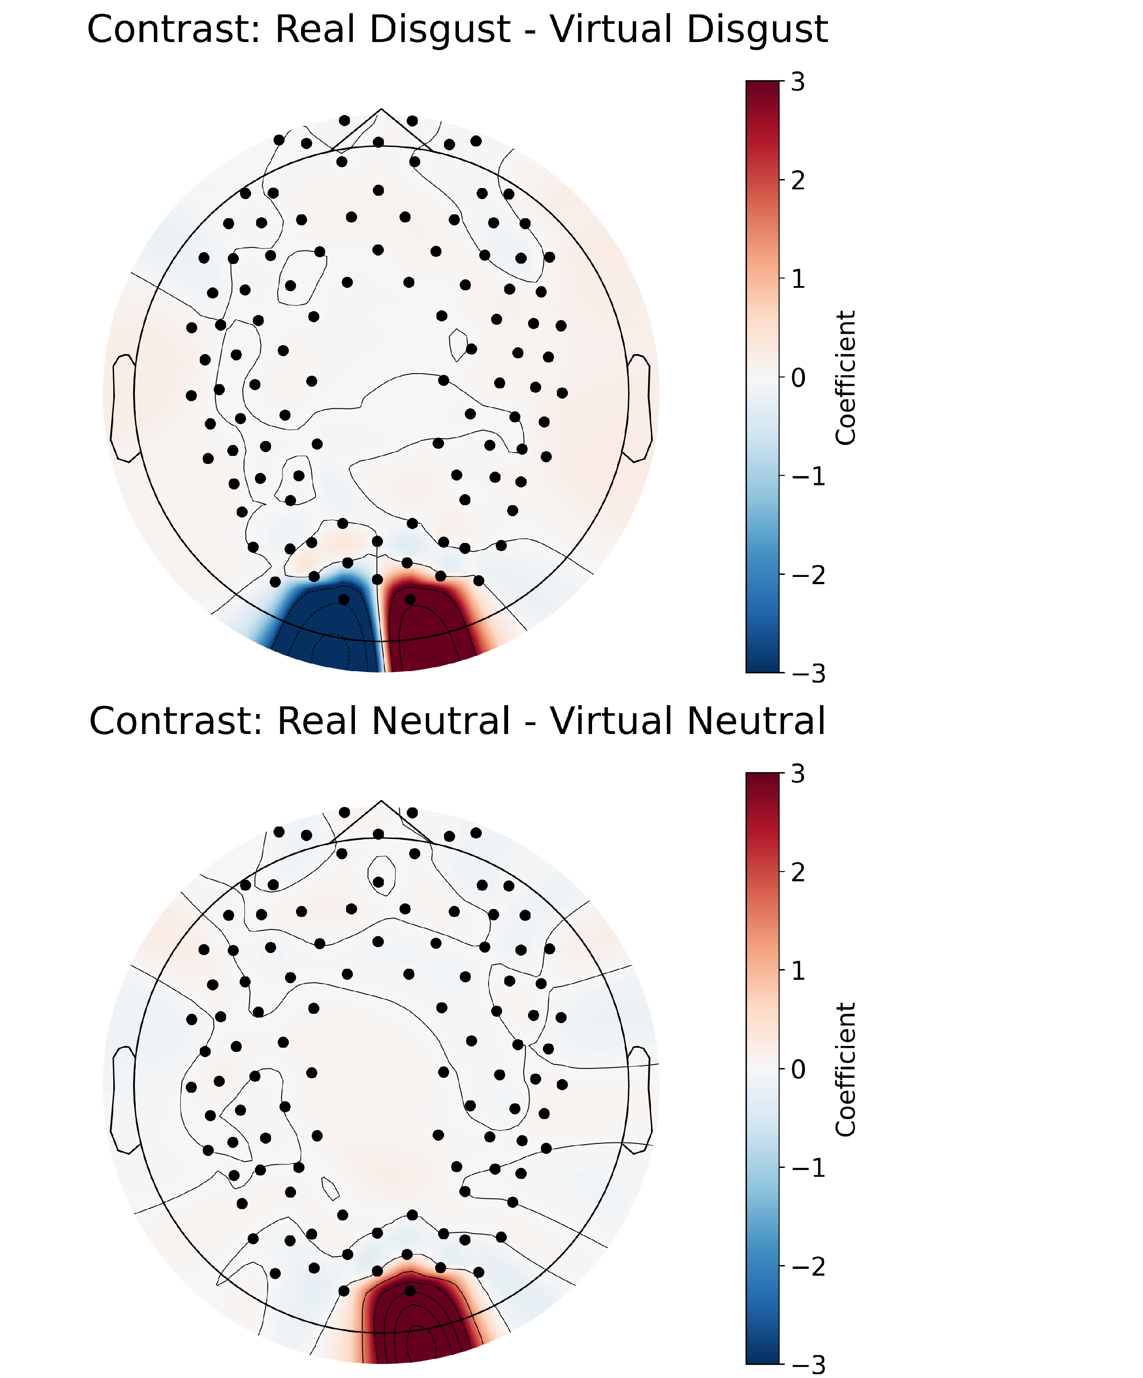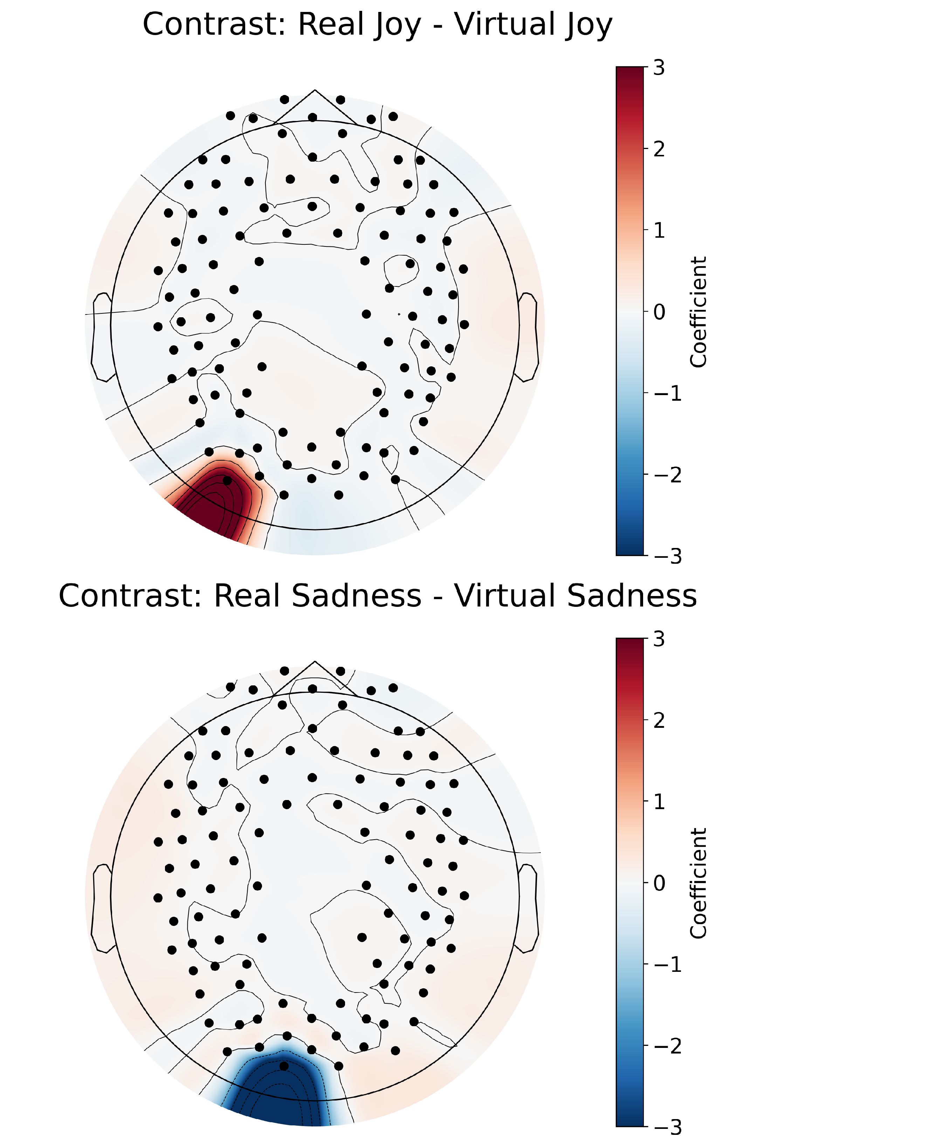The interaction of Real - Virtual within each emotion, as shown in Figure 3.4 revealed significant differences in occipital regions exclusively. Specifically, processing Disgust on real faces elicited greater activity in the right occipital region compared to processing Disgust on virtual faces, whereas the left occipital region showed the opposite pattern. Moreover, processing Joy and Neutral emotions on real faces also elicited greater activity in the occipital regions compared to processing the same emotions on virtual faces. We found processing Sadness on virtual faces produced more activity in the left occipital region for virtual faces compared to processing Sadness on real faces. These findings suggest that the neural response to emotional expressions is modulated by the realism of the face stimuli. The full table of the GLM contrasts for all main effects and interactions can be found in Appendix A.

Figure 3.4: GLM results for the contrast between real and virtual conditions within each emotion.

## Functional Connectivity Mapping

**Connectivity profiles of face type**

The contrast comparing functional connectivity profiles in response to real versus virtual faces (as shown in Figure 3.5) revealed significant differences in connectivity across the brain. Processing real faces was associated with stronger connectivity predominantly between the left to right parietal, left frontal to left parietal, left central/temporal to left parietal, left central/temporal to right parietal, and the right central/temporal to left parietal regions, whereas processing virtual faces was associated with only slightly stronger connectivity between the left central/temporal to right frontal region.

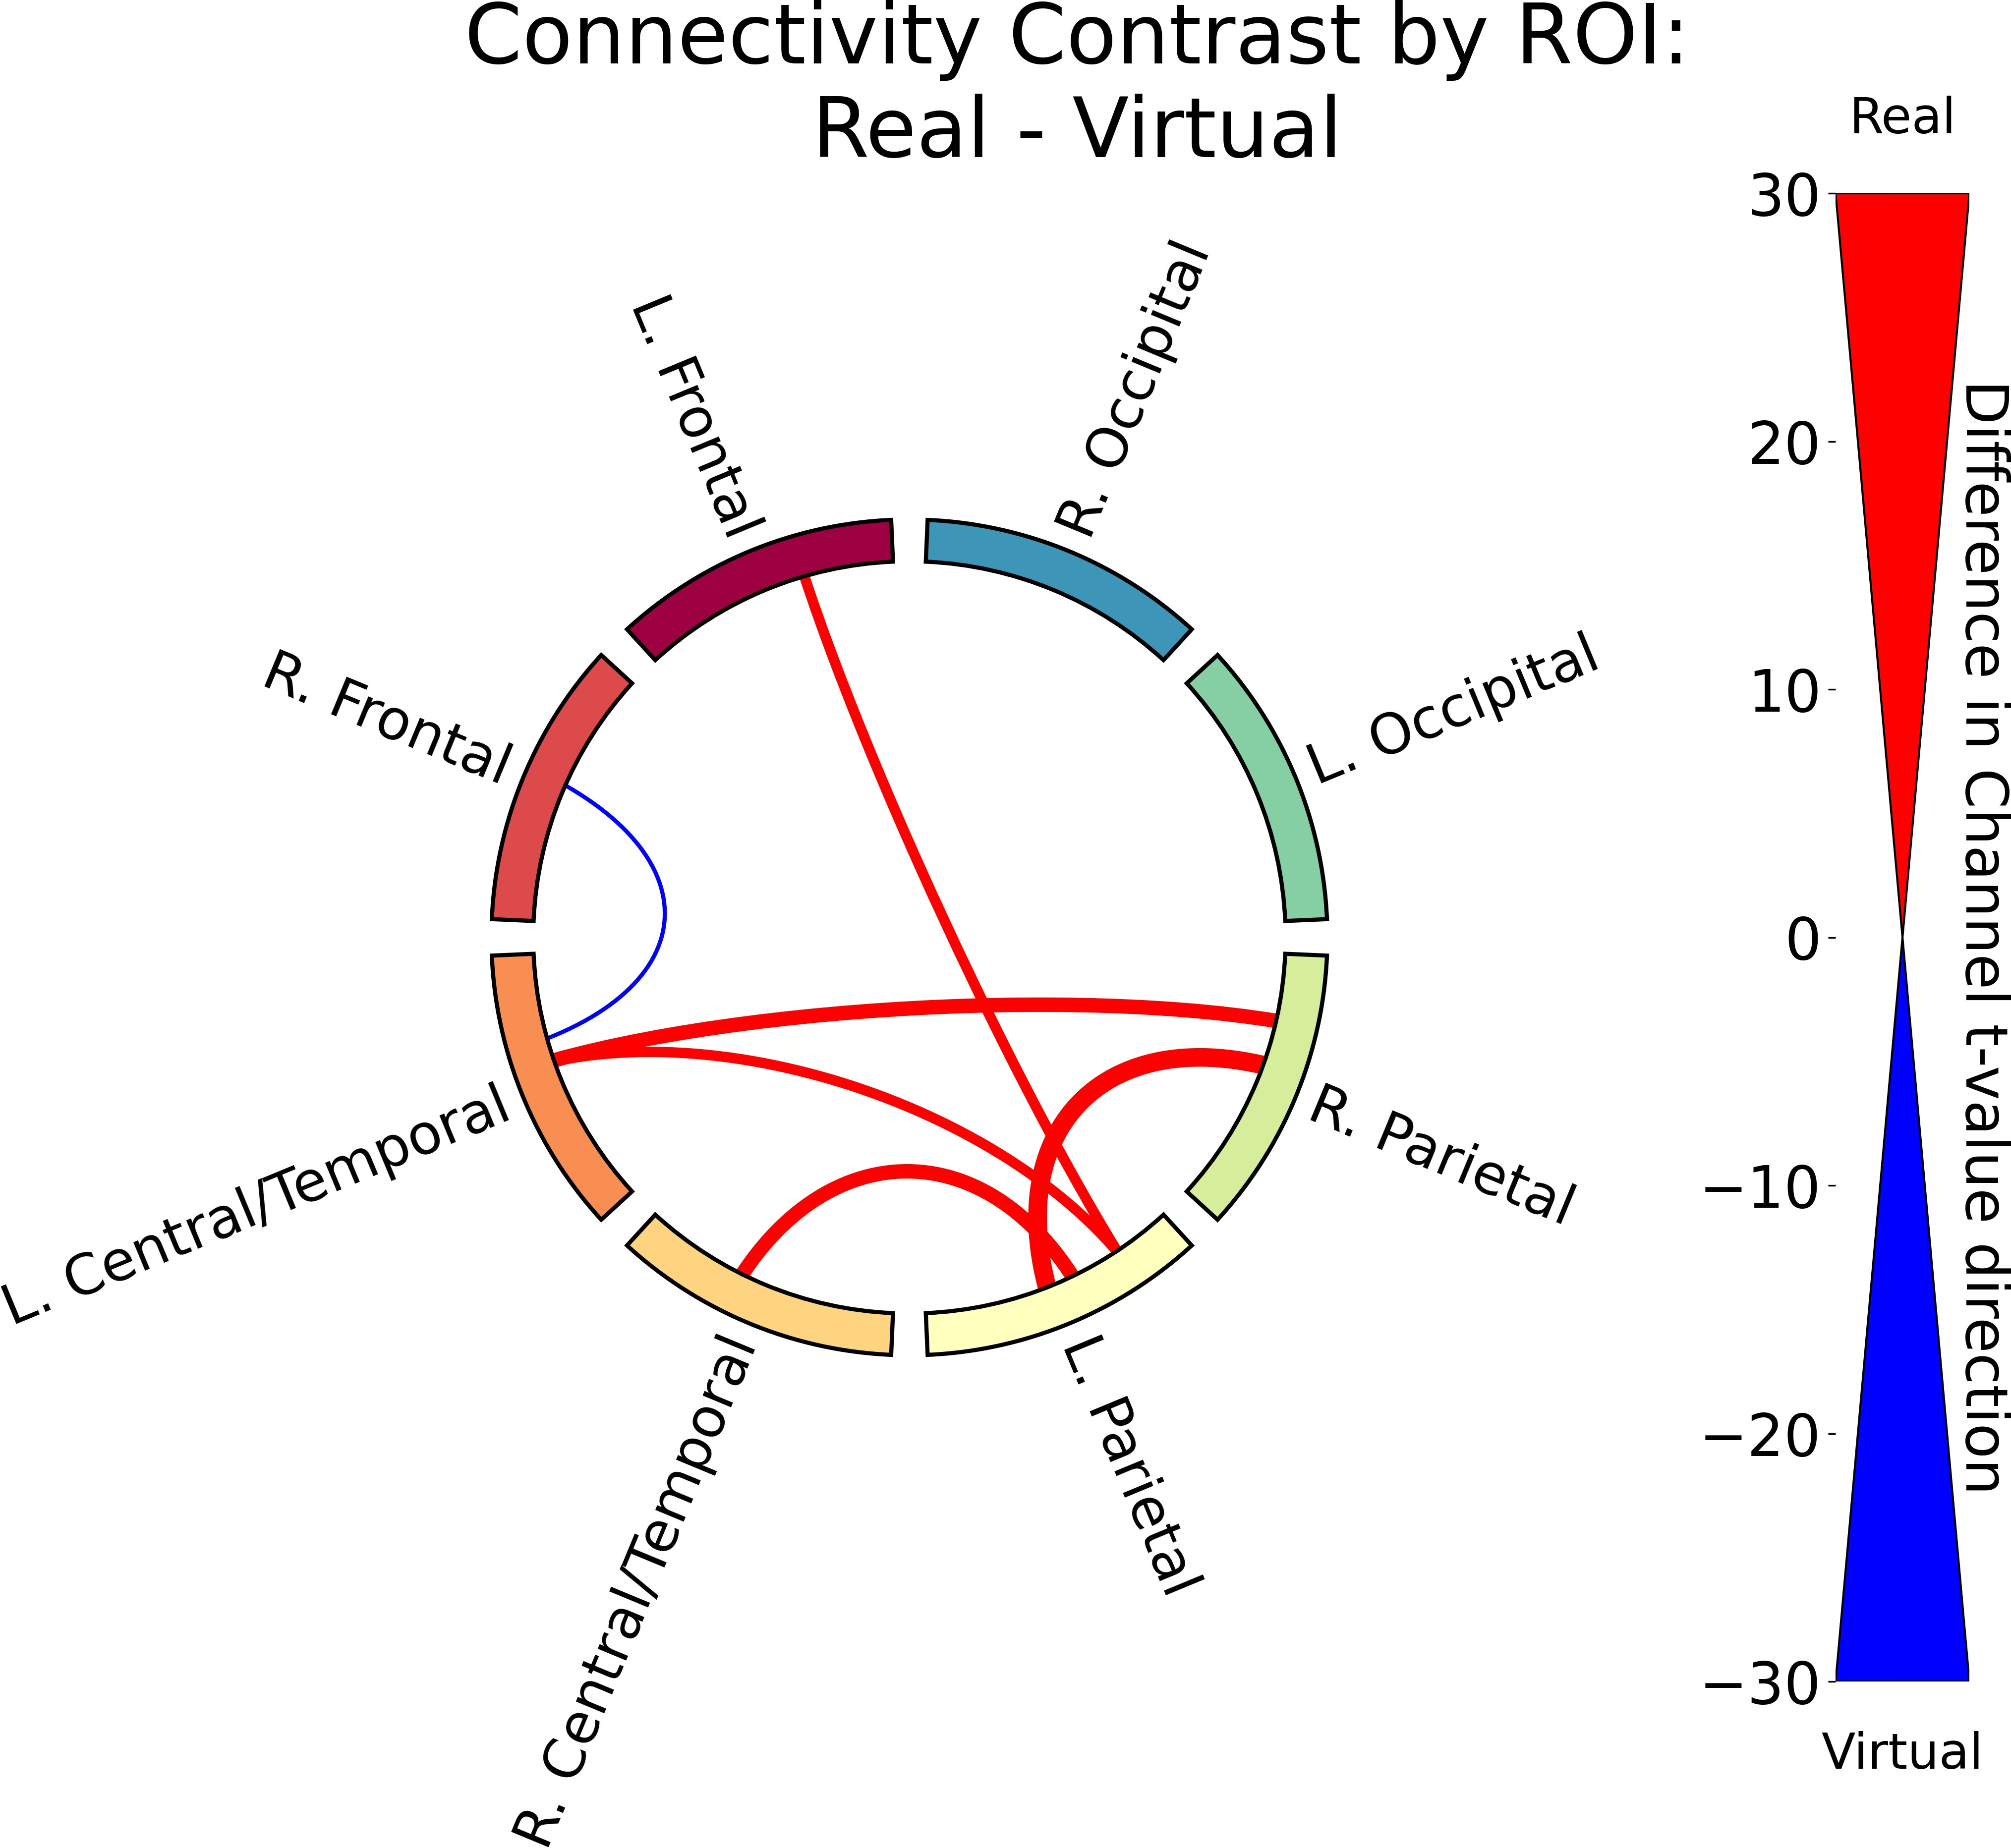

Figure 3.5: Functional connectivity results for the contrast between real and virtual conditions. The thickness of the lines represents the difference in the count of significantly different channel pairs between the two conditions. A red line signifies that real faces had more significant channels between those two ROI’s where the *t*-value was positive, while a blue line signifies that virtual faces had more significant channels between those two ROI’s where the *t*-value was negative. For clarity, only the top 15th percentile of connections (those with the most significant different channel pairs) are displayed for all functional connectivity contrasts.

**Connectivity profiles of facial emotion**

We also found significant differences in functional connectivity in response to differ- ent emotions across all ROI’s. A sample of the functional connectivity results which include only contrasts between Fear and the other emotions are plotted in Figure 3.6. We found the largest connectivity differences processing faces expressing Fear relative to Neutral faces, with significantly stronger connectivity between left central/temporal and right and left frontal, and right and left parietal. In general, we found processing faces expressing Fear produced significantly strong connectivity across the brain relative to faces expressing all other emotions, however this difference was weakest relative to processing angry faces. Interestingly most of the stronger connections emerge from the left central/temporal region, pointing to this region as a key area for processing Fear. The complete set of functional connectivity contrasts for all emotions can be found in Appendix B.

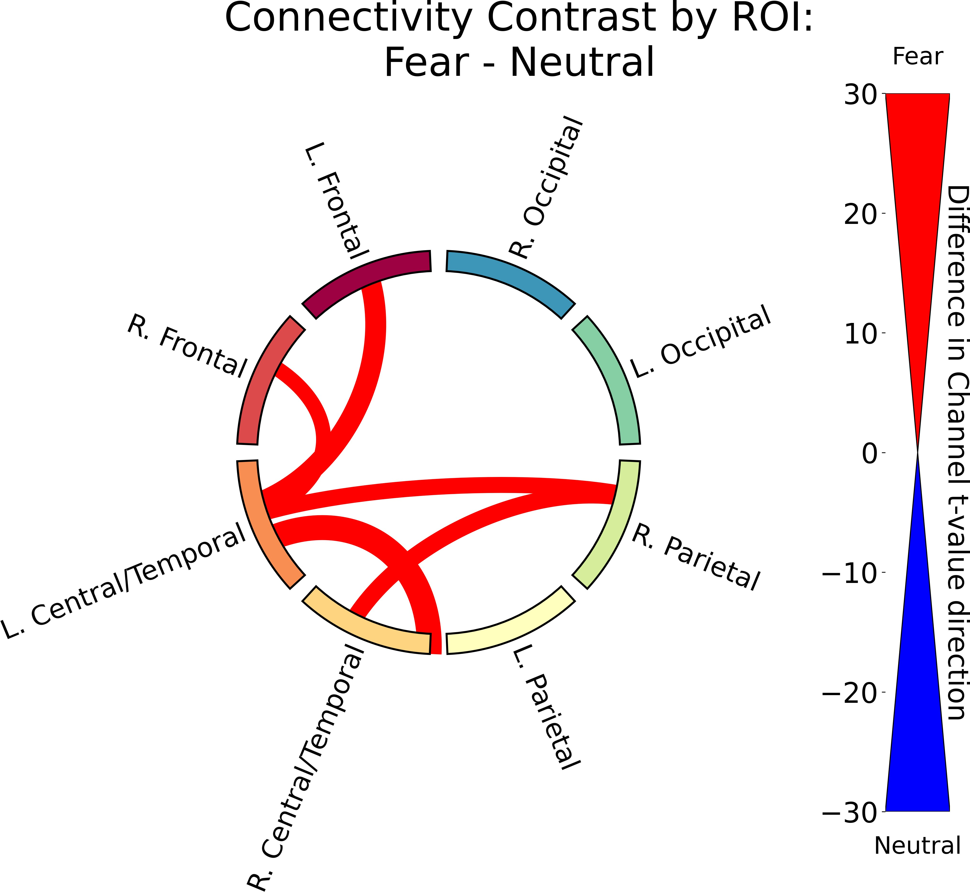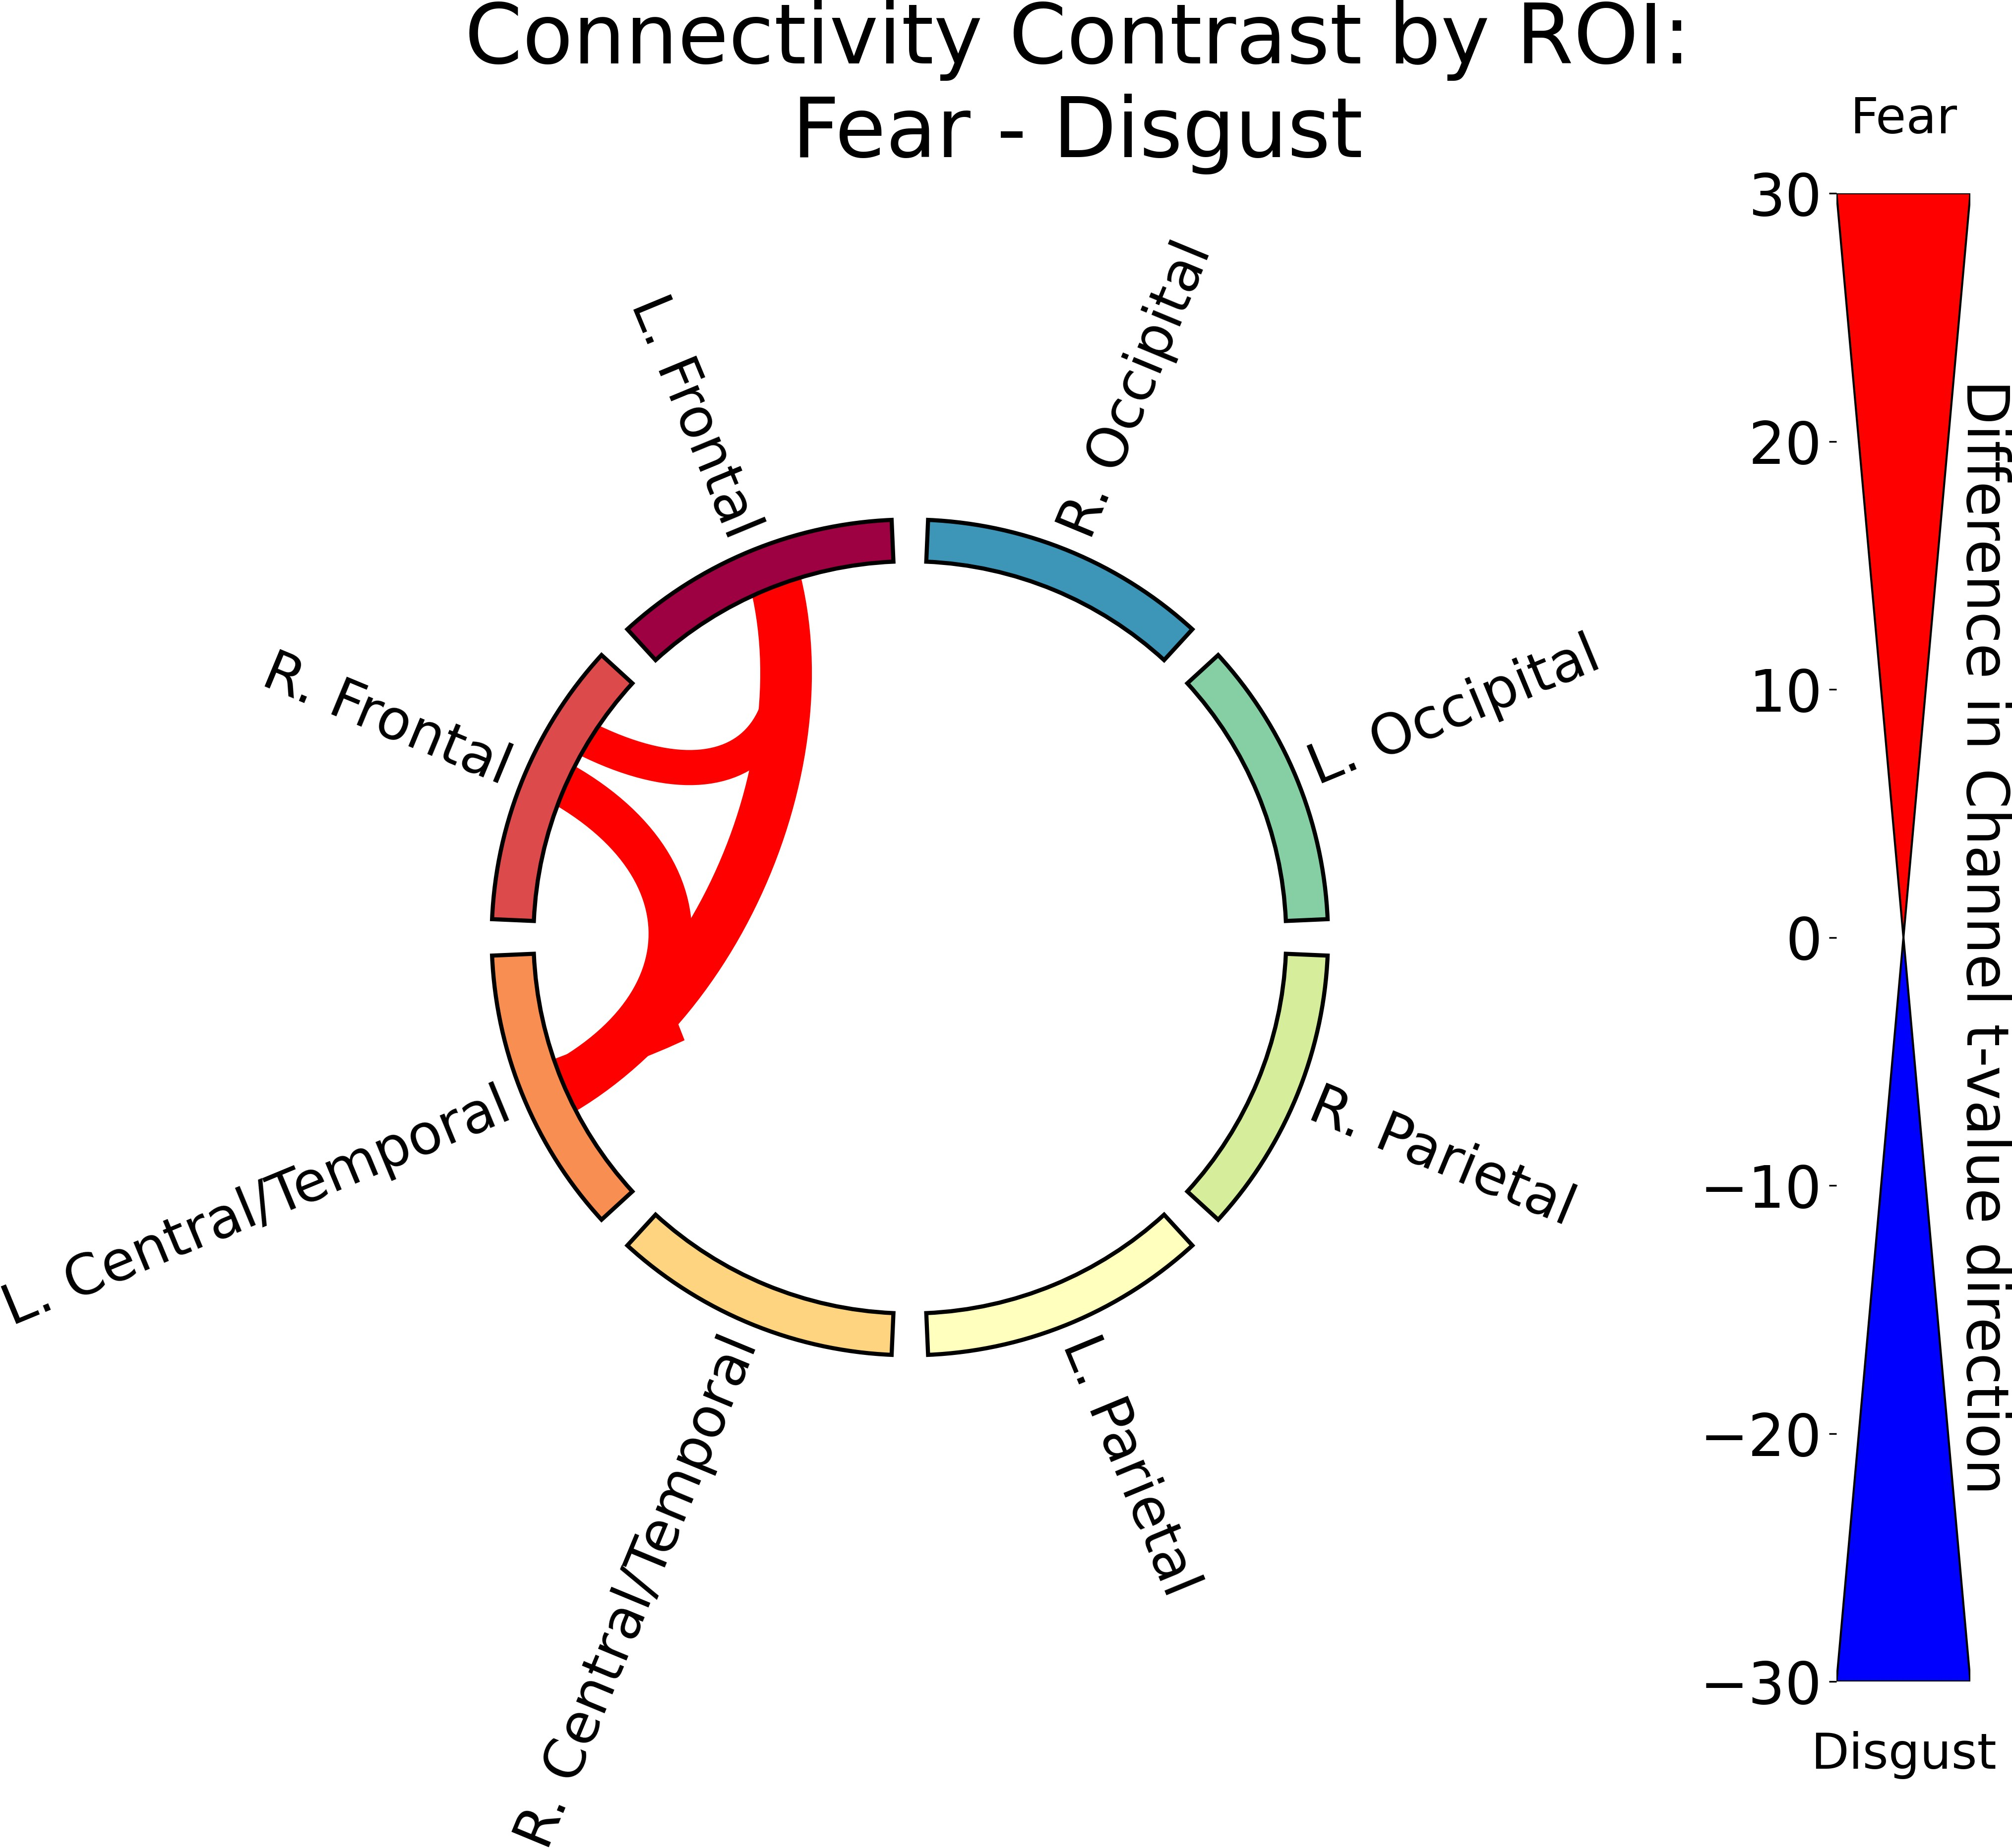

Figure 3.6: Functional connectivity results for Fear relative to Neutral and Disgust. (1/2)

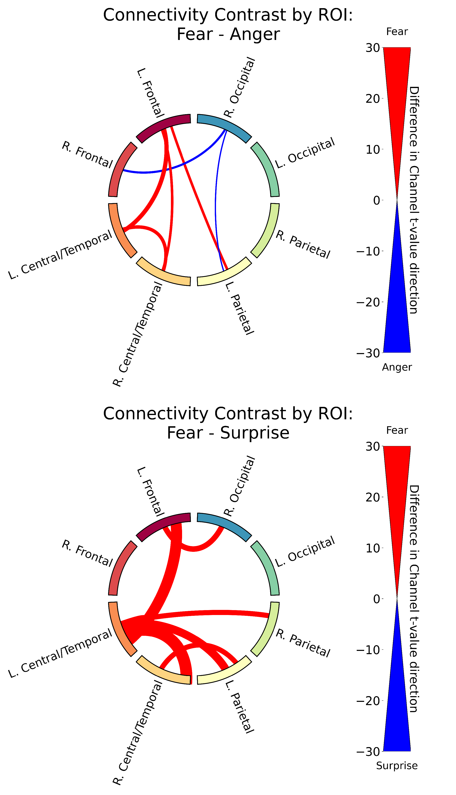 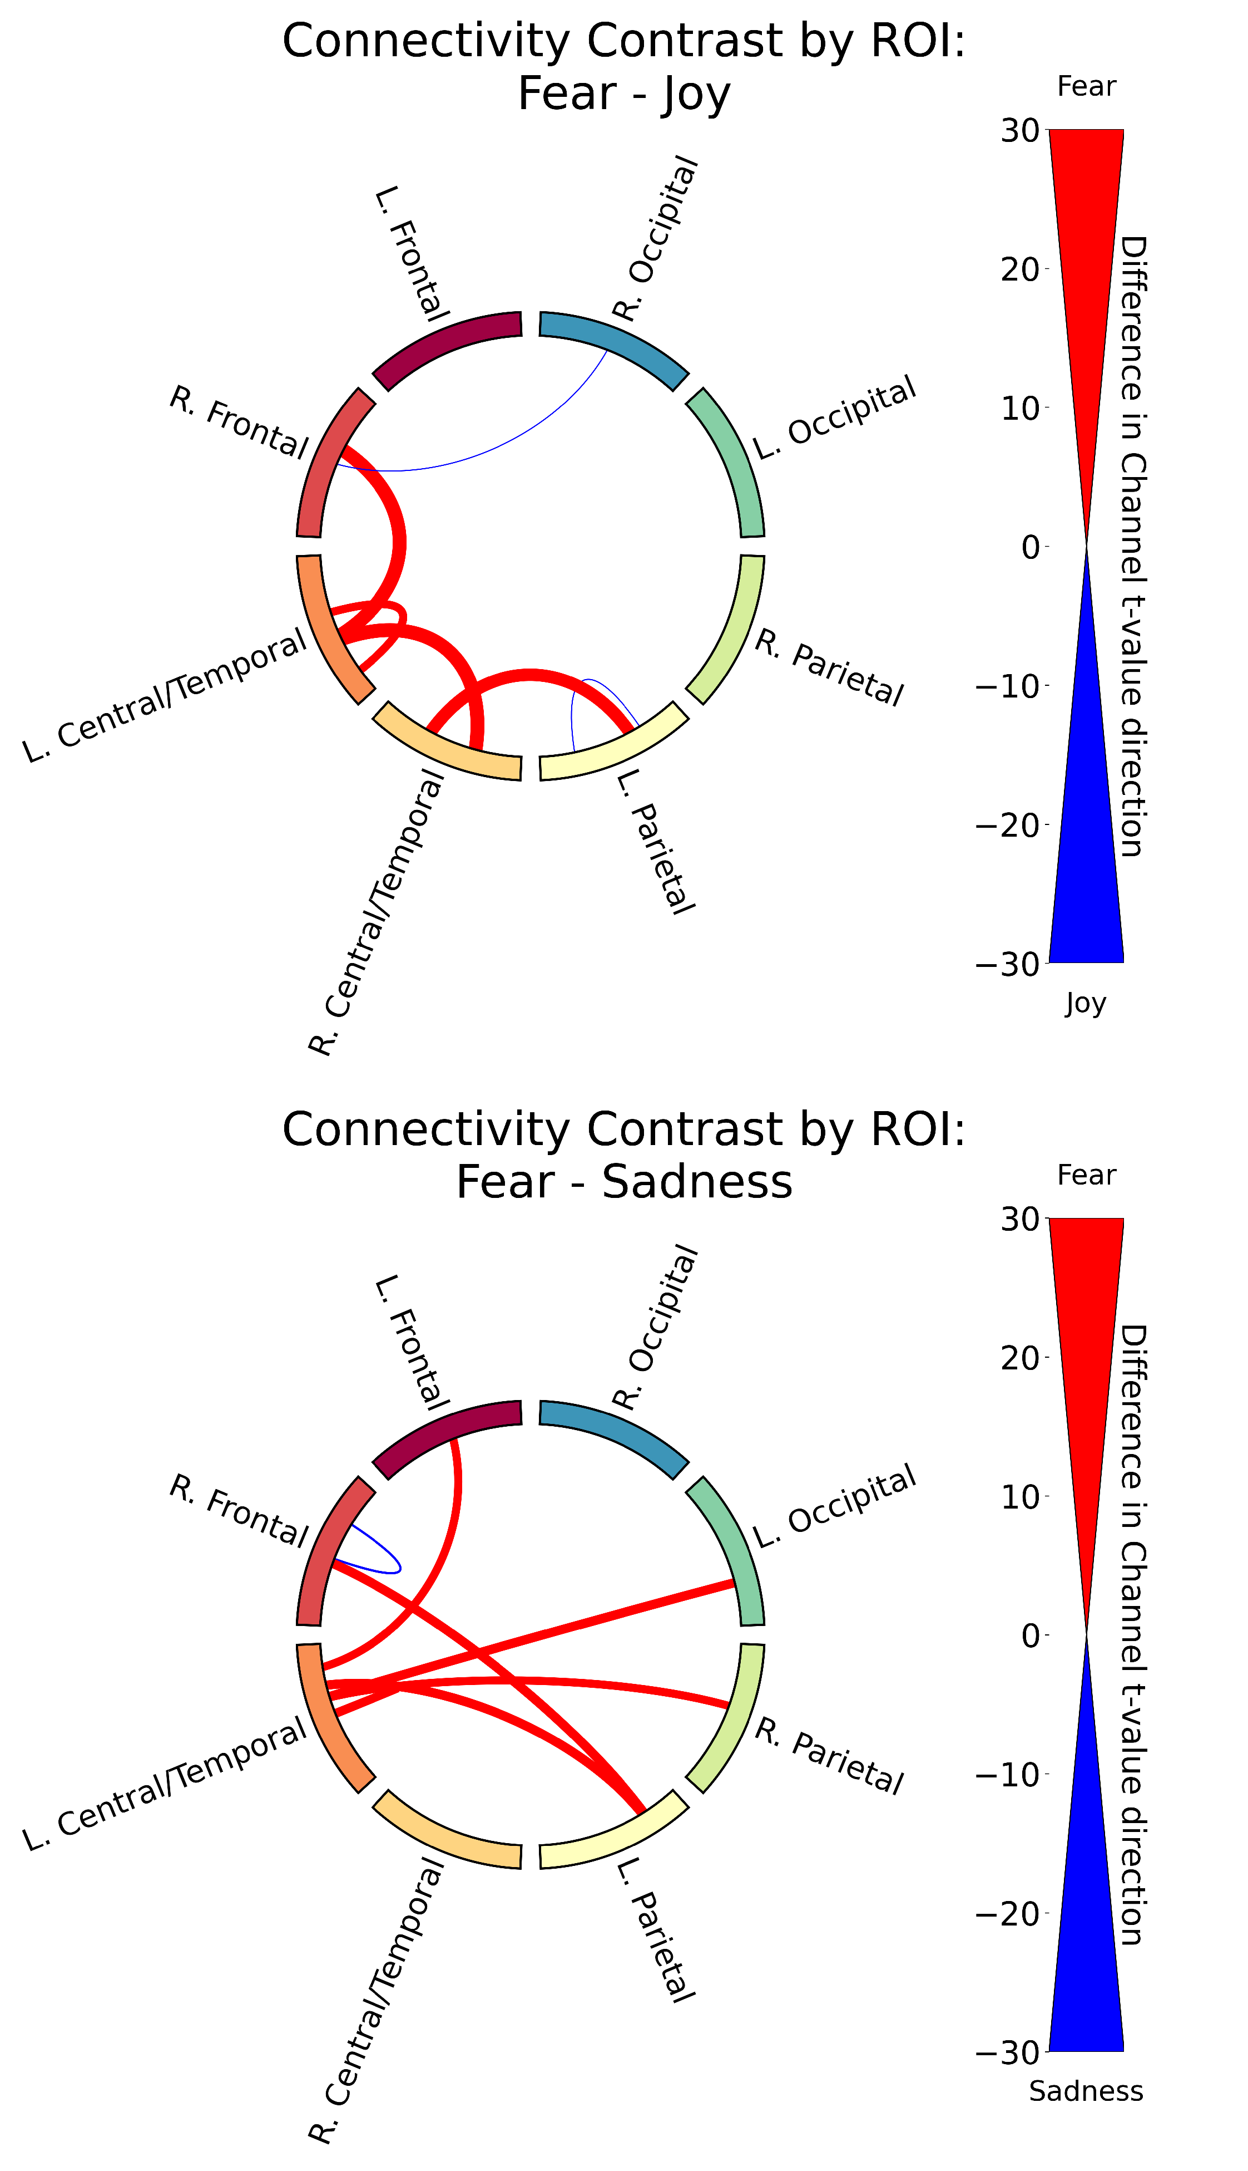

Functional connectivity results for Fear relative to Anger, Joy, Surprise, and Sadness. (2/2)

A higher level summary of the functional connectivity results for all emotions is shown in Figure 3.7, which shows the ratio of significant channels where the *t*-value was positive (red) or negative (blue) for each emotion pair. We found a cluster of emotions (Anger, Fear, and Joy) that had much stronger connectivity compared to the other emotions, with Anger and Fear having slightly higher connectivity than Joy. The other emotions (Neutral, Sadness, Surprise) had lower connectivity compared to Anger, Fear, and Joy, with Disgust having higher connectivity than Neutral. This lines up with Figure 3.6, which shows that processing Anger and Fear have higher connectivity relative to the other emotions.

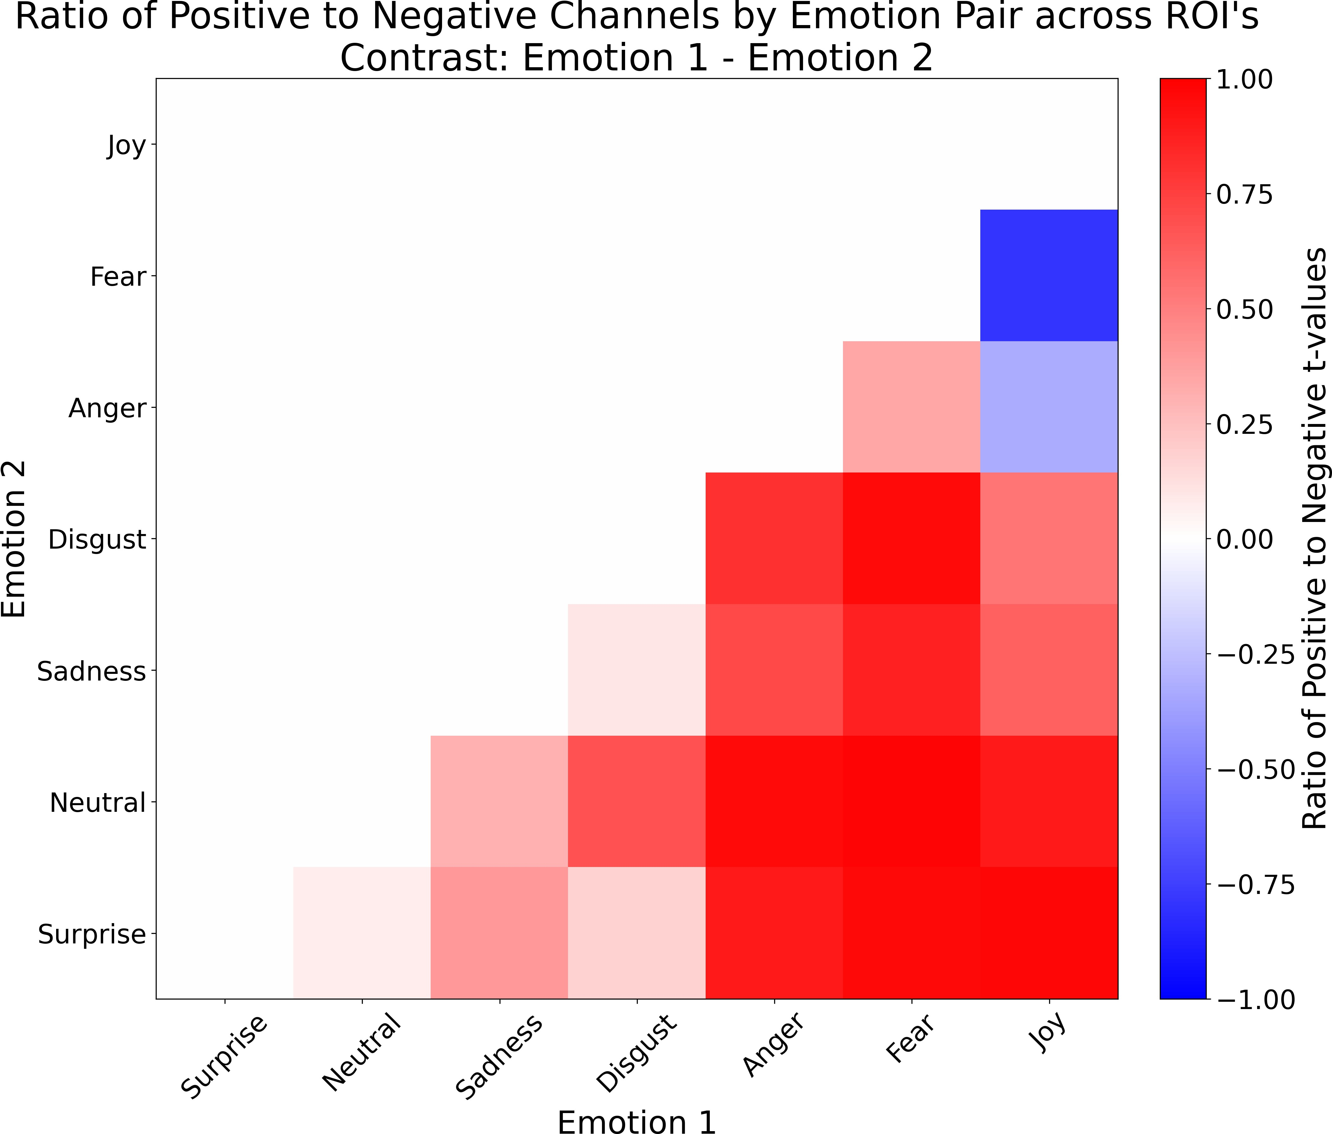

Figure 3.7: A heatmap summary of the functional connectivity results for the contrasts between different emotions across ROI’s. Red signifies that emotion 1 had a higher ratio of significant channels where the *t*-value was positive, while blue signifies that emotion 2 had a higher ratio of significant channels where the *t*-value was negative. The ratio was calculated by taking the difference of the count of significant channels where the *t*-value was positive and the count of significant channels where the *t*-value was negative, and dividing it by the total number of significant channels for that emotion pair.

To quantify the degree to which ROI’s differed across emotion, significant channels across the brain were summed and plotted as a heatmap (Figure 3.8). Two regions, left occipital and right occipital, (marked with an asterisk), produced the least number of significant connections, suggesting that the connectivity within and between these regions are very similar in response to all emotions and that neural indices that differentiate emotion processing likely occur in brain regions outside of visual cortex. Three regions,

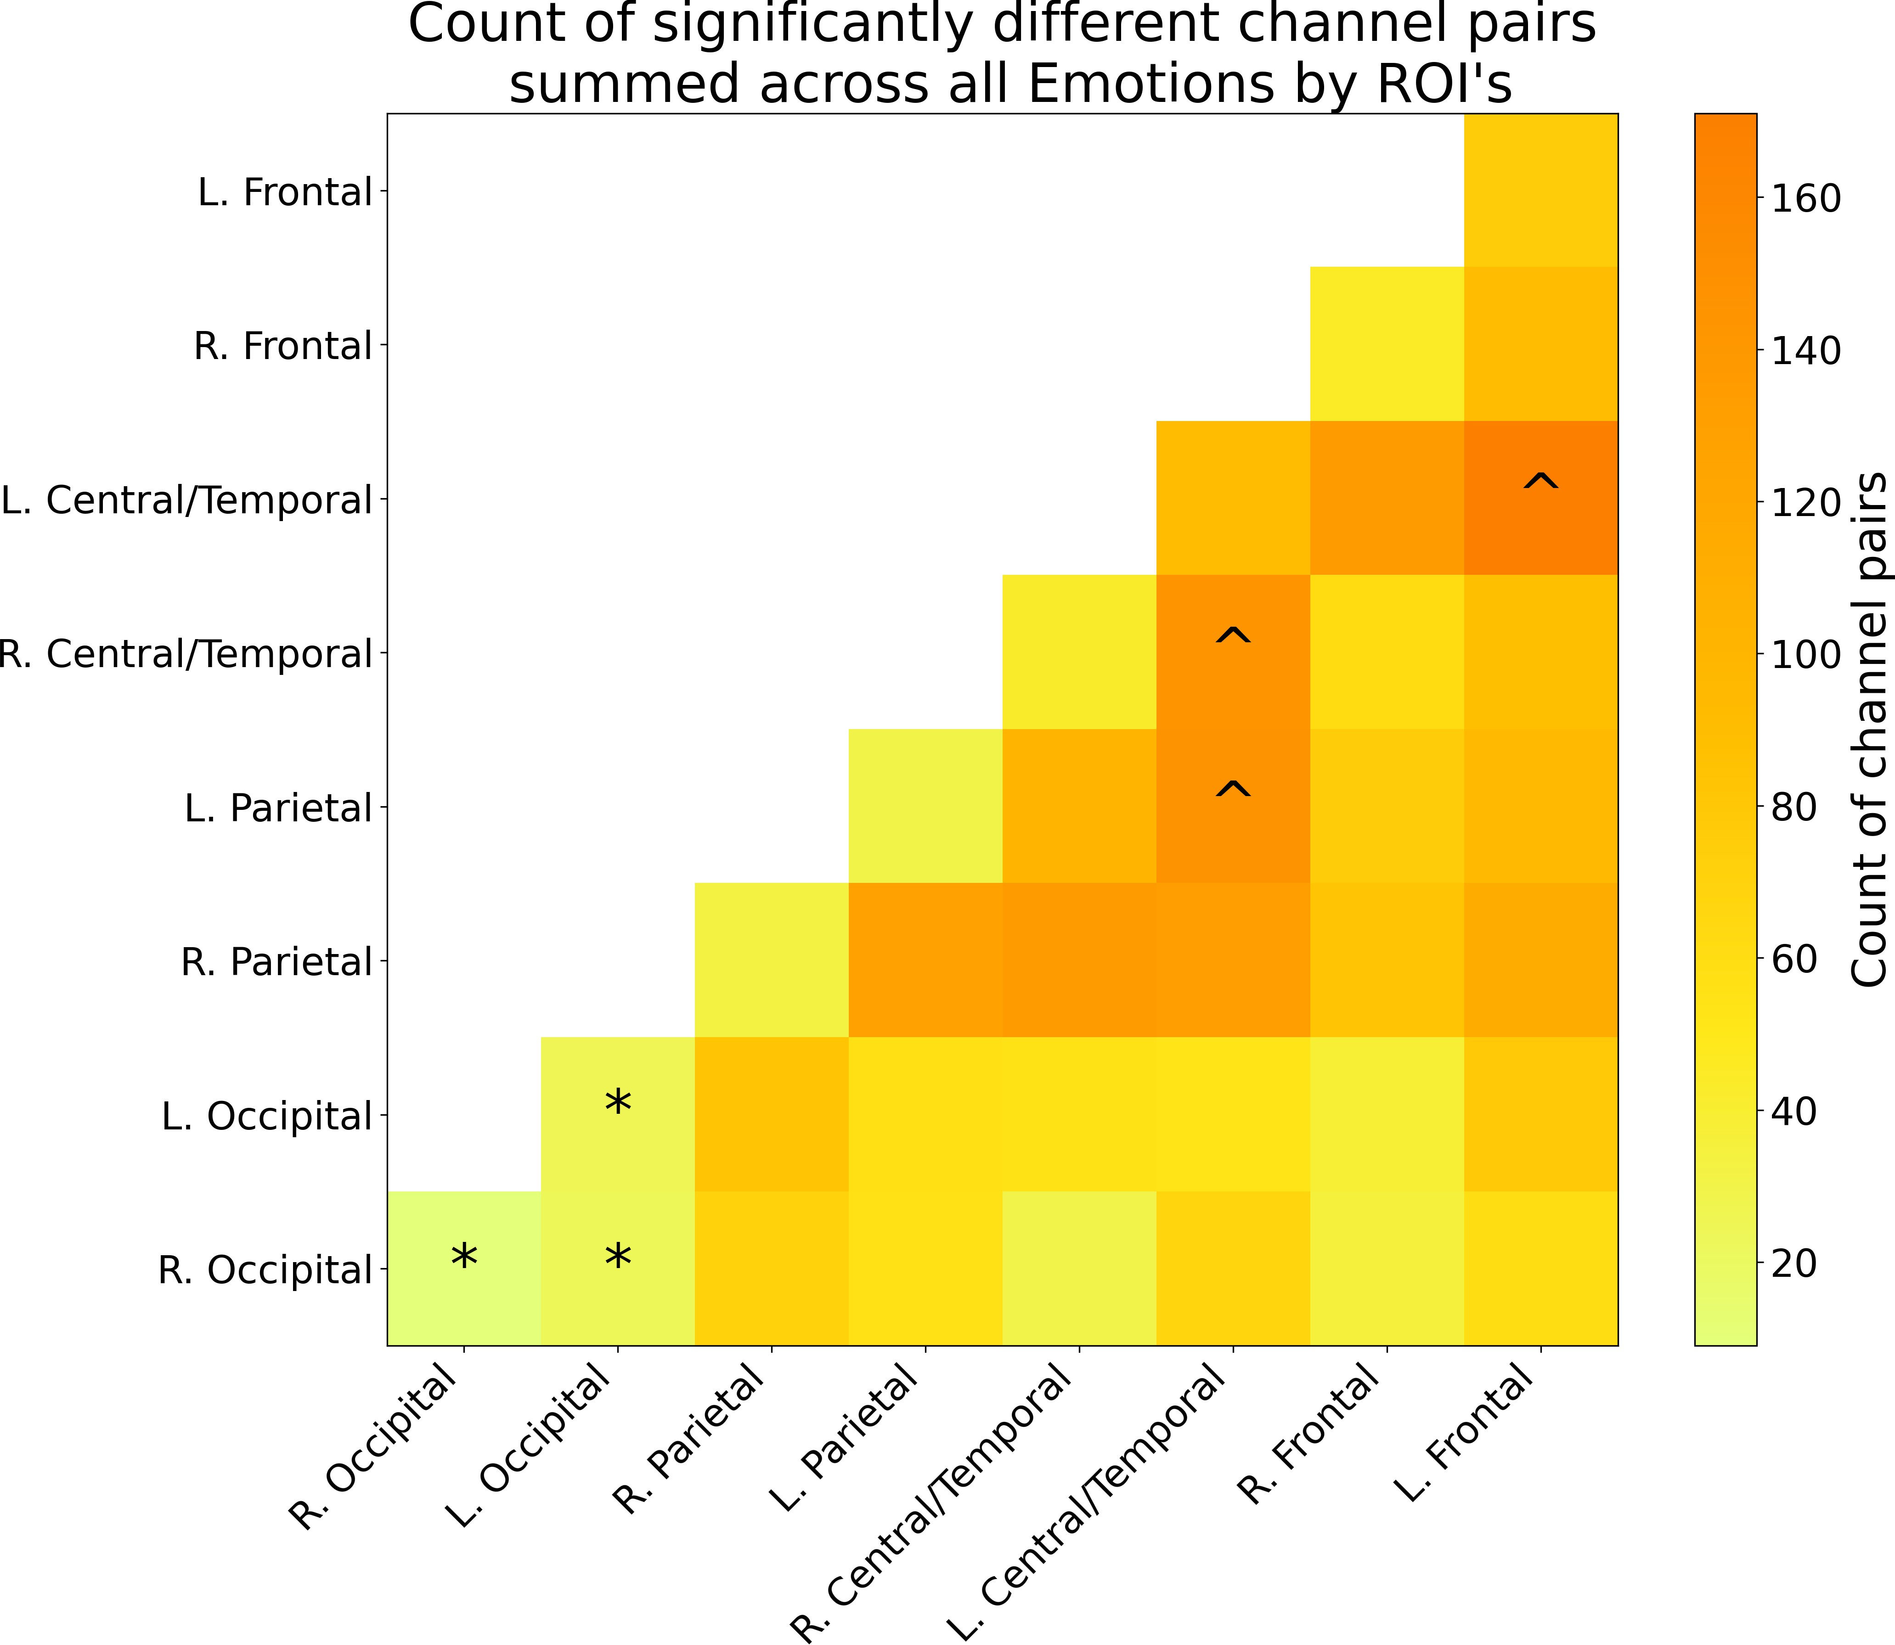left central/temporal, left parietal, and right central/temporal (marked with a caret), produced the most number of significant connections, suggesting that these regions are more variable in their connectivity patterns across emotions.

Figure 3.8: A heatmap summary of the number of significantly different channel pairs for each ROI summed across all emotions. The color bar on the right shows the number of significant channel pairs for each ROI, with brighter colors indicating a smaller number of significant channel pairs, and darker colors indicating a larger number of significant channel pairs. An asterisk (*) was placed on the 3 ROI’s with the least number of significantly different channel pairs to indicate that these ROI’s are more synchronized with each other than any other pair of ROI’s, regardless of the emotion. A caret (ˆ) was placed on the 3 ROI’s with the most number of significantly different channel pairs to indicate that these ROI’s are less synchronized with each other than any other pair of ROI’s, regardless of the emotion. Note that ROI’s can have differences within them, as each ROI is made up of multiple channels, and the differences are calculated between channels within the same ROI.

**Differential Functional connectivity profiles in response to emotion across face type**

The interaction of face type with emotion, Real - Virtual within each emotion (Fig- ure 3.9) revealed significant differences in functional connectivity across the brain. We found that processing Anger on virtual faces elicited greater connectivity between the left frontal to right central/temporal, left frontal to right frontal, and within the left frontal region, compared to processing Anger on real faces. Processing Disgust on virtual faces elicited greater connectivity between the left frontal to left parietal, right frontal to left parietal, right frontal to left central/temporal, left frontal to left occipital, and right cen- tral/temporal to right parietal, compared to processing Disgust on real faces. Processing Fear on virtual faces elicited greater connectivity between many ROI’s, particularly the left frontal to left occipital regions, between the left/right occipital regions, and between the left/right central/temporal and left/right occipital regions, compared to processing Fear on real faces. Processing Neutral on virtual faces elicited greater connectivity be- tween the left frontal to right frontal, left/right frontal to right parietal, and left/right parietal regions, compared to processing Neutral on real faces. Processing Sadness on real faces elicited greater connectivity between the left frontal to right central/tempo- ral, left central/temporal to right parietal, left central/temporal to right occipital, and right central/temporal to left parietal regions, compared to processing Sadness on virtual faces. Processing Surprise on real faces elicited greater connectivity between many ROI’s, such as the left frontal to left/right central/temporal, left frontal to right parietal, left-

/right central/temporal to left/right parietal, and within the left/right central/temporal regions, compared to processing Surprise on virtual faces. Processing Joy on real faces elicited greater connectivity between the left/right central/temporal to right parietal, and within right parietal regions, whereas processing Joy on virtual faces elicited greater connectivity between the left central/temporal to left/right occipital regions. Overall, these results indicate that the effect of face type on functional connectivity varies by

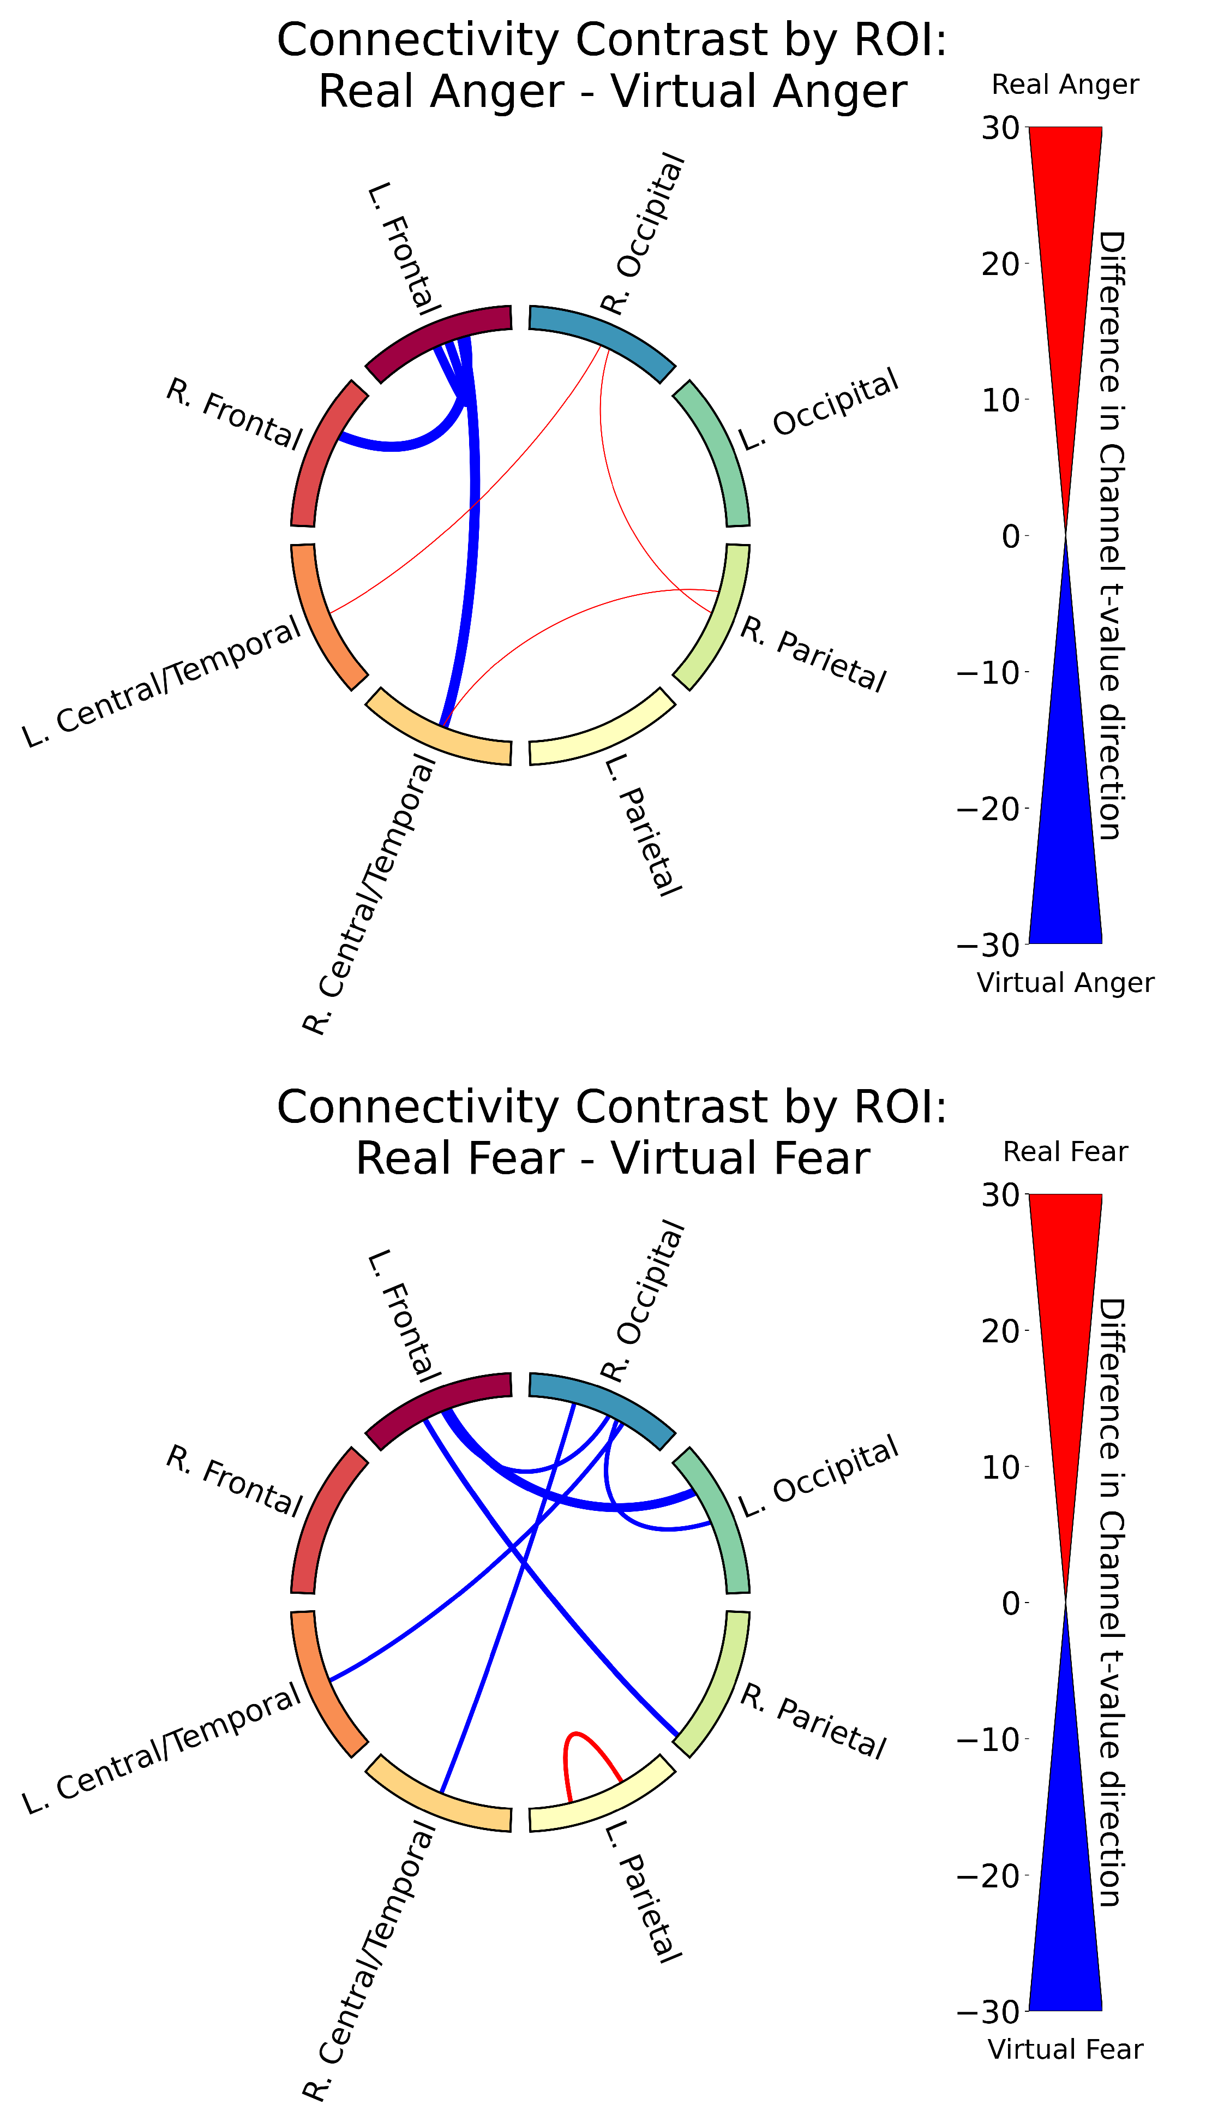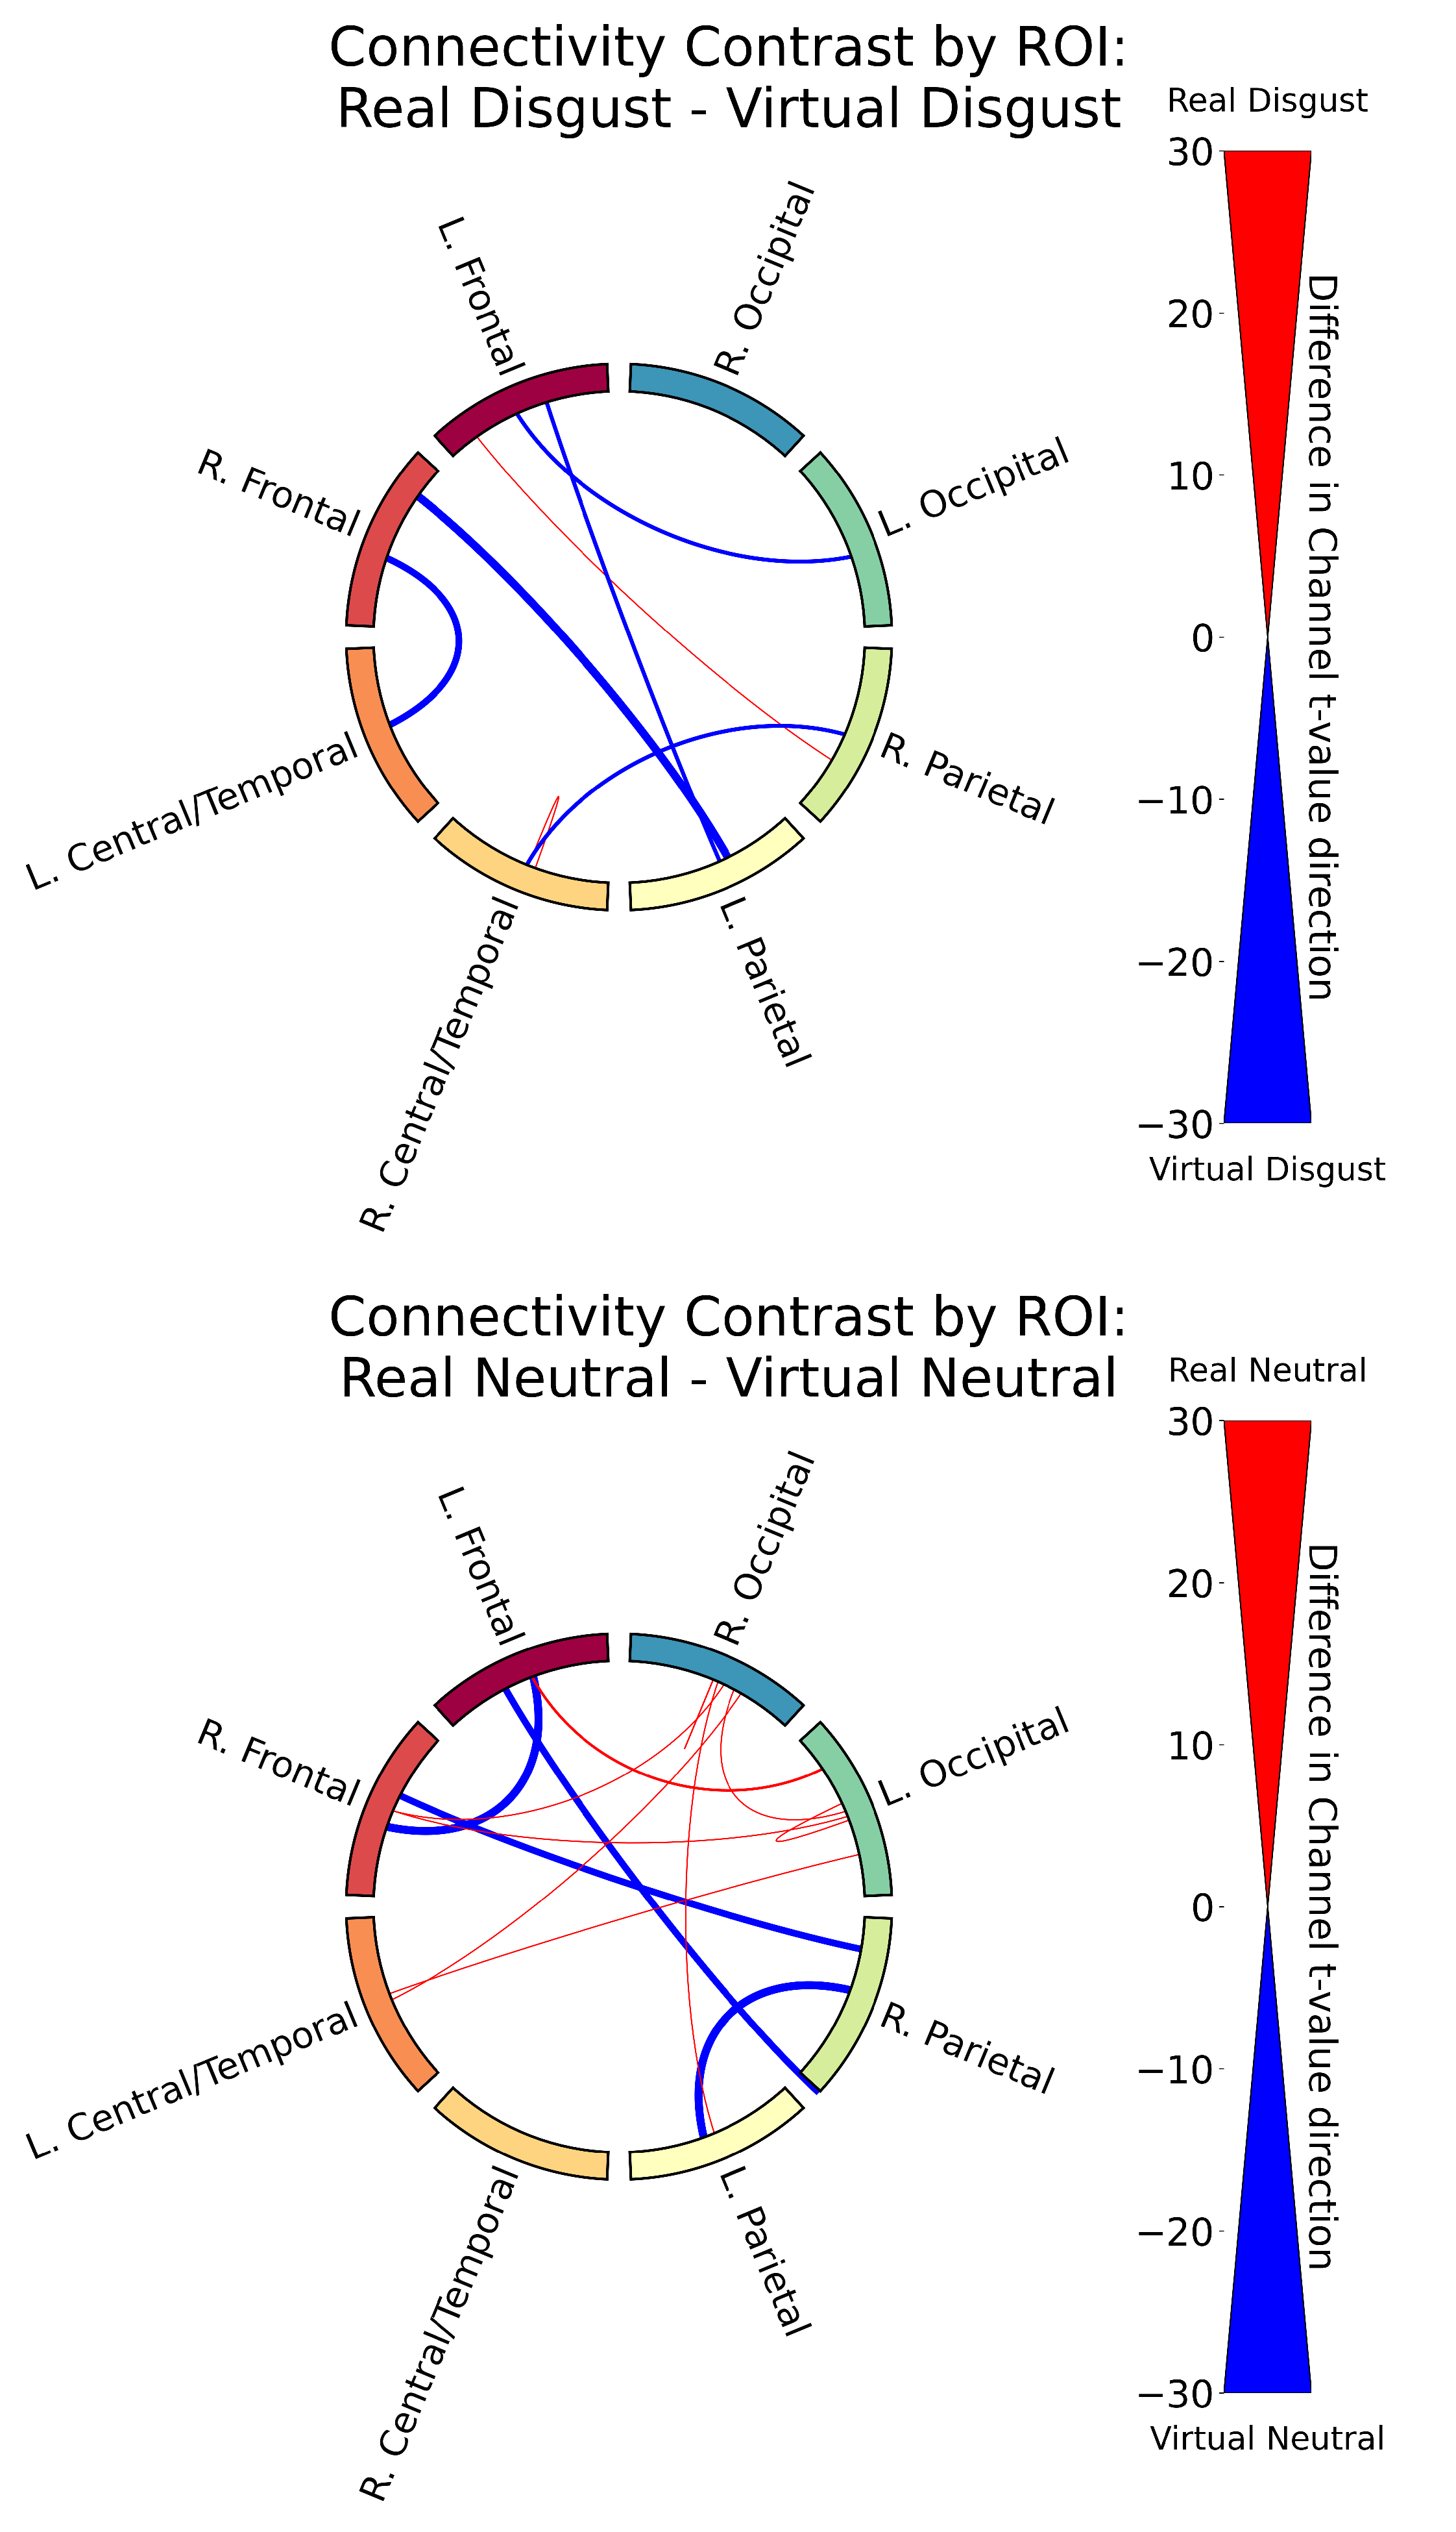emotion, with virtual faces generally eliciting greater connectivity for negative emotions (Anger, Disgust, Fear, Neutral), while real faces tend to elicit greater connectivity for positive emotions (Sadness, Surprise, Joy), and the specific brain regions involved differ across emotions. Like the GLM results, this indicates that the neural response to emo- tional expressions is modulated by the realism of the face stimuli. The full table of the functional connectivity contrasts for all main effects and interactions can be found in Appendix B.

Figure 3.9: Functional connectivity results for the contrast between real and virtual conditions within each emotion. (1/2)

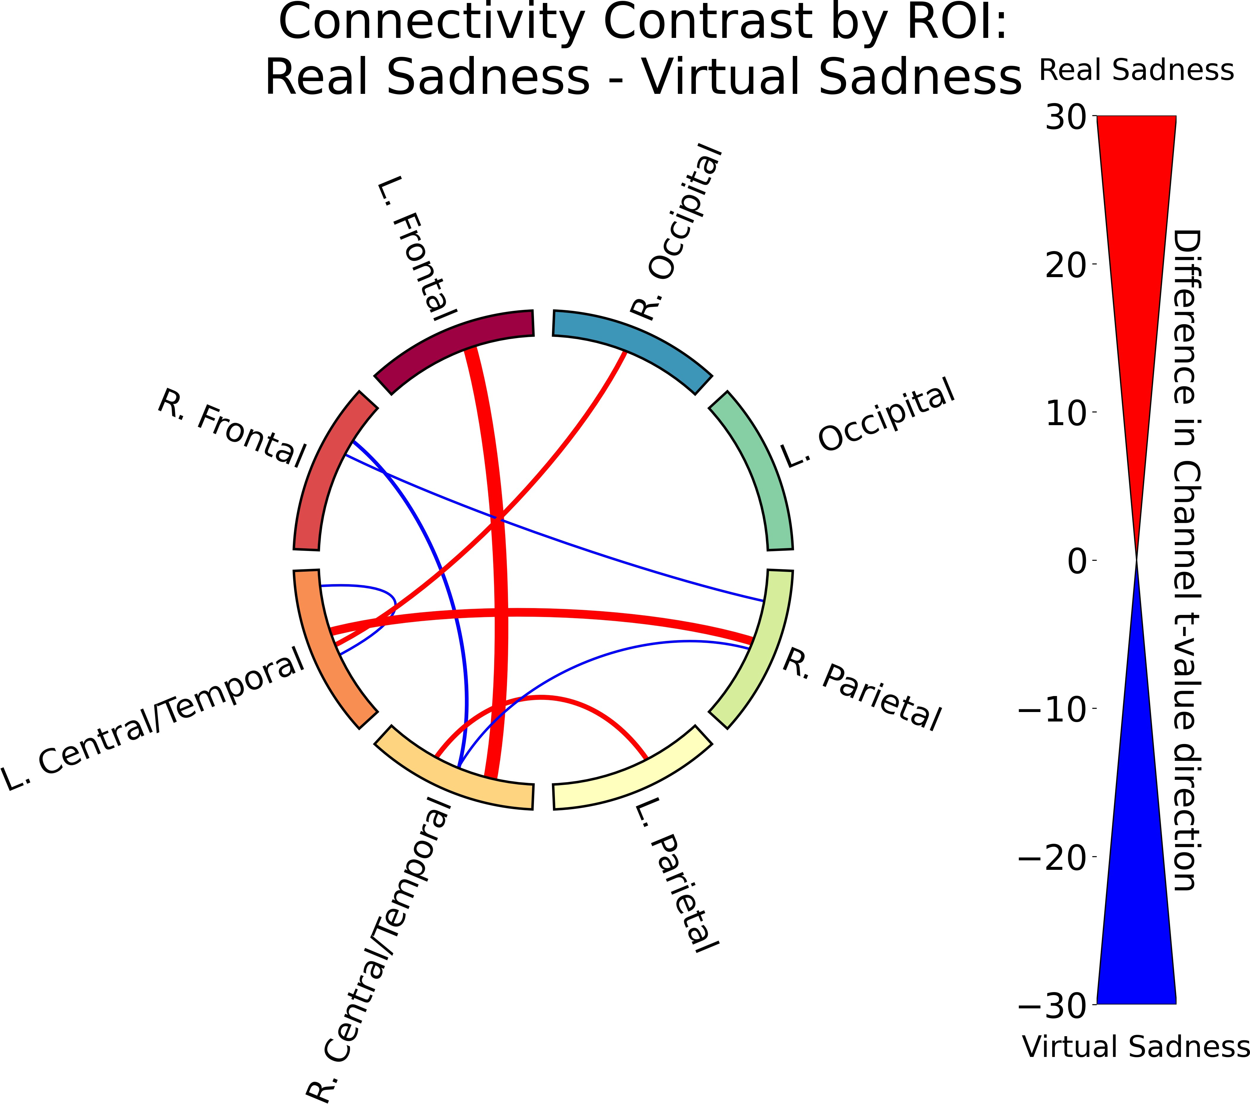 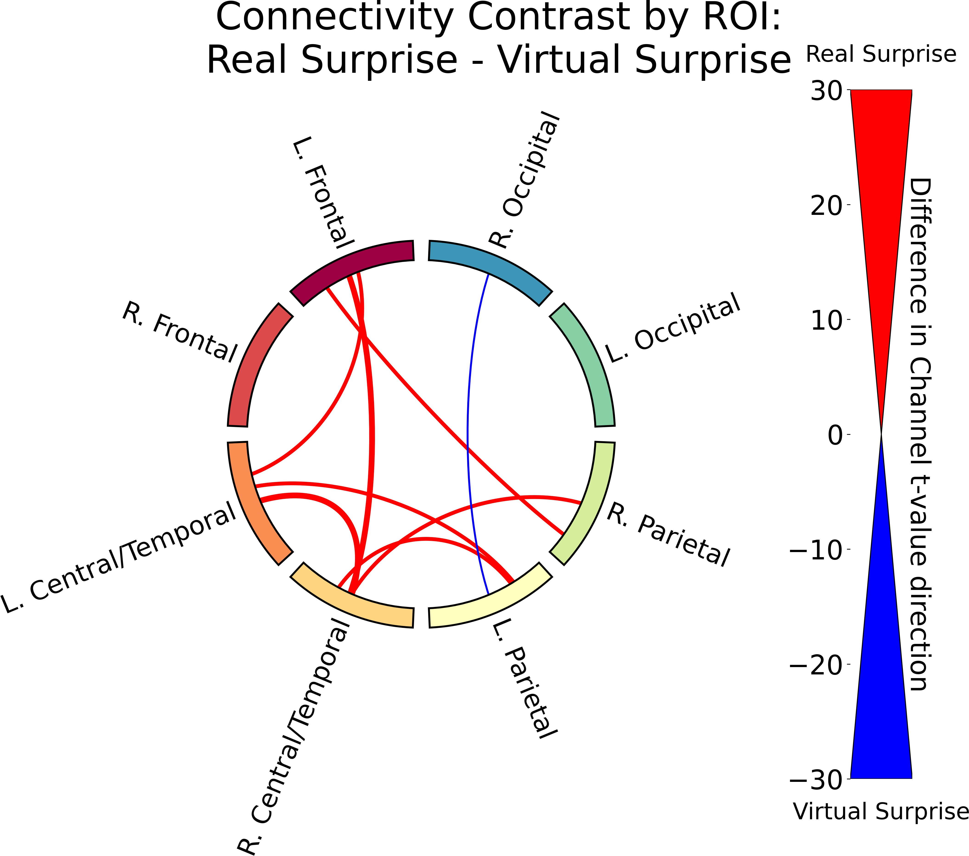

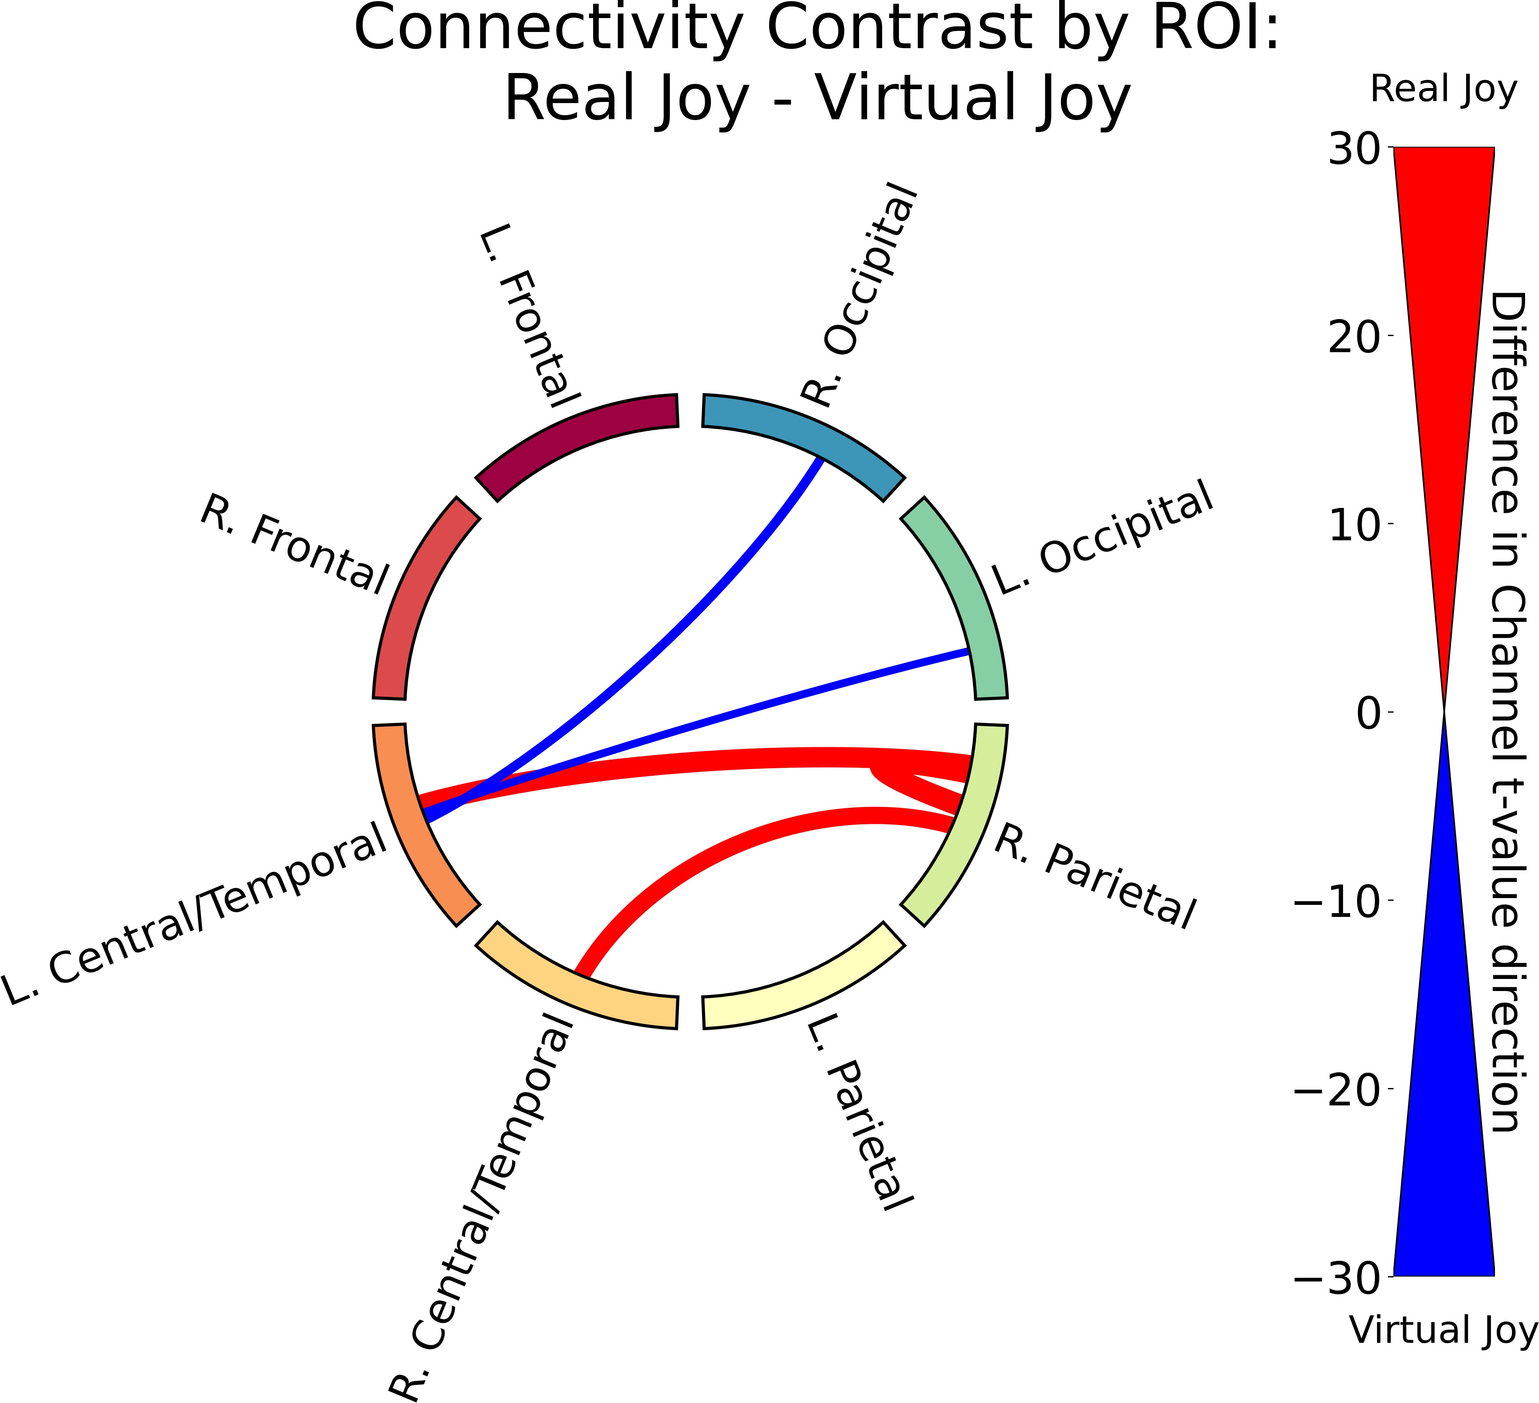Functional connectivity results for the contrast between real and virtual conditions within each emotion. (2/2)

## Memory Task Results

A two-way Type III ANOVA revealed a significant main effect of face type, *F* (1*,* 4802) = 7*.*96, *p* = 0*.*0048, indicating that memory performance was higher for real faces com- pared to virtual faces, as shown in Figure 3.10. There was no significant main effect of emotion, *F* (6*,* 4802) = 0*.*83, *p* = 0*.*55, nor a significant interaction between face type and emotion, *F* (6*,* 4802) = 0*.*46, *p* = 0*.*84. These findings suggest that while the realism of the face influences memory performance, the specific emotional expression does not have

a significant impact on memory accuracy. The full ANOVA table is shown in Appendix C.1.

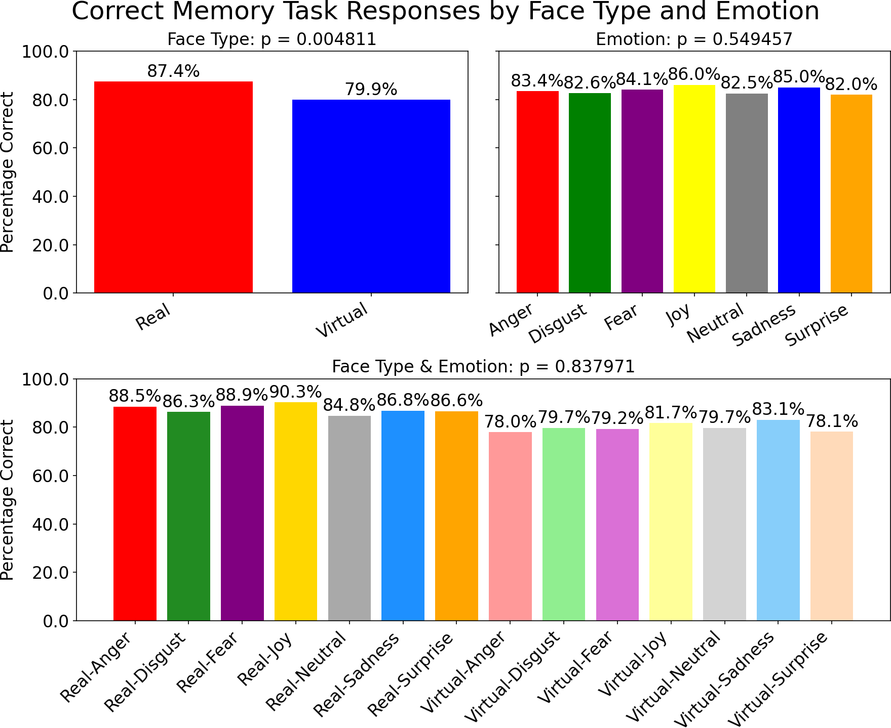

Figure 3.10: Proportion correct by condition in the memory task, plotted separately for real and virtual faces, for each emotion, and the interaction between face type and emotion. The *p*-values indicate the significance of the main effects and interaction.

**Chapter 4 Discussion**

With the rise of video games and generative AI technologies, humans are exposed to virtual faces daily. Yet, how our brain process these faces, and their emotions has received little attention. Using Functional Near-Infrared Spectroscopy (fNIRS), we captured the hemodynamic response of 52 participants during the processing of real-versus-virtual emotional facial expressions. Using complimentary techniques of activation magnitude analysis, which captures overall changes in hemoglobin levels, and functional connectivity mapping, which tracks how similarly regions of the brain respond to stimuli, we found significant overlaps and differences in brain regions involved in the processing of real-vs-virtual faces and different emotions.

*Now lead out with your top result (4.3 FCM for R/V faces), then second (4.2/4.4 RCM for Emotion), then third (Activity mag). FROM YOU’RE YOUR DISCUSSION BELOW (4.3)*: Functional connectivity analysis revealed distinct neural connectivity patterns associated with processing of real and virtual faces, supporting our first hypothesis, with significantly greater similarity in the central/temporal, parietal, and left-frontal regions … suggesting that the realism of facial stimuli modulates the underlying brain network dynamics during face processing. … Interestingly, magnitude analysis revealed that differences were primarily restricted to the occipital region, providing only partial support for our first hypothesis. This result was expected, as the occipital region is primarily response for processing visual input, and suggest that the brain’s visual center processes real and virtual faces differently. This juxtaposition suggests that while the level of activation in these regions remains stable, the similarity in HbT activity suggests that these regions are prioritized for the processing of real faces over that virtual faces.

*The emotional expression of faces also revealed differences in the connectivity and activation of participants’ neural responses. Here, focus on Fig 3.7, 3.8 – not all emotions were treated the same. Specifically, Fear and Anger were different, with high similarity in distinct regions. Focus first on – Neutral FCM results, as Neutral was your control condition. Then dive into emotion-vs-emotion.*

*Keep going like this*. Wherever possible, contrast activation magnitude with FCM.

We hypothesized that brain activity would show

1) there will be significant differences in activation patterns and functional connectivity profiles when comparing virtual faces to real faces,

2) different emotional expressions will elicit distinct activation patterns and functional connectivity profiles.

The present study aimed to characterize how the human brain processes emotional ex- pressions displayed by real versus virtual faces, using fNIRS to measure both activation and functional connectivity. We sought to determine whether face realism modulates neural responses to different emotions, and whether these effects extend beyond local activation to distributed network interactions. By directly comparing hemodynamic re- sponses to real and virtual faces across a range of basic emotions, our goal was to provide novel insights into the neural mechanisms underlying emotional face perception in the context of increasing virtual social interactions.

## Left occipital activation for virtual faces

Our finding that virtual faces elicit greater left occipital activation compared to real faces aligns with evidence that face realism modulates visual processing in a complex manner. Schindler et al. (2017) showed that the N170 EEG component, reflecting early face per- ception, is influenced by perceived realism in a u-shaped fashion, while the later Late Positive Potential (LPP) increases continuously with face realism. Notably, the N170 generators differ between highly stylized and very realistic faces, suggesting distinct neu- ral processes are engaged depending on realism. The LPP enhancement with increasing

38

realism is associated with broader occipito-parietal activity, converging with our fNIRS results that show stronger left occipital activation for virtual faces. This indicates that the neural response to virtual faces reflects the perceptual demands of artificial stimuli in the occipital area. Face perception reliably activates the lateral fusiform gyrus, typ- ically bilaterally but most robustly on the right hemisphere Haxby et al. (2000). This region shows greater responses to faces than to non-face objects. Although fNIRS can- not directly measure deep structures like the fusiform gyrus, it is close enough to detect activity in adjacent occipital regions that are functionally connected to the fusiform and contribute to early stages of face processing. Our observed higher left occipital activation for virtual faces compared to real faces may then reflect increased perceptual demands in upstream visual areas when viewing virtual faces.

## Higher Activation for Neutral and Surprise

Our results showed that neutral and surprise facial expressions elicited stronger activation than other emotions, particularly in the occipital, right parietal, and left central/tem- poral regions. There is consistent evidence of increased brain activation in response to neutral and surprise facial expressions, sometimes even exceeding responses to more overt emotional expressions. Moser et al. (2007) found both avatar and human emotional faces activated regions typically involved in emotion processing, such as the bilateral amygdala, fusiform gyri, cerebellum, and superior temporal gyrus. Notably, neutral face conditions also produced strong amygdala activation. This suggests that the amygdala may not only respond to emotional intensity, but also to the social relevance of faces in general. This aligns with previous findings showing that some neurons in the temporal lobe and amyg- dala are tuned to detect faces rather than specific emotions. Kesler/West et al. (2001) used fMRI to compare responses to neutral and scrambled faces. It revealed robust ac- tivation in regions like the fusiform gyri, amygdalae, entorhinal cortices, and superior

temporal sulcus during neutral face viewing. These findings confirm that emotionally neutral faces still engage core regions involved in face perception and social processing, likely due to their ambiguous or uncertain emotional content. Westgarth et al. (2021) re- viewed prior fNIRS and fMRI literature and found inconsistent results for emotional face processing in the PFC. While some studies reported increases in oxygenated hemoglobin in regions like the medial and ventral PFC, others showed decreases or no change, de- pending on the emotion or brain region. Our own fNIRS findings showed that both neutral and surprise expressions evoked stronger responses than other emotions, possibly because neutral and surprise faces are more ambiguous and require more cognitive ef- fort to interpret, especially in social contexts. These findings and our own challenge the assumption that strongly emotional faces always produce the strongest brain responses.

## Stronger connectivity for real faces

Our functional connectivity analysis revealed distinct neural connectivity patterns asso- ciated with processing both real and virtual faces, suggesting that the realism of facial stimuli modulates the underlying brain network dynamics during face processing. We observed stronger connectivity when processing real faces across parietal, frontal, and central/temporal regions. Hirsch et al. (2017) conducted a two-person fNIRS hyperscan- ning study finding cross-brain coherence in left frontal, temporal, and parietal regions during social interaction/live eye-to-eye contact. A notable limitation of their study was that there was no occipital coverage, but given that our findings found no significant connectivity differences in the left or right occipital region, this suggests that the occipi- tal region may not be as involved in these processes. These findings further support the notion that real face recognition engages a broader and more coherent neural network. Tarchi et al. (2023) further supports our observation of stronger neural connectivity for real faces, as EEG data revealed statistically significant differences in brain activation be-

tween real and synthetic stimuli. The observed discrimination ability, where participants correctly identified real versus synthetic faces with 77% accuracy, suggested a greater sen- sitivity to facial authenticity. Together, these results align with our connectivity analysis, reinforcing the notion that real faces engage brain networks, particularly in emotional and cognitive processing regions, more robustly than synthetic counterparts.

## Stronger connectivity for Fear

Among emotions, Fear (followed closely by Anger) elicited the strongest connectivity compared to the other emotions, especially for connections involving the left central/tem- poral cortex across frontal and parietal regions. Fearful faces signal potential threat, and the interpretation of these cues depends on contextual factors, whereas Anger signals the source of threat. Cushing et al. (2018) found that fear processing is engages the amyg- dala, particularly when eye gaze is not directed at the viewer compared to when it is. Jamieson et al. (2021) found that the connectivity from the amygdala to the dorsolateral prefrontal cortex (dlPFC) differs when processing fearful versus sad facial expressions. They reported increased connectivity when processing fearful faces compared to sad faces, attributing this to the higher salience and arousal associated with fear (Adolphs, 2013). This pattern resonates with our emotion connectivity summary heatmap (Figure 3.7), where fearful faces show robust network engagement relative to others. Additionally, Liang et al. (2018) found that facial emotion expressions can be successfully decoded from functional connectivity patterns, and the networks identified include brain regions beyond the conventional face-selective areas. This finding supports the notion that emo- tional face processing involves distributed networks rather than isolated regions, aligning with our connectivity results. Anger and Joy also produced notably strong connectivity, clustering with Fear in our summary heatmap. Lower connectivity for Disgust, Sadness, Surprise, and Neutral faces supports the idea that these emotions have lower arousal or

social salience compared to Fear, Anger, and Joy.

Our regional analysis found minimal connectivity differences among left and right occipital ROI across emotions, while central/temporal and parietal regions varied strongly (Figure 3.8). This fits with models of face perception, where early visual areas (e.g., occipital face area) feed into higher-level hubs like the fusiform face area. Underwood et al. (2021) that effective connectivity analyses reveal dynamic modulation between occipital, frontal, and subcortical regions, but that early visual areas remain relatively stable across emotion conditions, with emotional discrimination only arising in higher circuits. This suggests that while occipital areas are crucial for initial face processing, the emotional nuances of faces are primarily encoded in more distributed networks involving parietal and central/temporal regions.

## Superior memory for real faces

Our findings align with a growing consensus: real faces are remembered more accurately than artificial ones, even though both are processed as faces. Balas and Pacella (2015) found that artificial faces are remembered less efficiently and discriminated slightly worse than real faces, supporting the hypothesis that ”out-group” faces, those that are less fa- miliar or realistic, are processed differently. Complementing this, K¨atsyri (2018) showed that virtual faces trigger higher false alarm rates, a sign of reduced memory specificity, de- spite matched visual features and equivalent overall recognition sensitivity. Participants also rated these faces as eerier, highlighting a connection between reduced perceptual expertise and the uncanny valley experience. This suggests that artificial faces engage face-specific processing yet are represented more weakly in memory. K¨atsyri et al. (2020) found that real faces, compared to computer-generated (CG) faces, were associated with poorer performance in an implicit catch trial task. The effect was interpreted as reflect- ing an involuntary attentional response toward human faces, which are highly familiar

and socially salient visual stimuli. The automatic allocation of attention to real faces may have interfered with participants’ ability to withhold a motor response until the catch stimulus appeared, as required by the task. This is consistent with our finding that participants performed better on our memory task for real faces than virtual ones. Enhancing familiarity through exposure (Park et al., 2021) or increasing realism could help bridge this memory gap. Neuroscientific and evolutionary theories also propose that the human brain includes specialized modules (e.g., the fusiform face area), are highly at- tuned to natural facial features (Burke and Sulikowski, 2013). These modules are refined by experience and optimized for identity recognition, which may not be fully triggered by virtual faces, due to limited exposure or differences in visual features. This may signal evolutionary utility in processing real, familiar faces, and why virtual faces, even when perceived as faces, do not engage the same neural mechanisms as real faces.

## Limitations and Future Directions

This study was the first to use fNIRS to examine neural responses to real versus virtual emotional faces, providing novel insights into how face realism and emotion interact in the brain. However, several limitations should be acknowledged. First, since we recruited only from Ontario Tech University’s undergraduate student body, our sample of students were limited to that relatively young age range and community, and likely are more educated and technologically savvy than the general population. This may limit the generalizability of our findings to broader populations, particularly older adults or those with less exposure to virtual characters/avatars. As well, many participants did not pass our signal quality checks, due to reasons discussed in Holmes et al. (2024), such as hair color/texture affecting the signal quality. Additionally, our sample was predominantly female, which may have influenced our results as Weisenbach et al. (2014) found that females and males may differ in their accuracy and sensitivity when categorizing facial

emotions; for example, females have been shown to outperform males in identifying fearful faces. Kesler/West et al. (2001) also found men have a differential neural response depending upon the emotion presented. Future studies should include a wider range of participants, ideally representing the general population.

Second, since the virtual faces used in this study were all from one dataset (UIB- VFED), they were all of similar realism and stylization. Since Schindler et al. (2017) found that neural responses to virtual faces vary with realism, our findings may not generalize to other virtual face datasets with different levels of realism or stylization. Fu- ture work should explore a wider range of virtual face styles and realism levels to better understand how these factors influence neural processing.

## Conclusion

The present study investigated how the human brain processes emotional expressions on real and virtual faces, using fNIRS to assess both activation magnitude and func- tional connectivity. We found that virtual faces elicited greater left occipital activation, suggesting increased perceptual demands, while real faces were associated with stronger distributed connectivity and were recalled more accurately in a memory task. Our re- sults showed that neutral and surprise expressions produced the strongest activation, while fear and anger engaged broader neural networks. These findings highlight the com- plex interplay between face realism and emotion processing, implying that virtual faces, despite being processed as faces, do not engage the same neural mechanisms as real faces, and that emotional expressions are decoded in distributed networks in the brain, rather than isolated regions. Future research should explore how different levels of virtual face realism and stylization affect neural responses, and how these differences manifest in virtual social interactions.

# Bibliography

Adolphs, R. (2013). The Biology of Fear. *Current Biology*, 23(2):R79–R93. Publisher: Elsevier.

Balas, B. and Pacella, J. (2015). Artificial faces are harder to remember. *Computers in human behavior*, 52:331–337.

Barrett, L. F. (2006a). Are Emotions Natural Kinds? *Perspectives on Psychological Science*, 1(1):28–58.

Barrett, L. F. (2006b). Solving the emotion paradox: Categorization and the experience of emotion. *Personality and Social Psychology Review*, 10(1):20–46. PMID: 16430327.

Bastos, A. M. and Schoffelen, J.-M. (2016). A Tutorial Review of Functional Con- nectivity Analysis Methods and Their Interpretational Pitfalls. *Frontiers in Systems Neuroscience*, 9. Publisher: Frontiers.

Bendall, R. C. A., Eachus, P., and Thompson, C. (2016). A Brief Review of Research Us- ing Near-Infrared Spectroscopy to Measure Activation of the Prefrontal Cortex during Emotional Processing: The Importance of Experimental Design. *Frontiers in Human Neuroscience*, 10. Publisher: Frontiers.

Bergmann, T., Froese, L., Gomez, A., Sainbhi, A. S., Vakitbilir, N., Islam, A., Stein, K., Marquez, I., Amenta, F., Park, K., Ibrahim, Y., and Zeiler, F. A. (2023). Evaluation of

45

Morlet Wavelet Analysis for Artifact Detection in Low-Frequency Commercial Near- Infrared Spectroscopy Systems. *Bioengineering*, 11(1):0.

Bulgarelli, C., Blasi, A., McCann, S., Milosavljevic, B., Ghillia, G., Mbye, E., Touray, E., Fadera, T., Acolatse, L., Moore, S. E., Lloyd-Fox, S., Elwell, C. E., Eggebrecht,

A. T., and Team, t. B. S. (2025). Growth in early infancy drives optimal brain functional connectivity which predicts cognitive flexibility in later childhood. Pages: 2024.01.02.573930 Section: New Results.

Burke, D. and Sulikowski, D. (2013). The Evolution of Holistic Processing of Faces.

*Frontiers in Psychology*, 4:11.

Chen, Y., Stephani, T., Bagdasarian, M. T., Hilsmann, A., Eisert, P., Villringer, A., Bosse, S., Gaebler, M., and Nikulin, V. V. (2024). Realness of face images can be decoded from non-linear modulation of EEG responses. *Scientific Reports*, 14(1):5683. Publisher: Nature Publishing Group.

Conley, M. I., Dellarco, D. V., Rubien-Thomas, E., Cohen, A. O., Cervera, A., Totten- ham, N., and Casey, B. (2018). The racially diverse affective expression (RADIATE) face stimulus set. *Psychiatry Research*, 270:1059–1067.

Cui, X., Bray, S., and Reiss, A. L. (2010). Functional near infrared spectroscopy (NIRS) signal improvement based on negative correlation between oxygenated and deoxy- genated hemoglobin dynamics. *NeuroImage*, 49(4):3039–3046.

Cushing, C. A., Im, H. Y., Adams, R. B., Ward, N., Albohn, D. N., Steiner, T. G., and Kveraga, K. (2018). Neurodynamics and connectivity during facial fear perception: The role of threat exposure and signal congruity. *Scientific Reports*, 8(1):2776. Publisher: Nature Publishing Group.

De Borst, A. W. and De Gelder, B. (2015). Is it the real deal? Perception of virtual

characters versus humans: an affective cognitive neuroscience perspective. *Frontiers in Psychology*, 6.

Dyck, M., Winbeck, M., Leiberg, S., Chen, Y., Gur, R. C., and Mathiak, K. (2008). Recognition Profile of Emotions in Natural and Virtual Faces. *PLOS ONE*, 3(11):e3628. Publisher: Public Library of Science.

Ekman, P. and Friesen, W. V. (1971). Constants across cultures in the face and emotion.

*Journal of personality and social psychology*, 17(2):124.

Ekman, P. and Friesen, W. V. (1978). Facial action coding system. *Environmental Psychology & Nonverbal Behavior*.

Faita, C., Vanni, F., Lorenzini, C., Carrozzino, M., Tanca, C., and Bergamasco, M. (2015). Perception of Basic Emotions from Facial Expressions of Dynamic Virtual Avatars. In De Paolis, L. T. and Mongelli, A., editors, *Augmented and Virtual Reality*, volume 9254, pages 409–419. Springer International Publishing, Cham. Series Title: Lecture Notes in Computer Science.

Fishburn, F. A., Ludlum, R. S., Vaidya, C. J., and Medvedev, A. V. (2019). Tempo- ral Derivative Distribution Repair (TDDR): A motion correction method for fNIRS. *NeuroImage*, 184:171–179.

Friston, K. J. (2007). *Statistical parametric mapping: the analysis of functional brain images*. Elsevier / Academic Press, Amsterdam Boston, 1st ed edition.

Garc´ıa, A. S., Fern´andez-Sotos, P., Vicente-Querol, M. A., Lahera, G., Rodriguez- Jimenez, R., and Fern´andez-Caballero, A. (2020). Design of reliable virtual human facial expressions and validation by healthy people. *Integrated Computer-Aided Engi- neering*, 27(3):287–299.

Gramfort, A., Luessi, M., Larson, E., Engemann, D. A., Strohmeier, D., Brodbeck, C., Goj, R., Jas, M., Brooks, T., Parkkonen, L., and H¨am¨al¨ainen, M. (2013). MEG and EEG data analysis with MNE-Python. *Frontiers in Neuroscience*, 7. Publisher: Frontiers.

Hakim, U., De Felice, S., Pinti, P., Zhang, X., Noah, J., Ono, Y., Burgess, P. W., Hamil- ton, A., Hirsch, J., and Tachtsidis, I. (2023). Quantification of inter-brain coupling: A review of current methods used in haemodynamic and electrophysiological hyperscan- ning studies. *NeuroImage*, 280:120354.

Haxby, J. V., Hoffman, E. A., Gobbini, M. I., Haxby, J. V., Hoffman, E. A., Gobbini,

M. I., Haxby, J. V., Hoffman, E. A., and Gobbini, M. I. (2000). The distributed human neural system for face perception. *Trends in Cognitive Sciences*, 4(6):223–233. Publisher: Elsevier.

Hernandez, S. M. and Pollonini, L. (2020). NIRSplot: A Tool for Quality Assessment of fNIRS Scans. In *Biophotonics Congress: Biomedical Optics 2020 (Translational, Microscopy, OCT, OTS, BRAIN)*, page BM2C.5, Washington, DC. Optica Publishing Group.

Hirsch, J., Zhang, X., Noah, J. A., and Ono, Y. (2017). Frontal temporal and parietal sys- tems synchronize within and across brains during live eye-to-eye contact. *NeuroImage*, 157:314–330.

Hocke, L. M., Oni, I. K., Duszynski, C. C., Corrigan, A. V., Frederick, B. D., and Dunn,

J. F. (2018). Automated Processing of fNIRS Data—A Visual Guide to the Pitfalls and Consequences. *Algorithms*, 11(5):67. Number: 5 Publisher: Multidisciplinary Digital Publishing Institute.

Holmes, M., Aalto, D., and Cummine, J. (2024). Opening the dialogue: A preliminary

exploration of hair color, hair cleanliness, light, and motion effects on fNIRS signal quality. *PLOS ONE*, 19(5):e0304356. Publisher: Public Library of Science.

Hortensius, R., Hekele, F., and Cross, E. S. (2018). The Perception of Emotion in Artifi- cial Agents. *IEEE Transactions on Cognitive and Developmental Systems*, 10(4):852– 864.

Hu, P., Wang, P., Zhao, R., Yang, H., and Biswal, B. B. (2023). Characterizing the spatiotemporal features of functional connectivity across the white matter and gray matter during the naturalistic condition. *Frontiers in Neuroscience*, 17. Publisher: Frontiers.

Huppert, T. J. (2016). Commentary on the statistical properties of noise and its implica- tion on general linear models in functional near-infrared spectroscopy. *Neurophotonics*, 3(1):010401. Publisher: SPIE.

Jamieson, A. J., Davey, C. G., and Harrison, B. J. (2021). Differential Modulation of Effective Connectivity in the Brain’s Extended Face Processing System by Fearful and Sad Facial Expressions. *eNeuro*, 8(2). Publisher: Society for Neuroscience Section: Research Article: New Research.

Kegel, L. C., Brugger, P., Fru¨hholz, S., Grunwald, T., Hilfiker, P., Kohnen, O., Lo- ertscher, M. L., Mersch, D., Rey, A., Sollfrank, T., Steiger, B. K., Sternagel, J., Weber, M., and Jokeit, H. (2020). Dynamic human and avatar facial expressions elicit differ- ential brain responses. *Social Cognitive and Affective Neuroscience*, 15(3):303–317.

Kesler/West, M. L., Andersen, A. H., Smith, C. D., Avison, M. J., Davis, C. E., Kryscio,

R. J., and Blonder, L. X. (2001). Neural substrates of facial emotion processing using fMRI. *Cognitive Brain Research*, 11(2):213–226.

Kinder, K. T., Heim, H. L. R., Parker, J., Lowery, K., McCraw, A., Eddings, R. N., Defenderfer, J., Sullivan, J., and Buss, A. T. (2022). Systematic review of fNIRS

studies reveals inconsistent chromophore data reporting practices. *Neurophotonics*, 9(4):040601.

Kocsis, L., Herman, P., and Eke, A. (2006). The modified Beer–Lambert law revisited.

*Physics in Medicine & Biology*, 51(5):N91.

Kragel, P. A. and LaBar, K. S. (2016). Decoding the Nature of Emotion in the Brain.

*Trends in cognitive sciences*, 20(6):444–455.

K¨atsyri, J. (2018). Those Virtual People all Look the Same to me: Computer-Rendered Faces Elicit a Higher False Alarm Rate Than Real Human Faces in a Recognition Memory Task. *Frontiers in Psychology*, 9:1362.

K¨atsyri, J., de Gelder, B., and de Borst, A. W. (2020). Amygdala responds to direct gaze in real but not in computer-generated faces. *NeuroImage*, 204:116216.

K¨atsyri, J., M¨ak¨ar¨ainen, M., and Takala, T. (2017). Testing the ‘uncanny valley’ hy- pothesis in semirealistic computer-animated film characters: An empirical evaluation of natural film stimuli. *International Journal of Human-Computer Studies*, 97:149–161.

Liang, Y., Liu, B., Li, X., and Wang, P. (2018). Multivariate Pattern Classification of Facial Expressions Based on Large-Scale Functional Connectivity. *Frontiers in Human Neuroscience*, 12. Publisher: Frontiers.

Lindquist, K. A., Wager, T. D., Kober, H., Bliss-Moreau, E., and Barrett, L. F. (2012). The brain basis of emotion: A meta-analytic review. *Behavioral and Brain Sciences*, 35(3):121–143.

Luke, R., Larson, E. D., Shader, M. J., Innes-Brown, H., Yper, L. V., Lee, A. K. C., Sowman, P. F., and McAlpine, D. (2021). Analysis methods for measuring passive auditory fNIRS responses generated by a block-design paradigm. *Neurophotonics*, 8(2):025008. Publisher: SPIE.

Miranda de S´a, A. M. F. L., Ferreira, D. D., Dias, E. W., Mendes, E. M. A. M., and Felix, L. B. (2009). Coherence estimate between a random and a periodic signal: Bias, variance, analytical critical values, and normalizing transforms. *Journal of the Franklin Institute*, 346(9):841–853.

Mori, M., MacDorman, K. F., and Kageki, N. (2012). The Uncanny Valley [From the Field]. *IEEE Robotics & Automation Magazine*, 19(2):98–100.

Moser, E., Derntl, B., Robinson, S., Fink, B., Gur, R. C., and Grammer, K. (2007). Amygdala activation at 3T in response to human and avatar facial expressions of emotions. *Journal of Neuroscience Methods*, 161(1):126–133.

Oliver, M. M. and Amengual Alcover, E. (2020). UIBVFED: Virtual facial expression dataset. *PLOS ONE*, 15(4):e0231266.

Park, S., Kim, S. P., and Whang, M. (2021). Individual’s Social Perception of Virtual Avatars Embodied with Their Habitual Facial Expressions and Facial Appearance. *Sensors*, 21(17):5986.

Peirce, J., Gray, J. R., Simpson, S., MacAskill, M., H¨ochenberger, R., Sogo, H., Kastman, E., and Lindeløv, J. K. (2019). PsychoPy2: Experiments in behavior made easy. *Behavior Research Methods*, 51(1):195–203.

Pinti, P., Scholkmann, F., Hamilton, A., Burgess, P., and Tachtsidis, I. (2019). Current Status and Issues Regarding Pre-processing of fNIRS Neuroimaging Data: An Investi- gation of Diverse Signal Filtering Methods Within a General Linear Model Framework. *Frontiers in Human Neuroscience*, 12.

Pollonini, L., Bortfeld, H., and Oghalai, J. S. (2016). PHOEBE: a method for real time mapping of optodes-scalp coupling in functional near-infrared spectroscopy. *Biomedical Optics Express*, 7(12):5104–5119. Publisher: Optica Publishing Group.

Powell, L. J., Kosakowski, H. L., and Saxe, R. (2018). Social Origins of Cortical Face Areas. *Trends in cognitive sciences*, 22(9):752–763.

Reddy, P., Izzetoglu, M., Shewokis, P. A., Sangobowale, M., Diaz-Arrastia, R., and Izzetoglu, K. (2021). Evaluation of fNIRS signal components elicited by cognitive and hypercapnic stimuli. *Scientific Reports*, 11(1):23457. Publisher: Nature Publishing Group.

Sato, W., Yoshikawa, S., Kochiyama, T., and Matsumura, M. (2004). The amygdala processes the emotional significance of facial expressions: an fMRI investigation using the interaction between expression and face direction. *NeuroImage*, 22(2):1006–1013.

Schindler, S., Zell, E., Botsch, M., and Kissler, J. (2017). Differential effects of face- realism and emotion on event-related brain potentials and their implications for the uncanny valley theory. *Scientific Reports*, 7(1):45003. Publisher: Nature Publishing Group.

Scholkmann, F., Metz, A. J., and Wolf, M. (2014). Measuring tissue hemodynamics and oxygenation by continuous-wave functional near-infrared spectroscopy—how ro- bust are the different calculation methods against movement artifacts? *Physiological Measurement*, 35(4):717. Publisher: IOP Publishing.

Seabold, S. and Perktold, J. (2010). statsmodels: Econometric and statistical modeling with python. In *9th Python in Science Conference*.

Singh, A. K. and Dan, I. (2006). Exploring the false discovery rate in multichannel NIRS.

*NeuroImage*, 33(2):542–549.

Sollfrank, T., Kohnen, O., Hilfiker, P., Kegel, L. C., Jokeit, H., Brugger, P., Loertscher,

M. L., Rey, A., Mersch, D., Sternagel, J., Weber, M., and Grunwald, T. (2021). The Effects of Dynamic and Static Emotional Facial Expressions of Humans and Their

Avatars on the EEG: An ERP and ERD/ERS Study. *Frontiers in Neuroscience*, 15. Publisher: Frontiers.

Tachtsidis, I. and Scholkmann, F. (2016). False positives and false negatives in functional near-infrared spectroscopy: issues, challenges, and the way forward. *Neurophotonics*, 3(3):031405. Publisher: SPIE.

Tak, S. and Ye, J. C. (2014). Statistical analysis of fNIRS data: A comprehensive review.

*NeuroImage*, 85:72–91.

Tarchi, P., Cal`a, F., Frassineti, L., and Lanat`a, A. (2023). Electroencephalographic Cor- relates in Synthetic and Real Emotional Face Stimulation. In *2023 45th Annual Inter- national Conference of the IEEE Engineering in Medicine & Biology Society (EMBC)*, pages 1–4. ISSN: 2694-0604.

Underwood, R., Tolmeijer, E., Wibroe, J., Peters, E., and Mason, L. (2021). Networks underpinning emotion: A systematic review and synthesis of functional and effective connectivity. *Neuroimage*, 243:118486.

Weisenbach, S. L., Rapport, L. J., Briceno, E. M., Haase, B. D., Vederman, A. C., Bieliauskas, L. A., Welsh, R. C., Starkman, M. N., McInnis, M. G., Zubieta, J.-K., and Langenecker, S. A. (2014). Reduced emotion processing efficiency in healthy males relative to females. *Social Cognitive and Affective Neuroscience*, 9(3):316–325.

Westgarth, M. M. P., Hogan, C. A., Neumann, D. L., and Shum, D. H. K. (2021). A systematic review of studies that used NIRS to measure neural activation during emotion processing in healthy individuals. *Social Cognitive and Affective Neuroscience*, 16(4):345–369.

Xu, G., Zhang, M., Wang, Y., Liu, Z., Huo, C., Li, Z., and Huo, M. (2017). Functional connectivity analysis of distracted drivers based on the wavelet phase coherence of

functional near-infrared spectroscopy signals. *PLOS ONE*, 12(11):e0188329. Publisher: Public Library of Science.

Yu¨cel, M. A., Selb, J. J., Huppert, T. J., Franceschini, M. A., and Boas, D. A. (2017). Functional Near Infrared Spectroscopy: Enabling routine functional brain imaging. *Current Opinion in Biomedical Engineering*, 4:78–86.

**Appendix A GLM Contrasts**

Table A.1: Table of significant contrast results from the GLM analysis.

|  |  |  |  |  |  |  |
| --- | --- | --- | --- | --- | --- | --- |
| Contrast | Region | Ch Name | Coef. | Std.Err. | *z* | *pfdr* |

|  |  |  |  |  |  |  |
| --- | --- | --- | --- | --- | --- | --- |
| Real - Virtual | L. Occipital | S23 D15 hbt | -1.550 | 0.394 | -3.937 | 0.009 |
| Joy - Neutral | R. Parietal | S20 D29 hbt | 2.611 | 0.623 | 4.194 | 0.001 |
| Joy - Neutral | R. Occipital | S23 D30 hbt | -3.144 | 0.623 | -5.050 | 0.000 |
| Joy - Surprise | R. Occipital | S23 D16 hbt | -2.884 | 0.647 | -4.460 | 0.001 |
| Joy - Surprise | L. Central/Temporal | S25 D6 hbt | -2.379 | 0.647 | -3.679 | 0.012 |
| Fear - Neutral | R. Occipital | S23 D30 hbt | -2.126 | 0.557 | -3.819 | 0.014 |
| Fear - Surprise | R. Parietal | S20 D29 hbt | -2.048 | 0.568 | -3.606 | 0.032 |
| Anger - Neutral | R. Occipital | S23 D30 hbt | -3.620 | 0.652 | -5.547 | 0.000 |
| Disgust - Surprise | R. Occipital | S23 D16 hbt | -2.507 | 0.640 | -3.920 | 0.005 |
| Disgust - Surprise | L. Central/Temporal | S25 D6 hbt | -2.531 | 0.640 | -3.958 | 0.005 |
| Sadness - Neutral | L. Frontal | S4 D6 hbt | -2.257 | 0.601 | -3.754 | 0.018 |
| Sadness - Surprise | L. Frontal | S4 D6 hbt | -2.610 | 0.673 | -3.879 | 0.011 |
| Sadness - Surprise | R. Parietal | S20 D29 hbt | -2.304 | 0.673 | -3.425 | 0.032 |

Continued on next page

55

|  |  |  |  |  |  |  |
| --- | --- | --- | --- | --- | --- | --- |
| Contrast | Region | Ch Name | Coef. | Std.Err. | *z* | *pfdr* |

|  |  |  |  |  |  |  |
| --- | --- | --- | --- | --- | --- | --- |
| Neutral - Surprise | R. Parietal | S20 D29 hbt | -2.653 | 0.625 | -4.247 | 0.002 |
| Neutral - Surprise | R. Occipital | S23 D30 hbt | 2.461 | 0.625 | 3.940 | 0.004 |
| Real Joy - Real Disgust | R. Occipital | S23 D30 hbt | -5.344 | 1.093 | -4.889 | 0.000 |
| Real Joy - Real Sadness | R. Occipital | S24 D30 hbt | -3.816 | 0.964 | -3.958 | 0.008 |
| Real Joy - Real Neutral | R. Occipital | S23 D30 hbt | -5.786 | 0.980 | -5.906 | 0.000 |
| Real Joy - Real Surprise | R. Frontal | S9 D19 hbt | 3.093 | 0.997 | 3.101 | 0.050 |
| Real Joy - Real Surprise | L. Occipital | S23 D15 hbt | -3.754 | 0.997 | -3.764 | 0.017 |
| Real Joy - Real Surprise | R. Occipital | S23 D16 hbt | -3.577 | 0.997 | -3.587 | 0.017 |
| Real Joy - Real Surprise | L. Central/Temporal | S25 D6 hbt | -3.293 | 0.997 | -3.302 | 0.033 |
| Real Joy - Virtual Joy | L. Occipital | S32 D15 hbt | 3.484 | 0.966 | 3.607 | 0.032 |
| Real Joy - Virtual Fear | L. Occipital | S23 D15 hbt | -3.384 | 0.965 | -3.506 | 0.023 |
| Real Joy - Virtual Fear | R. Occipital | S23 D30 hbt | -3.649 | 0.965 | -3.781 | 0.016 |
| Real Joy - Virtual Disgust | L. Occipital | S23 D15 hbt | -4.428 | 0.986 | -4.490 | 0.001 |
| Real Joy - Virtual Sadness | L. Occipital | S23 D15 hbt | -4.435 | 0.973 | -4.556 | 0.001 |
| Real Joy - Virtual Surprise | R. Occipital | S23 D16 hbt | -3.197 | 0.949 | -3.368 | 0.039 |
| Real Joy - Virtual Surprise | R. Occipital | S23 D30 hbt | -3.410 | 0.949 | -3.593 | 0.034 |
| Real Fear - Real Disgust | R. Occipital | S23 D30 hbt | -4.918 | 1.087 | -4.522 | 0.001 |
| Real Fear - Real Neutral | R. Occipital | S23 D30 hbt | -5.360 | 0.980 | -5.470 | 0.000 |
| Real Fear - Virtual Joy | L. Central/Temporal | S25 D6 hbt | 4.150 | 1.054 | 3.938 | 0.008 |
| Real Fear - Virtual Disgust | L. Occipital | S23 D15 hbt | -4.112 | 1.009 | -4.073 | 0.002 |
| Real Fear - Virtual Disgust | L. Central/Temporal | S25 D6 hbt | 4.183 | 1.009 | 4.144 | 0.002 |
| Real Fear - Virtual Sadness | L. Occipital | S23 D15 hbt | -4.119 | 1.003 | -4.109 | 0.004 |
| Real Fear - Virtual Sadness | L. Central/Temporal | S25 D6 hbt | 3.595 | 1.003 | 3.585 | 0.017 |

|  |  |  |  |  |  |  |
| --- | --- | --- | --- | --- | --- | --- |
| Contrast | Region | Ch Name | Coef. | Std.Err. | *z* | *pfdr* |

|  |  |  |  |  |  |  |
| --- | --- | --- | --- | --- | --- | --- |
| Real Anger - Real Disgust | R. Occipital | S23 D30 hbt | -4.697 | 1.117 | -4.205 | 0.003 |
| Real Anger - Real Neutral | R. Occipital | S23 D30 hbt | -5.139 | 0.983 | -5.226 | 0.000 |
| Real Disgust - Real Surprise | L. Frontal | S4 D6 hbt | -3.742 | 1.107 | -3.380 | 0.025 |
| Real Disgust - Real Surprise | L. Occipital | S23 D15 hbt | -4.679 | 1.107 | -4.226 | 0.002 |
| Real Disgust - Real Surprise | R. Occipital | S23 D30 hbt | 4.221 | 1.107 | 3.813 | 0.007 |
| Real Disgust - Virtual Fear | L. Occipital | S23 D15 hbt | -4.309 | 1.013 | -4.252 | 0.002 |
| Real Disgust - Virtual Disgust | L. Occipital | S23 D15 hbt | -5.353 | 1.163 | -4.603 | 0.000 |
| Real Disgust - Virtual Disgust | R. Occipital | S23 D30 hbt | 5.028 | 1.163 | 4.323 | 0.001 |
| Real Disgust - Virtual Sadness | L. Occipital | S23 D15 hbt | -5.360 | 1.163 | -4.608 | 0.000 |
| Real Disgust - Virtual Sadness | R. Occipital | S23 D30 hbt | 4.254 | 1.163 | 3.657 | 0.013 |
| Real Disgust - Virtual Neutral | R. Occipital | S23 D30 hbt | 3.878 | 1.102 | 3.520 | 0.044 |
| Real Sadness - Real Neutral | R. Occipital | S23 D30 hbt | -3.749 | 0.912 | -4.110 | 0.002 |
| Real Sadness - Real Neutral | R. Occipital | S24 D30 hbt | 4.012 | 0.912 | 4.398 | 0.001 |
| Real Sadness - Real Surprise | L. Frontal | S4 D6 hbt | -3.743 | 1.059 | -3.534 | 0.021 |
| Real Sadness - Real Surprise | R. Occipital | S24 D30 hbt | 4.688 | 1.059 | 4.426 | 0.001 |
| Real Sadness - Virtual Joy | R. Occipital | S24 D30 hbt | 3.811 | 1.048 | 3.638 | 0.028 |
| Real Sadness - Virtual Disgust | L. Occipital | S23 D15 hbt | -3.951 | 1.088 | -3.633 | 0.029 |
| Real Sadness - Virtual Sadness | L. Occipital | S23 D15 hbt | -3.959 | 1.051 | -3.766 | 0.017 |
| Real Neutral - Real Surprise | R. Parietal | S20 D29 hbt | -3.553 | 0.933 | -3.809 | 0.007 |
| Real Neutral - Real Surprise | R. Occipital | S23 D30 hbt | 4.663 | 0.933 | 4.999 | 0.000 |
| Real Neutral - Virtual Joy | R. Occipital | S23 D30 hbt | 3.563 | 0.924 | 3.856 | 0.012 |
| Real Neutral - Virtual Anger | L. Frontal | S4 D6 hbt | 4.371 | 1.009 | 4.330 | 0.002 |
| Real Neutral - Virtual Anger | R. Occipital | S23 D30 hbt | 3.737 | 1.009 | 3.702 | 0.011 |

|  |  |  |  |  |  |  |
| --- | --- | --- | --- | --- | --- | --- |
| Contrast | Region | Ch Name | Coef. | Std.Err. | *z* | *pfdr* |

|  |  |  |  |  |  |  |
| --- | --- | --- | --- | --- | --- | --- |
| Real Neutral - Virtual Disgust | R. Occipital | S23 D30 hbt | 5.470 | 1.020 | 5.365 | 0.000 |
| Real Neutral - Virtual Sadness | L. Frontal | S4 D6 hbt | 4.863 | 0.963 | 5.051 | 0.000 |
| Real Neutral - Virtual Sadness | R. Occipital | S23 D30 hbt | 4.696 | 0.963 | 4.877 | 0.000 |
| Real Neutral - Virtual Neutral | R. Occipital | S23 D30 hbt | 4.320 | 0.994 | 4.346 | 0.001 |
| Real Surprise - Virtual Joy | L. Frontal | S4 D6 hbt | 3.580 | 1.038 | 3.448 | 0.029 |
| Real Surprise - Virtual Joy | L. Central/Temporal | S25 D6 hbt | 4.185 | 1.038 | 4.030 | 0.006 |
| Real Surprise - Virtual Anger | L. Frontal | S4 D6 hbt | 5.443 | 1.096 | 4.966 | 0.000 |
| Real Surprise - Virtual Anger | R. Frontal | S10 D17 hbt | -3.659 | 1.096 | -3.338 | 0.029 |
| Real Surprise - Virtual Anger | L. Occipital | S23 D15 hbt | 3.907 | 1.096 | 3.565 | 0.019 |
| Real Surprise - Virtual Disgust | L. Central/Temporal | S25 D6 hbt | 4.218 | 1.042 | 4.048 | 0.005 |
| Real Surprise - Virtual Sadness | L. Frontal | S4 D6 hbt | 5.935 | 1.000 | 5.937 | 0.000 |
| Real Surprise - Virtual Sadness | L. Central/Temporal | S7 D6 hbt | 3.660 | 1.000 | 3.661 | 0.007 |
| Real Surprise - Virtual Sadness | R. Parietal | S20 D29 hbt | 4.101 | 1.000 | 4.102 | 0.002 |
| Real Surprise - Virtual Sadness | L. Central/Temporal | S25 D6 hbt | 3.630 | 1.000 | 3.631 | 0.007 |
| Real Surprise - Virtual Neutral | L. Frontal | S4 D6 hbt | 3.189 | 1.025 | 3.111 | 0.048 |
| Real Surprise - Virtual Neutral | R. Frontal | S9 D19 hbt | -3.357 | 1.025 | -3.275 | 0.048 |
| Real Surprise - Virtual Neutral | R. Parietal | S20 D29 hbt | 3.539 | 1.025 | 3.453 | 0.048 |
| Real Surprise - Virtual Neutral | L. Occipital | S31 D15 hbt | -3.254 | 1.025 | -3.174 | 0.048 |
| Virtual Joy - Virtual Disgust | L. Occipital | S32 D15 hbt | -4.343 | 1.008 | -4.308 | 0.002 |
| Virtual Fear - Virtual Disgust | R. Occipital | S23 D30 hbt | 3.333 | 0.928 | 3.590 | 0.034 |
| Virtual Fear - Virtual Sadness | L. Frontal | S4 D6 hbt | 3.597 | 1.021 | 3.522 | 0.044 |
| Virtual Anger - Virtual Disgust | L. Frontal | S4 D6 hbt | -3.633 | 1.033 | -3.518 | 0.019 |
| Virtual Anger - Virtual Disgust | L. Occipital | S23 D15 hbt | -4.581 | 1.033 | -4.436 | 0.001 |

|  |  |  |  |  |  |  |
| --- | --- | --- | --- | --- | --- | --- |
| Contrast | Region | Ch Name | Coef. | Std.Err. | *z* | *pfdr* |

|  |  |  |  |  |  |  |
| --- | --- | --- | --- | --- | --- | --- |
| Virtual Anger - Virtual Disgust | L. Central/Temporal | S25 D6 hbt | 3.565 | 1.033 | 3.452 | 0.019 |
| Virtual Anger - Virtual Sadness | L. Occipital | S23 D15 hbt | -4.589 | 1.018 | -4.508 | 0.001 |
| Virtual Disgust - Virtual Sadness | L. Frontal | S4 D6 hbt | 4.125 | 1.044 | 3.950 | 0.008 |
| Virtual Disgust - Virtual Surprise | L. Occipital | S23 D15 hbt | 3.761 | 1.001 | 3.758 | 0.018 |
| Virtual Sadness - Virtual Surprise | L. Occipital | S23 D15 hbt | 3.768 | 0.978 | 3.853 | 0.012 |

**Appendix B**

**Functional Connectivity Contrasts**

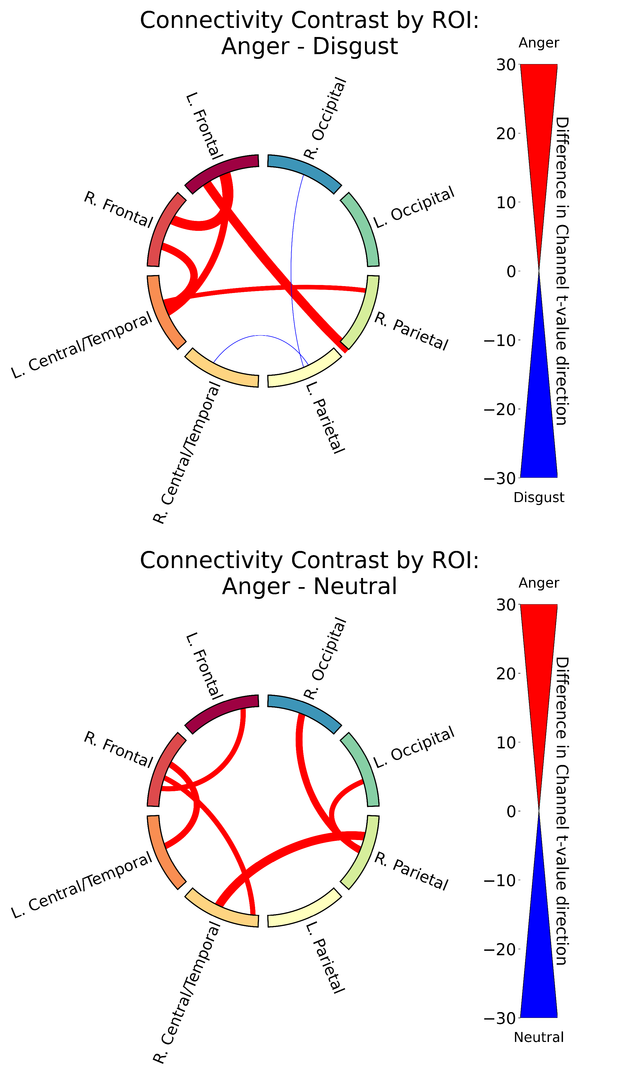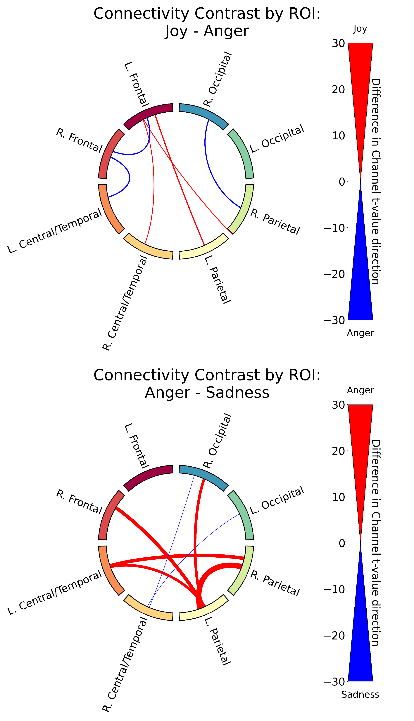

Figure B.1: Functional connectivity results for Anger contrasts: Anger vs. Disgust, Joy, Neutral, and Sadness. (1/4)

60

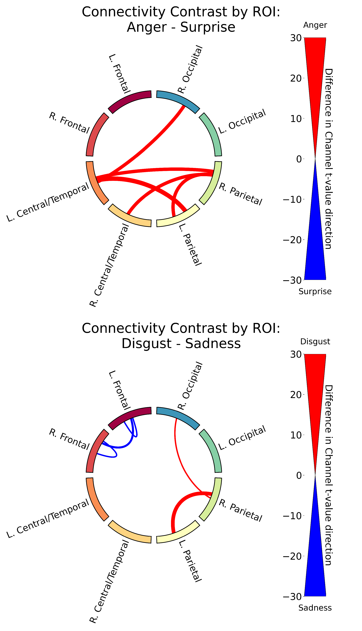 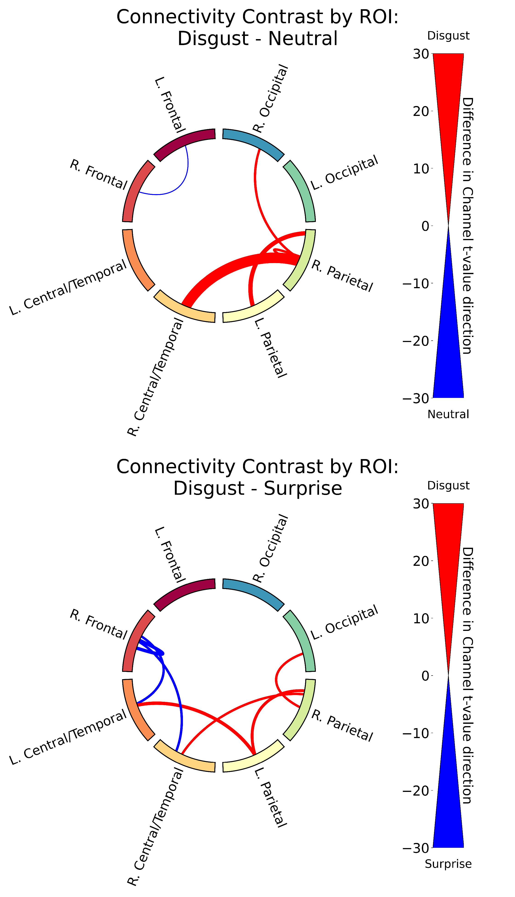

Functional connectivity results for Anger vs. Surprise and Disgust contrasts: Disgust vs. Neutral, Sadness, and Surprise. (2/4)

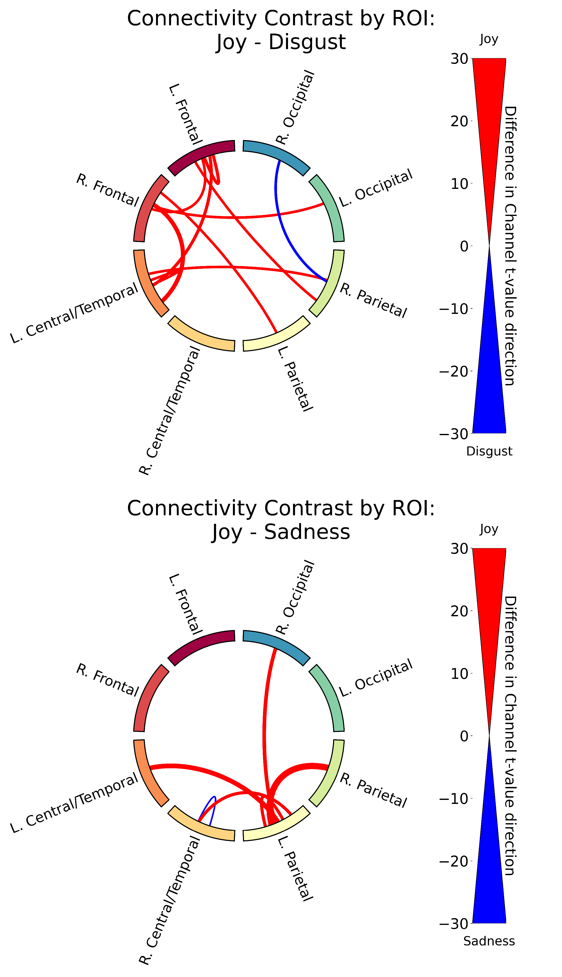 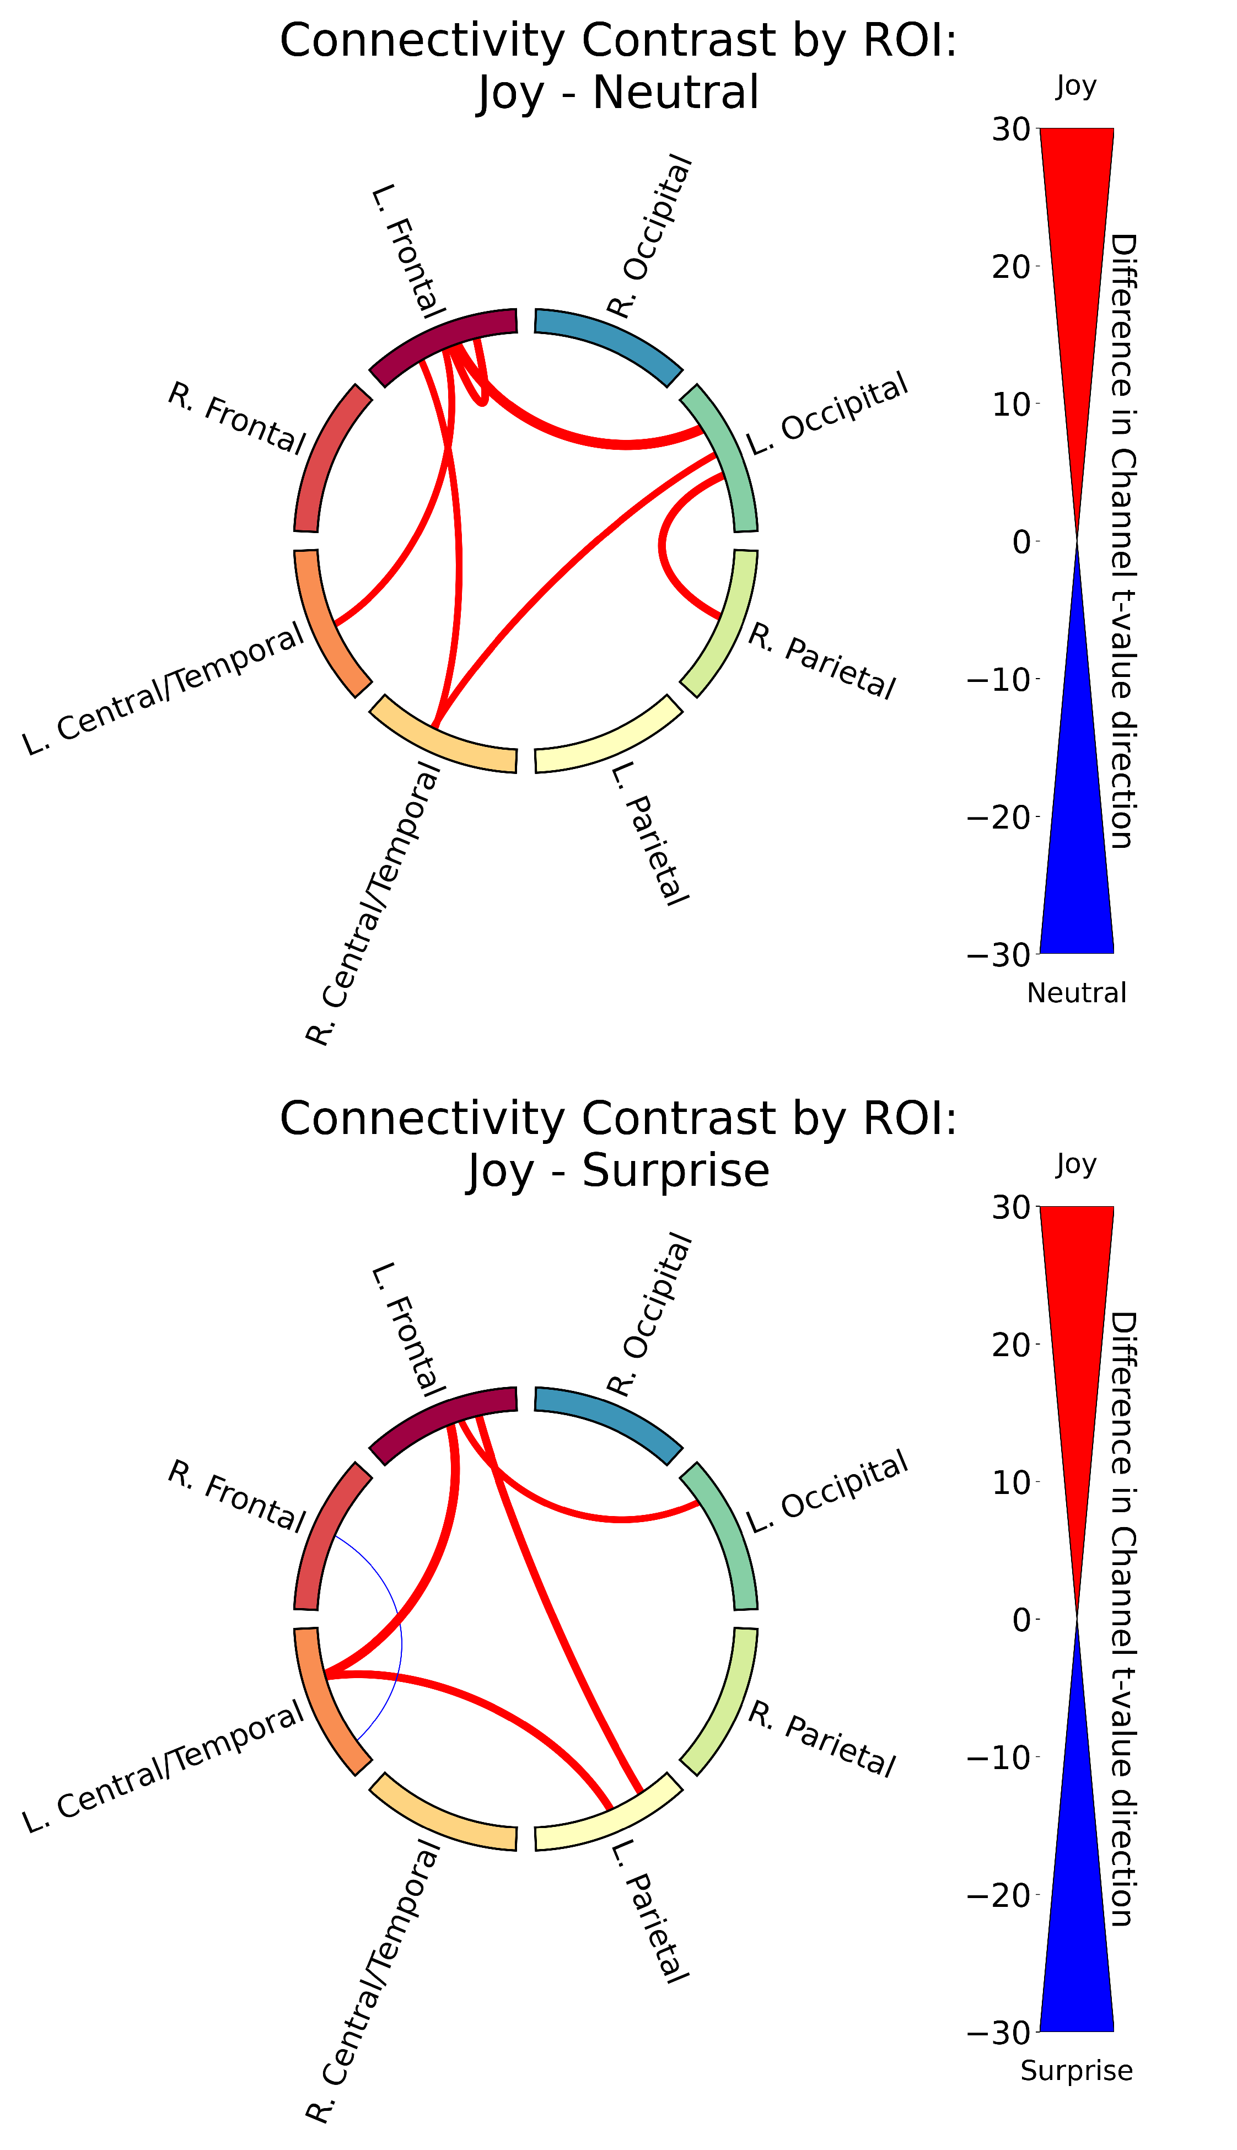

Functional connectivity results for Joy contrasts: Joy vs. Disgust, Neutral, Sadness, and Surprise. (3/4)

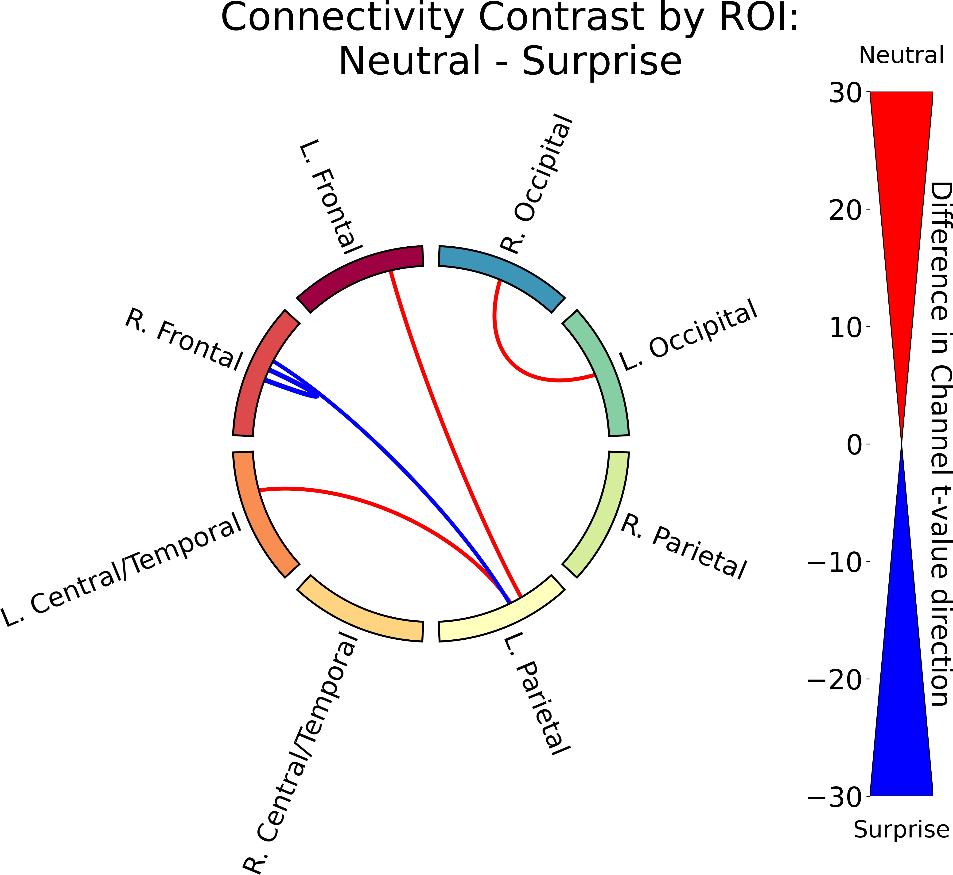 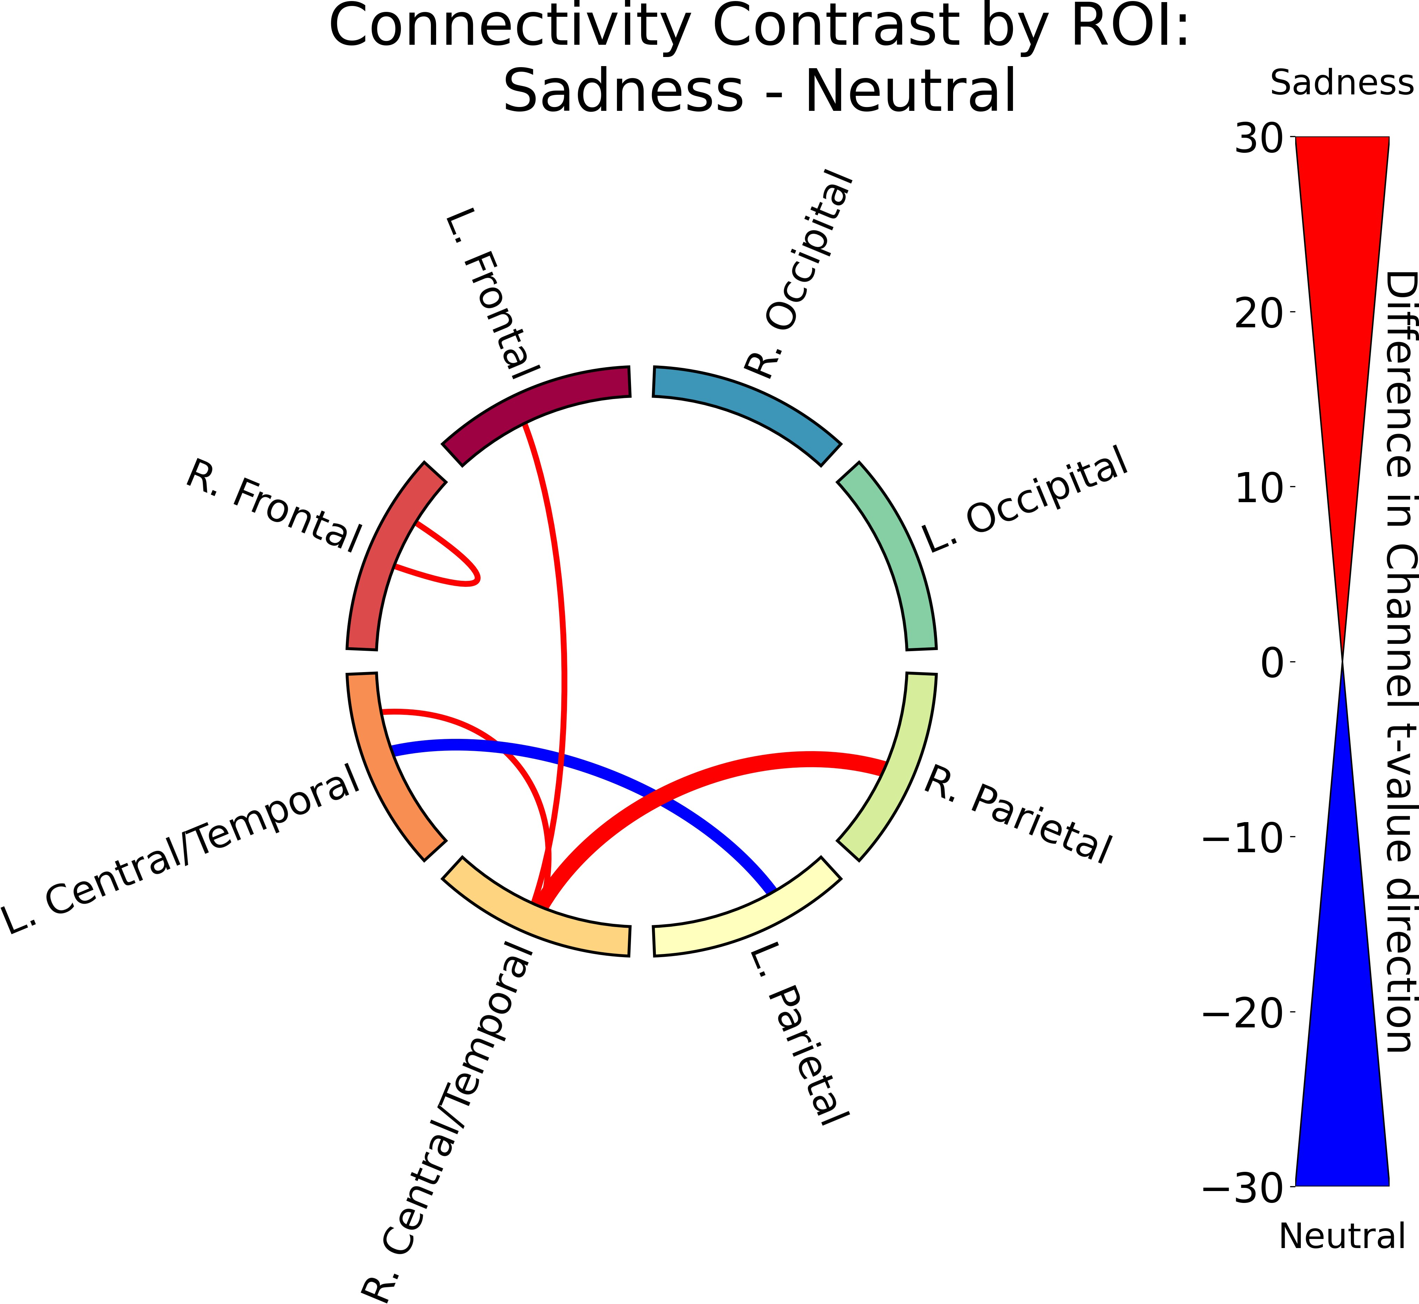

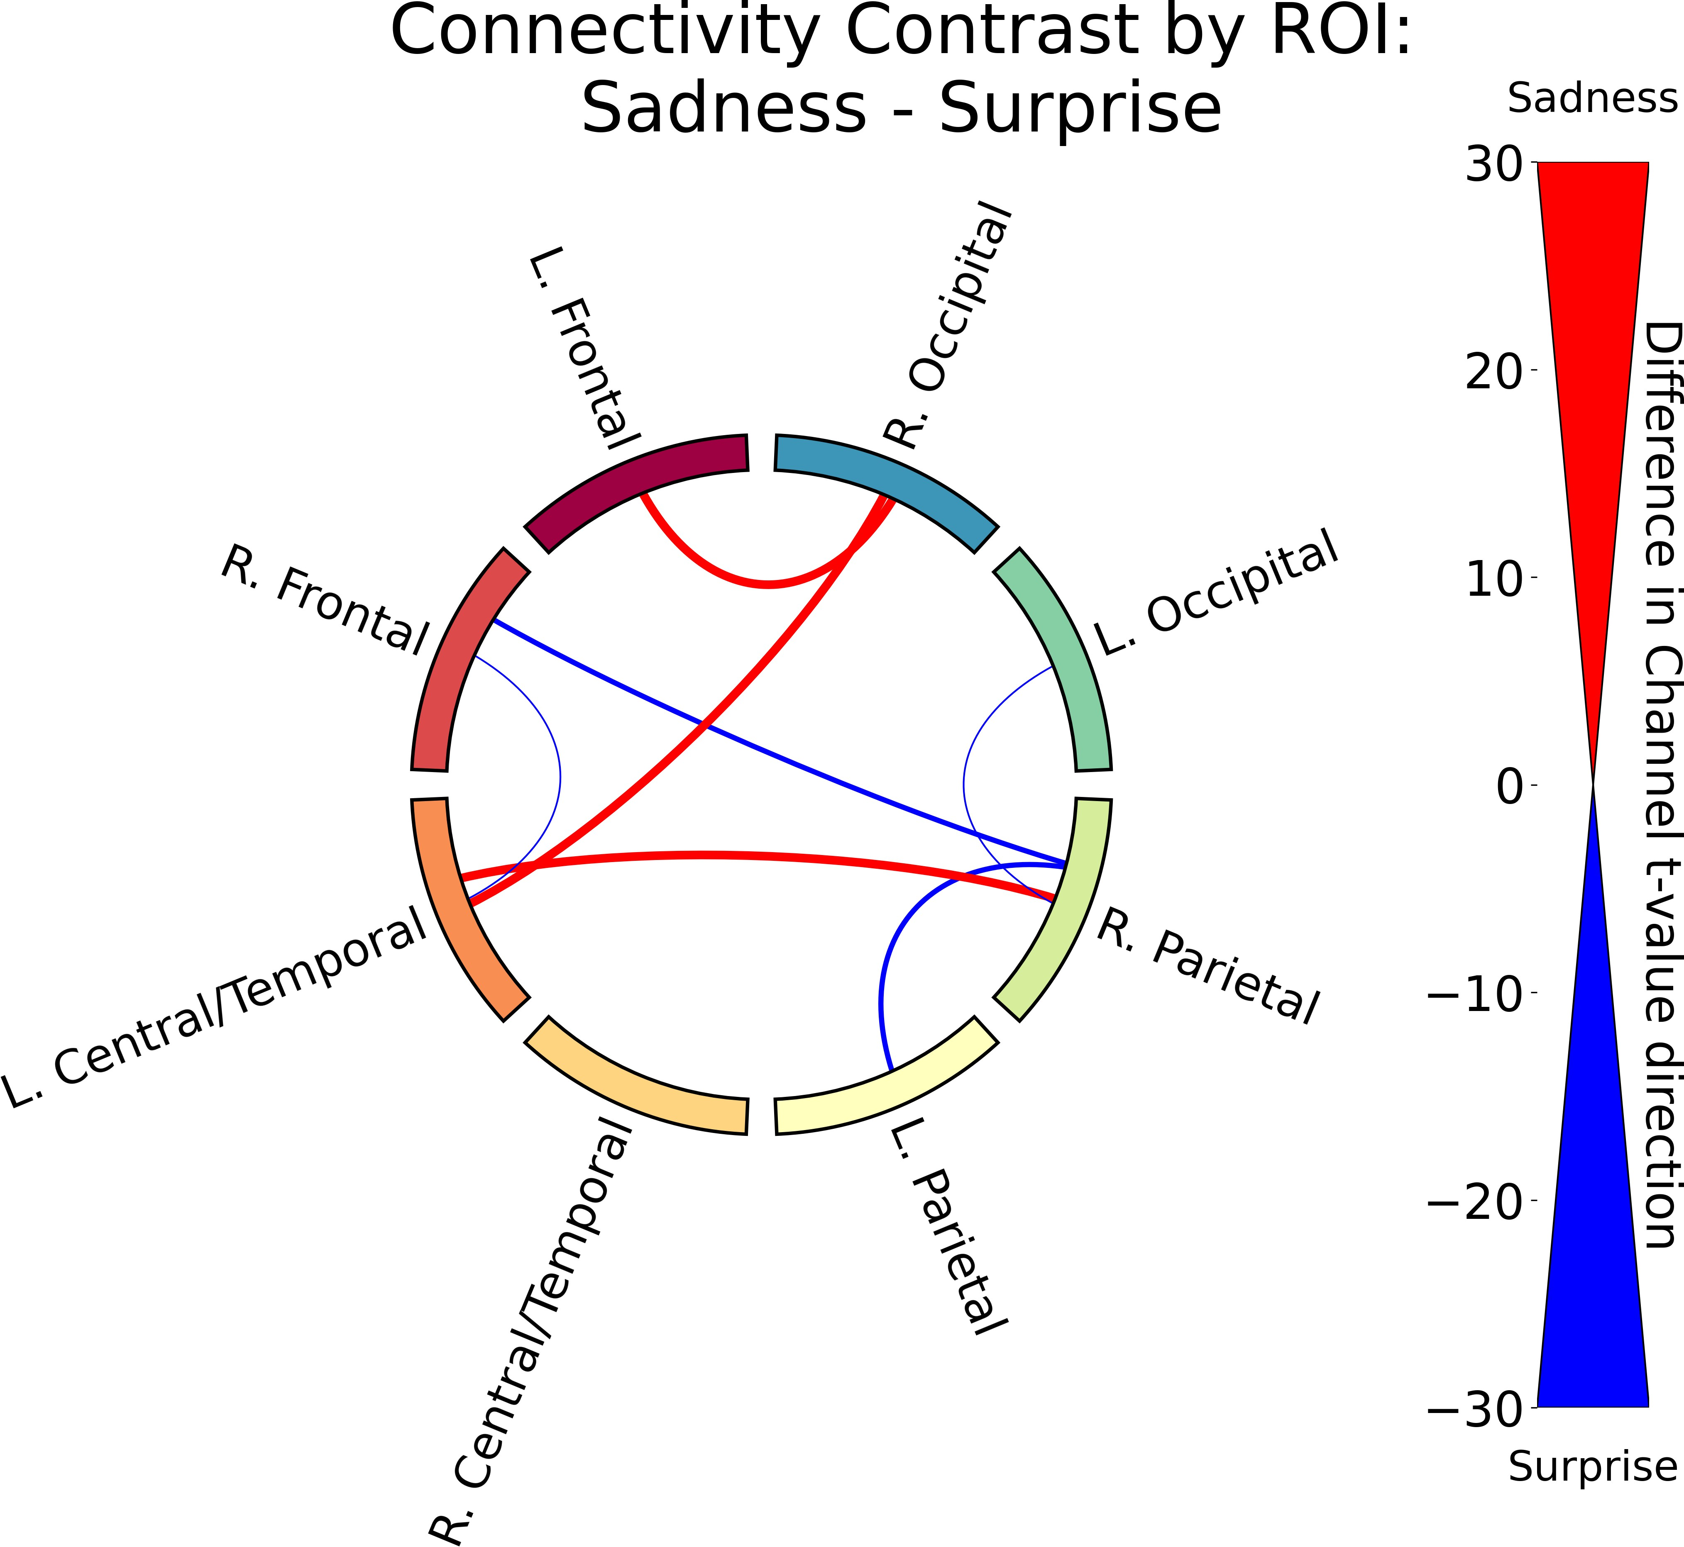Functional connectivity results for Neutral and Sadness contrasts: Neutral vs. Surprise, Sadness vs. Neutral, and Sadness vs. Surprise. (4/4)

Table B.1: Ratio of positive to negative *t*-values for each contrast. The ratio is calculated as Ratio = (Number of Positive *t*-values - Number of Negative *t*-values) / (Number of Positive *t*-values + Number of Negative *t*-values). For condition1 - condition2, a positive ratio indicates that condition1 has more positive *t*-values than condition2, while a negative ratio indicates the opposite.

Contrast

Ratio

|  |  |
| --- | --- |
| Real - Virtual | 0.632 |
| Joy - Fear | -0.797 |

Table B.1: Ratio of positive to negative *t*-values for each contrast. The ratio is calculated as Ratio = (Number of Positive *t*-values - Number of Negative *t*-values) / (Number of Positive *t*-values + Number of Negative *t*-values). For condition1 - condition2, a positive ratio indicates that condition1 has more positive *t*-values than condition2, while a negative ratio indicates the opposite.

Contrast

Ratio

|  |  |
| --- | --- |
| Joy - Anger | -0.323 |
| Joy - Disgust | 0.541 |
| Joy - Sadness | 0.622 |
| Joy - Neutral | 0.894 |
| Joy - Surprise | 0.976 |
| Fear - Anger | 0.345 |
| Fear - Disgust | 0.959 |
| Fear - Sadness | 0.865 |
| Fear - Neutral | 0.977 |
| Fear - Surprise | 0.966 |
| Anger - Disgust | 0.805 |
| Anger - Sadness | 0.709 |
| Anger - Neutral | 0.957 |
| Anger - Surprise | 0.897 |
| Disgust - Sadness | 0.099 |
| Disgust - Neutral | 0.677 |
| Disgust - Surprise | 0.172 |
| Sadness - Neutral | 0.311 |
| Sadness - Surprise | 0.400 |
| Neutral - Surprise | 0.077 |

Table B.1: Ratio of positive to negative *t*-values for each contrast. The ratio is calculated as Ratio = (Number of Positive *t*-values - Number of Negative *t*-values) / (Number of Positive *t*-values + Number of Negative *t*-values). For condition1 - condition2, a positive ratio indicates that condition1 has more positive *t*-values than condition2, while a negative ratio indicates the opposite.

Contrast

Ratio

|  |  |
| --- | --- |
| Real Joy - Real Fear | -0.284 |
| Real Joy - Real Anger | -0.546 |
| Real Joy - Real Disgust | 0.881 |
| Real Joy - Real Sadness | -0.390 |
| Real Joy - Real Neutral | 0.602 |
| Real Joy - Real Surprise | 0.306 |
| Real Joy - Virtual Joy | 0.400 |
| Real Joy - Virtual Fear | -0.882 |
| Real Joy - Virtual Anger | -0.985 |
| Real Joy - Virtual Disgust | -0.636 |
| Real Joy - Virtual Sadness | 0.161 |
| Real Joy - Virtual Neutral | 0.158 |
| Real Joy - Virtual Surprise | 0.624 |
| Real Fear - Real Anger | -0.254 |
| Real Fear - Real Disgust | 0.832 |
| Real Fear - Real Sadness | -0.016 |
| Real Fear - Real Neutral | 0.617 |
| Real Fear - Real Surprise | 0.400 |
| Real Fear - Virtual Joy | 0.395 |
| Real Fear - Virtual Fear | -0.578 |

Table B.1: Ratio of positive to negative *t*-values for each contrast. The ratio is calculated as Ratio = (Number of Positive *t*-values - Number of Negative *t*-values) / (Number of Positive *t*-values + Number of Negative *t*-values). For condition1 - condition2, a positive ratio indicates that condition1 has more positive *t*-values than condition2, while a negative ratio indicates the opposite.

Contrast

Ratio

|  |  |
| --- | --- |
| Real Fear - Virtual Anger | -0.880 |
| Real Fear - Virtual Disgust | 0.103 |
| Real Fear - Virtual Sadness | 0.525 |
| Real Fear - Virtual Neutral | 0.366 |
| Real Fear - Virtual Surprise | 0.779 |
| Real Anger - Real Disgust | 0.823 |
| Real Anger - Real Sadness | 0.115 |
| Real Anger - Real Neutral | 0.853 |
| Real Anger - Real Surprise | 0.739 |
| Real Anger - Virtual Joy | 0.858 |
| Real Anger - Virtual Fear | -0.482 |
| Real Anger - Virtual Anger | -0.914 |
| Real Anger - Virtual Disgust | 0.359 |
| Real Anger - Virtual Sadness | 0.507 |
| Real Anger - Virtual Neutral | 0.743 |
| Real Anger - Virtual Surprise | 0.659 |
| Real Disgust - Real Sadness | -0.792 |
| Real Disgust - Real Neutral | 0.306 |
| Real Disgust - Real Surprise | -0.400 |
| Real Disgust - Virtual Joy | -0.188 |

Table B.1: Ratio of positive to negative *t*-values for each contrast. The ratio is calculated as Ratio = (Number of Positive *t*-values - Number of Negative *t*-values) / (Number of Positive *t*-values + Number of Negative *t*-values). For condition1 - condition2, a positive ratio indicates that condition1 has more positive *t*-values than condition2, while a negative ratio indicates the opposite.

Contrast

Ratio

|  |  |
| --- | --- |
| Real Disgust - Virtual Fear | -0.959 |
| Real Disgust - Virtual Anger | -0.979 |
| Real Disgust - Virtual Disgust | -0.545 |
| Real Disgust - Virtual Sadness | -0.372 |
| Real Disgust - Virtual Neutral | -0.373 |
| Real Disgust - Virtual Surprise | -0.275 |
| Real Sadness - Real Neutral | 0.859 |
| Real Sadness - Real Surprise | 0.649 |
| Real Sadness - Virtual Joy | 0.694 |
| Real Sadness - Virtual Fear | -0.333 |
| Real Sadness - Virtual Anger | -0.825 |
| Real Sadness - Virtual Disgust | 0.036 |
| Real Sadness - Virtual Sadness | 0.308 |
| Real Sadness - Virtual Neutral | 0.489 |
| Real Sadness - Virtual Surprise | 0.885 |
| Real Neutral - Real Surprise | -0.480 |
| Real Neutral - Virtual Joy | -0.463 |
| Real Neutral - Virtual Fear | -0.937 |
| Real Neutral - Virtual Anger | -0.969 |
| Real Neutral - Virtual Disgust | -0.856 |

Table B.1: Ratio of positive to negative *t*-values for each contrast. The ratio is calculated as Ratio = (Number of Positive *t*-values - Number of Negative *t*-values) / (Number of Positive *t*-values + Number of Negative *t*-values). For condition1 - condition2, a positive ratio indicates that condition1 has more positive *t*-values than condition2, while a negative ratio indicates the opposite.

Contrast

Ratio

|  |  |
| --- | --- |
| Real Neutral - Virtual Sadness | -0.550 |
| Real Neutral - Virtual Neutral | -0.588 |
| Real Neutral - Virtual Surprise | -0.105 |
| Real Surprise - Virtual Joy | 0.267 |
| Real Surprise - Virtual Fear | -0.912 |
| Real Surprise - Virtual Anger | -0.928 |
| Real Surprise - Virtual Disgust | -0.200 |
| Real Surprise - Virtual Sadness | 0.123 |
| Real Surprise - Virtual Neutral | 0.058 |
| Real Surprise - Virtual Surprise | 0.432 |
| Virtual Joy - Virtual Fear | -0.867 |
| Virtual Joy - Virtual Anger | -0.979 |
| Virtual Joy - Virtual Disgust | -0.767 |
| Virtual Joy - Virtual Sadness | -0.203 |
| Virtual Joy - Virtual Neutral | -0.476 |
| Virtual Joy - Virtual Surprise | -0.150 |
| Virtual Fear - Virtual Anger | -0.686 |
| Virtual Fear - Virtual Disgust | 0.722 |
| Virtual Fear - Virtual Sadness | 0.728 |
| Virtual Fear - Virtual Neutral | 0.877 |

Table B.1: Ratio of positive to negative *t*-values for each contrast. The ratio is calculated as Ratio = (Number of Positive *t*-values - Number of Negative *t*-values) / (Number of Positive *t*-values + Number of Negative *t*-values). For condition1 - condition2, a positive ratio indicates that condition1 has more positive *t*-values than condition2, while a negative ratio indicates the opposite.

Contrast Ratio

Virtual Fear - Virtual Surprise 0.908 Virtual Anger - Virtual Disgust 0.870 Virtual Anger - Virtual Sadness 0.941 Virtual Anger - Virtual Neutral 0.938 Virtual Anger - Virtual Surprise 0.990 Virtual Disgust - Virtual Sadness 0.351 Virtual Disgust - Virtual Neutral 0.436 Virtual Disgust - Virtual Surprise 0.739 Virtual Sadness - Virtual Neutral -0.020 Virtual Sadness - Virtual Surprise 0.561 Virtual Neutral - Virtual Surprise 0.515

**Appendix C Memory Task**

## ANOVA Results

Table C.1: Two-way ANOVA results for the effect of Face Type and Emotion and their interaction on the correct responses.

Intercept C(Face Type) C(Emotion)

C(Face Type):C(Emotion)

Residual

sum sq

261.07756

1.17722

0.73335

0.40872

df

1.00000

1.00000

6.00000

6.00000

*F*

PR(*>F* )

1764.58989 0.00000

7.95666

0.82610

0.46041

0.00481

0.54946

0.83797

710.47356 4802.00000

70

*Appendix C. Memory Task* 71

## Memory Task No Response Distribution

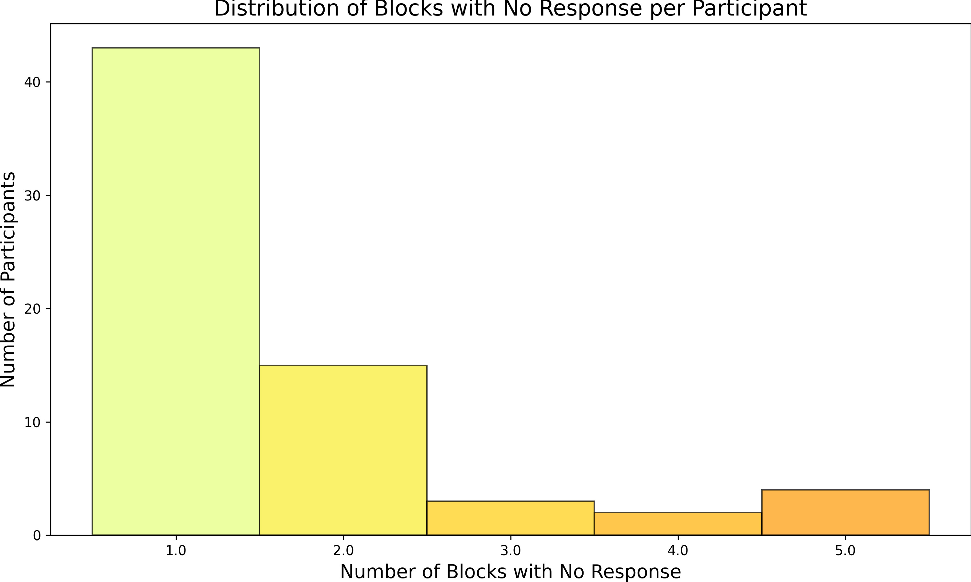

Figure C.1: Distribution of the number of no responses across the 56 blocks for each participant in the memory task.